

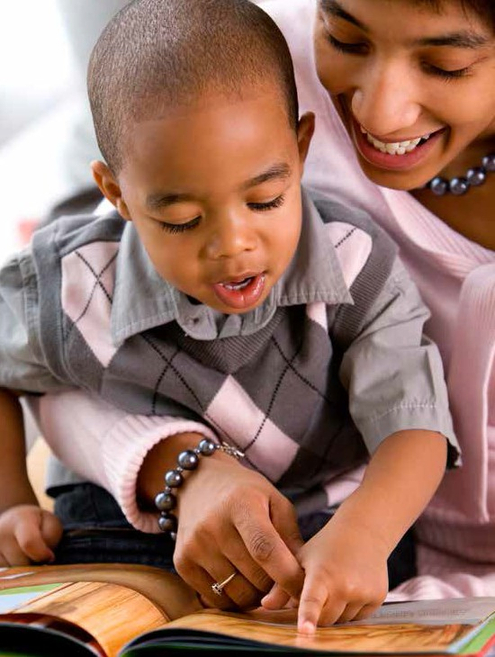

NYSITELL Parent
Information Brochure

Welcome to the New York State public school system! The mission of the New York State Education Department’s (NYSED) Office of Bilingual Education and World Languages (OBEWL) is to ensure that all New York State (NYS) students, including English Language Learners (ELLs)/Multilingual Learners (MLLs), attain the highest level of academic success and language proficiency. We strive to ensure that all students’ individual educational paths and socio-emotional needs are met in multiple languages leading them to college and career readiness.

INTRODUCTION
At enrollment you indicated that your child’s home or primary language is other than English, and an educator interviewed him or her to determine the possible need for additional English language support. The information gathered during the interview indicated that your child might qualify for ELL services and be identified as a possible ELL/MLL. To confirm your child’s eligibility for additional English language support, your child will now be given the New York State Identification Test for English Language Learners (NYSITELL).

WHAT IS THE PURPOSE OF THE NYSITELL?
The purpose of the NYSITELL is to assess the English language level of new students whose home or primary language is other than English. Your child’s score on the NYSITELL (Entering, Emerging, Transitioning, Expanding, or Commanding) will determine if he or she is entitled to receive ELL services and will determine the level of English language support. The results will also help teachers plan the best program for your child based on his or her strengths and needs in listening, speaking, reading, and writing in English.

WHEN IS THE NYSITELL GIVEN?
The NYSITELL is administered to possible ELLs/MLLs only once following registration in a New York State school system.

WHAT KINDS OF QUESTIONS WILL STUDENTS BE ASKED?
The NYSITELL includes multiple choice, short written response, long written response, and oral response questions in listening, speaking, reading, and writing.

HOW DO I GET THE RESULTS?
The school in which your child is enrolled will mail a parent notification letter that will indicate the level and any additional actions that you need to take. If your child is identified as an ELL/MLL, you will be asked to attend an orientation session at which time you will learn about ELL programs that are available for your child.

WHAT DO THE PROFICIENCY LEVELS MEAN?
Depending upon the score your child receives, he or she may be considered an ELL/MLL. A description of the proficiency levels is provided in the table below:

Level | Description of English Language  Proficiency Level
Entering  (Beginning) | A student at the Entering level has great dependence on supports and structures to advance academic language skills and has not yet met the linguistic demands necessary to demonstrate English language proficiency in a variety of academic contexts (settings). | Eligible for Services
Emerging  (Low Intermediate) | A student at the Emerging level has some dependence on supports and structures to advance academic language skills and has not yet met the linguistic demands necessary to demonstrate English language proficiency in a variety of academic contexts (settings). | Eligible for Services
Transitioning  (Intermediate) | A student at the Transitioning level shows some independence in advancing academic language skills, but has yet to meet the linguistic demands necessary to demonstrate English language proficiency in a variety of academic contexts (settings). | Eligible for Services
Expanding  (Advanced) | A student at the Expanding level shows great independence in advancing academic language skills and is approaching the linguistic demands necessary to demonstrate English language proficiency in a variety of academic contexts (settings). | Eligible for Services

WHO ADMINISTERS AND SCORES THE TEST?
The NYSITELL is administered and scored by qualified New York State educators.

IF MY CHILD HAS AN IEP, ARE TESTING ACCOMMODATIONS PERMITTED DURING THE NYSITELL?
Yes, testing accommodations on a student’s IEP are allowable on the NYSITELL. Speak to your child’s teacher to get specific information about accommodations that your child is entitled too.

WHAT SERVICES IS MY CHILD ENTITLED TO ONCE HE OR SHE IS IDENTIFIED AS AN ELL/MLL?
Once your child is identified as an ELL/MLL, he or she is entitled to: Bilingual Education (Transitional or Dual Language) and/or English as a New Language (ENL) services. Your child’s proficiency level determines the minutes of ELL services (class time) that he or she will receive each week. See chart below for specific minutes according to proficiency level.

Level | Grades K-8 Minutes of ENL Instruction per week | Grades 9-12 Minutes  of ENL Instruction per week | Students in Bilingual  Programs
Entering (Beginning) | 360 minutes | 540 minutes | - 1 Home Language Arts Course  - Minimum of 2 bilingual content area subjects
Emerging  (Low Intermediate) | 360 minutes | 360 minutes | - 1 Home Language Arts Course  - Minimum of 2 bilingual content area subjects
Transitioning (Intermediate) | 180 minutes | 180 minutes | - 1 Home Language Arts Course  - Minimum of 1 bilingual content area subject
Expanding (Advanced) | 180 minutes | 180 minutes | - 1 Home Language Arts Course  - Minimum of 1 bilingual content area subject

ONCE I LEARN THE RESULTS, HOW CAN I HELP AT HOME?
- Read to your child in his or her home/primary language and/or English (research shows that reading to your child in your home language will help support English literacy skills).
- Tell stories to your child in your home/primary language.
- Visit your local library and borrow audio books in your home/primary language or English.
- Be sure to attend parent-teacher conferences scheduled by your school.
- Schedule an individual meeting with your child’s teacher to learn about specific ways that you can help your child succeed.
- Schedule time every day for your child to do homework and, if possible, provide a quiet place, free from distractions, where he or she can work.
- Plan family outings to museums. Guides at the museum can help you navigate an exhibit with your child.
- Museums and libraries often offer low cost and/or free enrichment classes after school or on weekends.

For questions and concerns about ELL services please contact
nysparenthotline@nyu.edu
ELL Parent Hotline: (800) 469-8224


Additional questions?
Please send questions or comments to the Office of Bilingual Education and World Languages OBEFLS@nysed.gov
Or call: 718-722-2445
For more information on the NYSITELL visit: http://www.p12.nysed.gov/assessment/nysitell/

