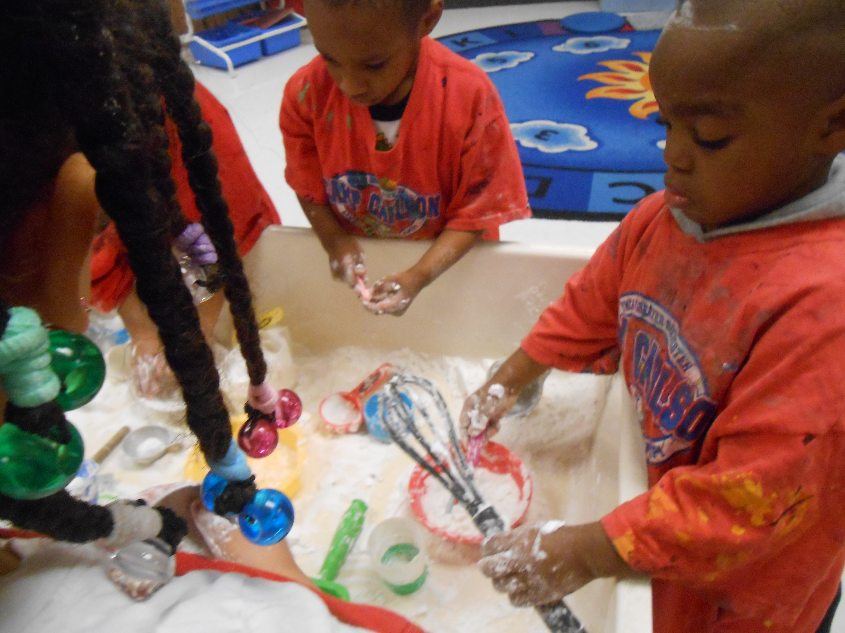
Rainbow Fish News
January, 2014

Many of you have seen children at play when you come to drop your child off, or at pick-up. Often at this age children may play by themselves with their own set of toys, or even play next to each other with the same toys. Several children in the class are even beginning to play cooperatively with others. As I’m sure you would expect, some children have disagreements throughout the day. We handle this, when possible, by involving children in telling both sides, and coming up with a solution together that both people can live with. This is a skill that can take years to understand and use by his or her self, but it is so important for them to learn how to solve problems on their own, or to ask for help when needed. We hope that you are beginning to hear some of this language at home. When your child is trying to work through a problem, you may hear, ‘I have an idea!’ and after things are resolved you may hear, ‘We solved the problem!’ It is important for children to learn something from these natural situations where they feel such strong emotions.
Reminder: The half day morning program extends to 3:00 PM starting February 3. On that day children will have a short nap time and should bring in a large blanket to be wrapped in, or two small blankets, one for under and one for over. I am putting a copy of the new schedule on the back of this paper for you to keep. Since the day will be longer, I am hoping that more parents will be available to volunteer in the classroom. Children love it when a parent comes in to read to the class, eat lunch or breakfast with us, or even just to play at Work Time. When the time adjusts, parents are welcome to come in at 2:55 and be a part of our Goodbye Time! The children are excited, and so are Kato and I!

Here are some classmates playing with our pretend snow, made from baking soda and shaving cream. Sensory play gives many opportunities to problem solve with materials and with other children’s wants/needs.

No School on Monday January 20, 2014 for Martin Luther King Jr. Day. (Daycare children can still come in, but it will not be a regular program day.)
There will be no school the week of February 17-21. (Daycare children can still come in, but it will not be a regular program day.)

Continual Reminders;
- Please send your child with weather appropriate clothing every day
- A zip up coat for outside and hood or hat with mittens or gloves and boots. We love going outside anytime it is over 20 degrees.
- Sneakers with socks and loose fitting clothing that CAN get dirty for inside play, and projects in the room
- An extra change of clothes in case of a spill or accident
- If you have the time and would like to volunteer in the class 10:00, 10:40, 12:15, or 1:40 is a great time to come in, call me!
- My contact information; 263-4283 then ask for me or for Rainbow Fish, Christine.cook@rochesterymca.org

