Discipline Contract
Mrs. Wagner - Room 130 – Sixth Grade

Since a contract is a promise between two people, this paper has two parts. Our class came up with reminders that we feel will make our room and effective environment for learning. These reminders are listed below along with privileges and acknowledgments for showing our best model citizen behavior. Please review this with your child and sign it together. Your support in making this school year the best one ever is important for everyone’s success. THANK YOU!!

Classroom Behavior Reminders
- I can be a positive leader in the classroom
- I can take responsibility for my actions and learning
- I can give respect to others as they can give respect to me.
- I can be caring and supportive to my 6th grade crew members.
- I can be honest and show integrity at all times.

Our daily number for our actions will added up and used to earn rewards for doing the right thing: | Negative Consequences for infractions against the behavior expectations:
PRAISE & PRIDE  Club Tilley  Popcorn & a movie  Prizes  Positive Notes home  Teacher for a day  Free homework coupons  Computer free time  Teacher chair  Kindergarten helpers  PRAISE & PRIDE | - Verbal warning from the teacher and redirection.  - Verbal reminder and student’s card moves to 2.  - Verbal reminder and student’s card moves to 1, visit to buddy teacher where they are expected to “Take-a-break” and reflect upon the ten design principles.  - Student will be expected to re-join the class after counsel from the teacher and a phone call home.  - Behavior infractions after being sent to “Take-a-break” will result in card moved to “0”, removal from the room, formal discipline referral written and consultation with the principal.  *Students can ALWAYS earn their cards back and every day starts fresh.

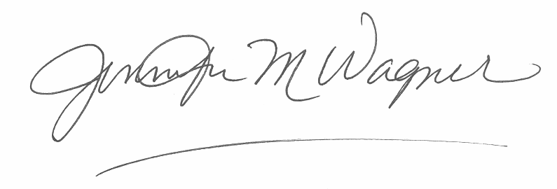
By signing below you agree to support and follow the behavior expectations stated above.

________________________________________________________
Teacher signature

_______________________________________________________
Student signature

________________________________________________________________________________
Parent signature

