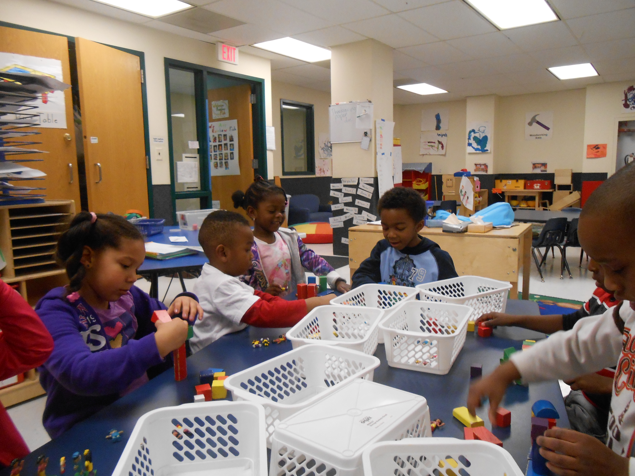
Continual Reminders;
- Please send your child with weather appropriate clothing every day
- A zip up coat for outside and hood or hat with mittens or gloves and boots.
- Sneakers with socks and loose fitting clothing that CAN get dirty for inside play, and projects in the room
- An extra change of clothes in case of a spill or accident
- If you have the time and would like to volunteer in the class 9:00 is a great time to come in and read to kids, call me!
- My contact information; 263-4283 then ask for me or for Rainbow Fish, Christine.cook@rochesterymca.org
Rainbow Fish News
December, 2013

Hands. We use them for so many things in Pre-Kindergarten. We use our hands to feel textures and exploring our world. We use them to hold pencils, markers and crayons. They help to draw and begin to write, and to put puzzles together. So much of what a child learns and understands comes through the hands. This also means that they are touching many, many surfaces. In the winter children tend to share germs along with the toys. The best way to keep everyone healthy is for children to wash their hands well. In the classroom we try to teach hand washing with a song (to the tunes of “Row, row, row your boat” Wash, wash, wash your hands, play this handy game. Scrub and rub, and rub and scrub, the germs go down the drain.) and also when children wash after using the bathroom, or before eating, as well as every time we come in from outside. The other thing we like to encourage about children’s hands is that they should be kept to themselves. At this age several children tend to touch each other to play, hug and wrestle. Some children cannot seem to tell the difference between when it is OK and when it is not. Many times we ask children to only keep their hands to themselves. We hope everyone still has gloves or mittens at home and want to see children wearing them every day. Thank you for making sure that you reinforce the skills we teach.

The last day before Winter Recess is December 20 and that day will be our Stay in Bed and Read Day. Children will be encouraged to come in their pajamas and bring a book.

Winter Recess is December 23-January 3 with school resuming on January 6. Child care will be open those weeks, but closed on December 25.

