Geography Shapes Greek Life

Ancient Greece consisted mainly of a mountainous peninsula jutting out into the Mediterranean Sea. It also included about 2,000 islands in the Aegean (ih•JEE•uhn) and Ionian (eye•OH•nee•uhn) seas. Lands on the eastern edge of
the Aegean were also part of ancient Greece. (See the map on page 121.) The region’s physical geography directly shaped Greek traditions and customs.

The Sea The sea shaped Greek civilization just as rivers shaped the ancient civilizations of Egypt, the Fertile Crescent, India, and China. In one sense, the Greeks did not live on a land but around a sea. Greeks rarely had to travel more
than 85 miles to reach the coastline. The Aegean Sea, the Ionian Sea, and the neighboring Black Sea were important transportation routes for the Greek people. These seaways linked most parts of Greece. As the Greeks became skilled
sailors, sea travel connected Greece with other societies. Sea travel and trade were also important because Greece lacked natural resources, such as timber, precious metals, and usable farmland.

The Land Rugged mountains covered about three-fourths of ancient Greece. The mountain chains ran mainly from northwest to southeast along the Balkan Peninsula. Mountains divided the land into a number of different regions. This
significantly influenced Greek political life. Instead of a single government, the Greeks developed small, independent communities within each little valley and its surrounding mountains. Most Greeks gave their loyalty to these local communities. In ancient times, the uneven terrain also made land transportation difficult. Of the few roads that existed, most were little more than dirt paths. It often took travelers several days to complete a journey that might take a few hours today. Much of the land itself was stony, and only a small part of it was arable, or suitable for farming. Tiny but fertile valleys covered about one-fourth of Greece.

The small streams that watered these valleys were not suitable for large-scale irrigation projects. With so little fertile farmland or fresh water for irrigation, Greece was never able to support a large population. Historians estimate that no
more than a few million people lived in ancient Greece at any given time. Even this small population could not expect the land to support a life of luxury. A desire for more living space, grassland for raising livestock, and adequate farmland may have been factors that motivated the Greeks to seek new sites for colonies.

The Climate Climate was the third important environmental influence on Greek civilization. Greece has a varied climate, with temperatures averaging 48 degrees Fahrenheit in the winter and 80 degrees Fahrenheit in the summer. In ancient times, these moderate temperatures supported an outdoor life for many Greek citizens. Men spent much of their leisure time at outdoor public events. They met often to discuss public issues, exchange news, and take an active part in civic life.
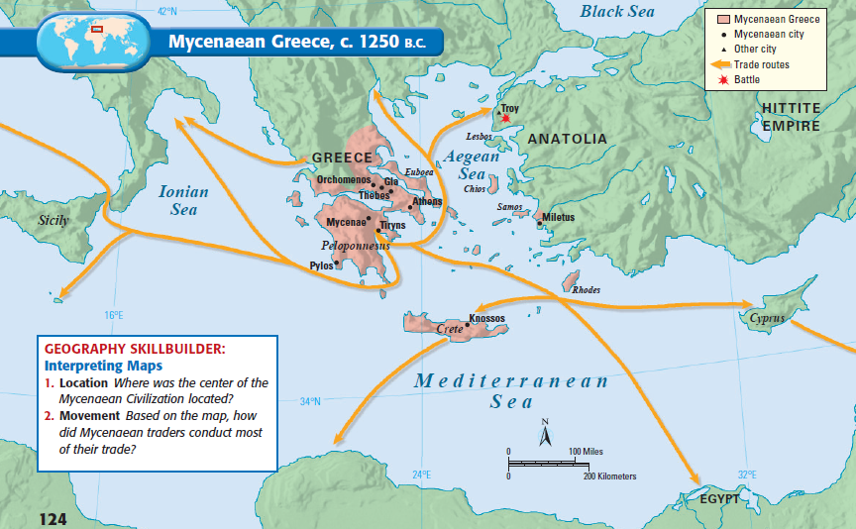

Analyzing Causes - In what ways did Greece’s location by the sea and its mountainous land affect its development?

Rome’s Geography

According to legend, the city of Rome was founded in 753 B.C. by Romulus and Remus, twin sons of the god Mars and a Latin princess. The twins were abandoned on the Tiber River as infants and raised by a she-wolf. The twins decided to build a city near the spot. In reality, it was men not immortals who built the
city, and they chose the spot largely for its strategic location and fertile soil.

Rome was built on seven rolling hills at a curve on the Tiber River, near the center of the Italian peninsula. It was midway between the Alps and Italy’s southern tip. Rome also was near the midpoint of the
Mediterranean Sea. The historian Livy wrote about the city’s site:

Not without reason did gods and men choose this spot for the site of our city—the
[salubrious] hills, the river to bring us produce from the inland regions and sea-borne
commerce from abroad, the sea itself, near enough for convenience yet not so near as
to bring danger from foreign fleets, our situation in the very heart of Italy—all these
advantages make it of all places in the world the best for a city destined to grow great.
LIVY, The Early History of Rome

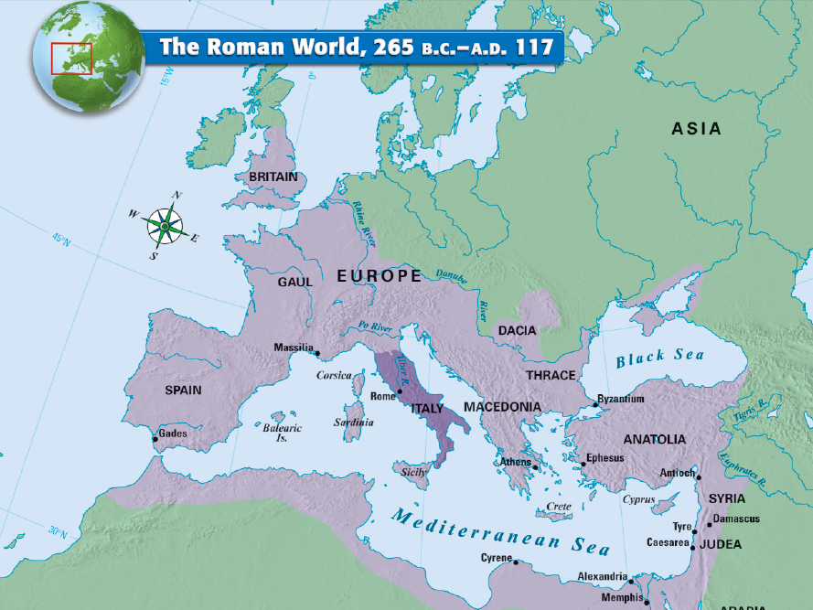

The Geography of the Indian Subcontinent
Geographers often refer to the landmass that includes India, Pakistan, and Bangladesh as the Indian subcontinent. A wall of the highest mountains in the world—the Hindu Kush, Karakorum, and Himalayan ranges—separates this
region from the rest of the Asian continent.

Rivers, Mountains, and Plains The world’s tallest mountains to the north and a large desert to the east helped protect the Indus Valley from invasion. The mountains guard an enormous flat and fertile plain formed by two rivers—the
Indus and the Ganges (GAN•jeez). Each river is an important link from the interior of the subcontinent to the sea. The Indus River flows southwest from the Himalayas to the Arabian Sea. Much of the lower Indus Valley is occupied by the Thar Desert. Farming is possible only in the areas directly watered by the Indus. The Ganges drops down from the Himalayas and flows eastward across northern India. It joins the Brahmaputra River as it flows to the Bay of Bengal.

The Indus and Ganges and the lands they water make up a large area that stretches 1,700 miles across northern India and is called the Indo-Gangetic Plain. Like the Tigris, the Euphrates, and the Nile, these rivers carry not only water for
irrigation, but also silt, which produces rich land for agriculture.

Below the Indo-Gangetic Plain, the southern part of the subcontinent is a peninsula that thrusts south into the Indian Ocean. The center of the peninsula is a high plateau cut by twisting rivers. This region is called the Deccan (DEK•uhn)
Plateau. The plateau is framed by low mountain ranges called the Eastern and Western Ghats. These mountains keep moist air from reaching the plateau, making it a dry region. A narrow border of lush, tropical land lies along the coasts of southern India.

Monsoons Seasonal winds called monsoons dominate India’s climate. From October to February, winter monsoons from the northeast blow dry air westward across the country. Then, from the middle of June through October, the winds shift. These monsoons blow eastward from the southwest, carrying moisture from the ocean in great rain clouds. The powerful storms bring so much moisture that flooding often happens. When the summer monsoons fail to develop, drought often causes crop disasters.

Environmental Challenges The civilization that emerged along the Indus River faced many of the same challenges as the ancient Mesopotamian and Egyptian
civilizations.

• Yearly floods spread deposits of rich soil over a wide area. However, the floods along the Indus were unpredictable.
• The rivers sometimes changed course.
• The cycle of wet and dry seasons brought by the monsoon winds was unpredictable. If there was too little rain, plants
withered in the fields and people went hungry. If there was too much rain, floods swept away whole villages.

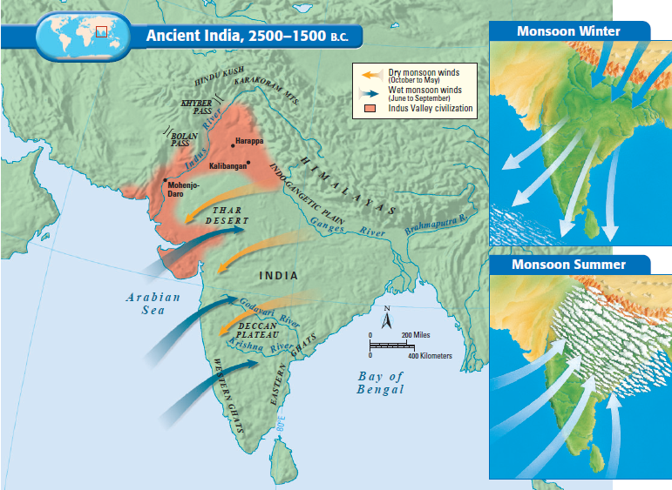

The Geography of China
Natural barriers somewhat isolated ancient China from all other civilizations. To China’s east lay the Yellow Sea, the East China Sea, and the Pacific Ocean. Mountain ranges and deserts dominate about two-thirds of China’s landmass.
In west China lay the Taklimakan (TAH•kluh•muh•KAHN) Desert and the icy 15,000-foot Plateau of Tibet. To the southwest are the Himalayas. And to the north are the desolate Gobi Desert and the Mongolian Plateau.

River Systems Two major river systems flow from the mountainous west to the Pacific Ocean. The Huang He (hwahng•HUH), also known as the Yellow River, is found in the north. In central China, the Chang Jiang (chang•jyhang), also called Yangtze (yang•SEE), flows east to the Yellow Sea. The Huang He, whose name means “yellow river,” deposits huge amounts of yellowish silt when it overflows its banks. This silt is actually fertile soil called loess (LOH•uhs), which is blown by the winds from deserts to the west and north.

Environmental Challenges Like the other ancient civilizations in this chapter, China’s first civilization developed in a river valley. China, too, faced the dangers of floods—but its geographic isolation posed its own challenges.

• The Huang He’s floods could be disastrous. Sometimes floods devoured whole villages, earning the river the
nickname “China’s Sorrow.”
• Because of China’s relative geographic isolation, early settlers had to supply their own goods rather than trading with
outside peoples.
• China’s natural boundaries did not completely protect these settlers from outsiders. Invasions from the west and north
occurred again and again in Chinese history.

China’s Heartland Only about 10 percent of China’s land is suitable for farming.Much of the land lies within the small plain between the Huang He and the Chang Jiang in eastern China. This plain, known as the North China Plain, is China’s heartland. Throughout China’s long history, its political boundaries have expanded and contracted depending on the strength or weakness of its ruling families. Yet the heartland of China remained the center of its civilization.

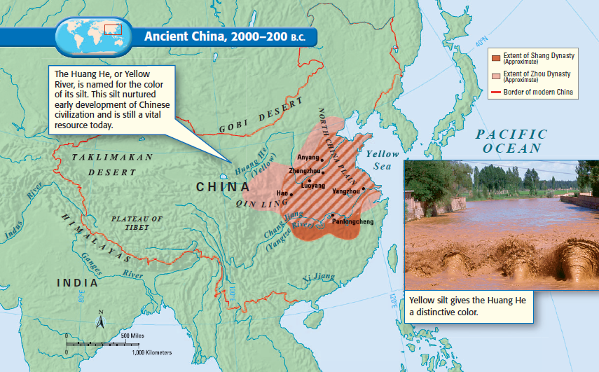

Early Mesoamerican Civilizations - The Olmec

The story of developed civilizations in the Americas begins in a region called Mesoamerica. (See map below)
This area stretches south from central Mexico to northern Honduras. It was here, more than 3,000 years ago, that the first complex societies in the Americas arose.

Mesoamerica’s first known civilization builders were a people known as the Olmec. They began carving out a society around 1200 B.C. in the jungles of southern Mexico. The Olmec influenced neighboring groups, as well as the later civilizations of the region. They often are called Mesoamerica’s “mother culture.”

Around 1860, a worker clearing a field in the hot coastal plain of southeastern Mexico uncovered an extraordinary stone sculpture. It stood five feet tall and weighed an estimated eight tons. The sculpture was of an enormous head, wearing a headpiece. The head was carved in a strikingly realistic style, with thick lips, a flat nose, and large oval eyes. Archaeologists had never seen anything like it in the Americas. This head, along with others that were discovered later, was a remnant of the Olmec civilization.

The Olmec emerged about 1200 B.C. and thrived from approximately 800–400 B.C. They lived along the Gulf Coast of Mexico, in the modern-day Mexican states of Veracruz and Tabasco. On the surface, the Gulf Coast seemed an unlikely site for a high culture to take root. The region was hot and humid and covered with swamps and jungle. In some places, giant trees formed a thick cover that prevented most sunlight from reaching the ground. Up to 100 inches of rain fell every year. The rainfall swelled rivers and caused severe flooding.

However, the region also had certain advantages. There were abundant deposits of salt and tar, as well as fine clay used in making pottery. There was also wood and rubber from the rain forest. The hills to the north provided hard stone from which the Olmec could make tools and monuments. The rivers that laced the region provided a means of transport. Most important, the flood plains of these rivers provided fertile land for farming.

The Olmec appear to have been a prosperous people who directed a large trading network throughout Mesoamerica. Olmec goods traveled as far as Mexico City to the north and Honduras to the south. In addition, raw materials—including iron ore and various stones—reached San Lorenzo from faraway regions. This trade network helped boost the Olmec economy and spread Olmec influence.
