FOUNDING A NEW NATION

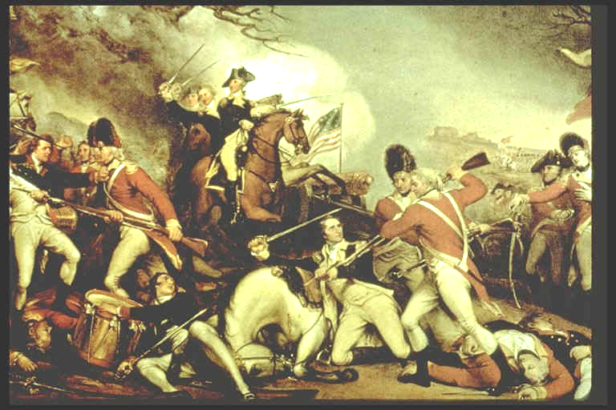

THE AMERICAN REVOLUTION

DOCUMENT 1: The American Revolution Timeline Pg. 3
DOCUMENT 2: What were the Causes of the American Revolution Pg. 4-6
DOCUMENT 3: A Letter to Benjamin Franklin Pg. 6
DOCUMENT 4: The Stamp Act Parliamentary Testimony Pg 7-8
DOCUMENT 5: The Boston Massacre: March 5th 1770 Pg. 9
DOCUMENT 6: Paul Revere Engraving of Boston Massacre Pg. 10
DOCUMENT 7: Diary of John Adams a His Involvement in the Boston Massacre Trial Pg. 11
DOCUMENT 8: Tea Act of 1773 by Heather Waters Gilder Lehrman Institute Pg. 11
DOCUMENT 9: Letter to Reverend Samson Occum From Phillis Wheatley Pg. 12
DOCUMENT 10: Remember the Ladies Pg. 13
DOCUMENT 11: Declaration of Independence A portrait by John Trumball Pg. 14
DOCUMENT 12: Thomas Paine Common Sense Pg. 15
DOCUMENT 13: The True Interest of America Impartially Started 1776 Pg. 16
DOCUMENT 14: Washington’s Letter to Continental Congress Pg. 17
DOCUMENT 15: Diary of Albigence Waldo, Surgeon at Valley Forge, 1777 Pg. 17
DOCUMENT 16: Account by Benedict Arnold to explain his reason for treason Pg. 18
DOCUMENT 17: African American Slaves role in Independence Pg. 18
DOCUMENT 1 AMERICAN REVOLUTION TIMELINE

TIMELINE: 1763 - 1790
1763 End of Seven Years’ War; British Empire much expanded in North America
1763 Pontiac’s Rebellion
1763 Proclamation Line of 1763 Forbids English settlement west of the Appalachians
1763-1765 Glenville’s first colonial trade regulations passed
1765 Protests against regulations, especially Stamp Act
1766 Stamp Act Repealed
1767 Townshend Acts
1768 Protests against Townshend Acts, including activism by the Sons of Liberty
1770 Boston Massacre
1773 Boston Tea Party
1774 Coercive Acts (Intolerable Acts)
1774 First Continental Congress meets, presses Declaration of American Rights, calls for organized boycott of British goods.
1775 British attempt to seize arms stored at Concord (Massachusetts) leads to the Beginning of war
1775 George Washington named commander-in-chief of Continental Army; fighting spreads beyond New England
1776 Publication of Thomas Paine’s Common Sense
1776 Congress adopts Declaration of Independence
1777 Americans win battle of Saratoga (New York)
1778 Americans sign treaties of alliance with France
1779 American defeat Iroquois in upstate New York
1781 American-French combined forces force Cornwallis to surrender at Yorktown (Virginia)
1781 Articles of Confederation ratified by all the former colonies
1783 Peace of Paris signed; Americans gain independence and territory to the Mississippi
1785 Land Ordinance passed, dividing western land where Native American titles had been extinguished into a rectangular grid of 36-square-mile townships and 640-acre lots
1786-1787 Shay’s Rebellion (Massachusetts)
1786 Annapolis Convention
1787 Northwest Ordinance passed, specifying process by which territories could become states
1787 Constitutional Convention
1787-1790 States ratify new Constitution

DOCUMENT 2
What Were the Causes of The American Revolution
Traditionally, Americans have viewed the American Revolution as a popular uprising by an aroused colonial population against interference with their rights by a tyrannical king and government. Recent historians have pointed out that this traditional view, reflected in the treatment of the American Revolution in most of our history textbooks, is based largely on the accounts and records of the American participants in the struggle. These accounts, colored as they are by the emotions and justifications of biased observers, are questionable as historical evidence, yet they continue to form the basis for our view of the American Revolution. The excerpts on the following pages, therefore, are presented in two sections. The first consists of statements by contemporaries — the arguments advanced by the colonists to justify their defiance of British colonial policy, and counter-arguments advanced by Tory observers. In reading this section, it is interesting to note the shifting legal foundations upon which colonial resistance was based. Thus, James Otis attacked the British for denying the colonists the traditional rights of Englishmen; when revenue taxes were imposed, the colonists raised the cry of "No Taxation Without Representation!"; and finally they justified their revolution and war for independence on the basis of the "natural rights of man."

The second section is composed of interpretations by modern historians, presenting varied and sometimes conflicting views on the causes and nature of the developing struggle. The first selection deals with the changing colonial arguments themselves, while the others deal either with basic causes or the role of particular groups in the development of the revolution. These selections can have meaning for you only after you have read your textbook carefully and have become familiar with the events and persons referred to in the selections.

How Did Contemporaries View the Developing Struggle?
1. James Otis sees the use of writs of assistance (general search warrants') as a violation of the traditional rights of Englishmen.
Everyone with this writ may be a tyrant; if this commission be legal, a tyrant in a legal manner also may control, imprison, or murder anyone within the realm. In the next place, it is perpetual; there is no return. A man is accountable to no person for his doings. Every man may reign secure in his petty tyranny and spread terror and desolation around him. In the third place, a person with this writ, in the daytime, may enter all houses, shops, etc., at will and command all to assist him. Fourthly, by this writ not only deputies, etc., but even their menial servants are allowed to lord it over us. Now one of the most essential branches of English liberty is the freedom of one's house. A man's house is his castle; and while he is quiet, he is as well guarded as a prince in his castle. This writ . . . would totally annihilate this privilege. Custom-house officers may enter our houses when they please; we are commanded to permit their entry. Their menial servants may enter, may break locks, bars, and everything in their way; and whether they break through malice or revenge, no man, no court, can inquire. Bare suspicion without oath is sufficient . . . What a scene does this open. Every man, prompted by revenge, ill humor, or wantonness to inspect the inside of his neighbor's house, may get a writ of assistance. Others will ask it for self-defense; one arbitrary exertion will provoke another, until society be involved in tumult and in blood.
Charles F. Adams, ed., The Works of John Adams. Boston. Little, Brown and Co., 1851, II, 521 ff.

2. Some colonial leaders argue that the king had delegated local authority to the colonies in the charters, which represented contracts between the king and the colonies. John Adams points to specific rights that the kings had granted to the colonies.
The charter to the treasurer and company of Virginia, 23 May, 1609, grants ample powers of government, legislative, executive, and judicial, and then contains an express covenant [agreement], "to and with the said treasurer and company . . . that they . . . shall be free from all taxes and impositions forever, upon any goods or merchandises, at any time or times hereafter, either upon importation thither, or exportation from thence, into our realm of England, or into any other of our realms or dominions." . . .
After the acts of navigation were passed, Virginia sent agents to England, and a remonstrance [protest] against those acts. Charles, in answer, sent a declaration under the privy seal, 19 April, 1676, affirming "that taxes ought not to be laid upon the inhabitants and proprietors of the colony, but by the common consent of the general assembly; except such impositions as the parliament should lay on the commodities imported into England from the colony." And he ordered a charter under the great seal, to secure this right to the Virginians.
John Adams, Novanglus, in Works, IV, 108—10.

3. Among the traditional rights of Englishmen, claim colonial leaders, was the right to consent to taxes levied against them. The Stamp Act Congress emphasizes the issue of "No taxation without representation."
The members of this Congress, sincerely devoted, with the warmest sentiments of affection and duty to His Majesty's person and Government . . . esteem it our indispensable duty to make the following declarations of our humble opinion, respecting the most essential rights and liberties of the colonies, and of the grievances under which they labour, by reason of several late Acts of Parliament. I. That His Majesty's subjects in these colonies, owe the same allegiance to the Crown of Great Britain, that is owing from his subjects born within the realm, and all due subordinaion to that august body the Parliament of Great Britain.
II. That His Majesty's liege subjects in these colonies, are entitled to all the inherent rights and liberties of his natural born subjects within the kingdom of Great Britain.
III. That it is inseparably essential to the freedom of a people, and the undoubted right of Englishmen, that no taxes be imposed on them, but with their own consent, given personally, or by their representatives.
IV. That the people of these colonies are not, and from their local circumstances cannot be, represented in the House of Commons in Great Britain.
V. That the only representatives of the people of these colonies, are persons chosen therein by themselves, and that no taxes ever have been, or can be constitutionally imposed on them, but by their respective legislatures.
Resolutions of the Stamp Act Congress, Oct. 19, 1765. E. and H. Morgan, The Stamp Act Crisis. Univ. of North Carolina, 1953, 106—107.

4. To these arguments, the First Continental Congress add the distinction between an external tax, designed to regulate trade (seen as a legitimate exercise of power) and an internal tax, designed to raise revenue (which is regarded as taxation without representation^).
Resolved . . . That the foundation of English liberty, and of all free governments, is a right in the people to participate in their legislative council: and as the English colonists are not represented, and from their local and other circumstances, cannot properly be represented in the British parliament, they are entitled to a free and exclusive power of legislation in their several provincial legislatures, where their right of representation can alone be preserved, in all cases of taxation and internal polity . . . But, from the necessity of the case, and a regard to the mutual interest of both countries, we cheerfully consent to the operation of such acts of the British parliament, as are bona fide, restrained to the regulation of our external commerce, for the purpose of securing the commercial advantages of the whole empire to the mother country, and the commercial benefits of its respective members; excluding every idea of taxation, internal or external, for raising a revenue on the subjects in America, without their consent.
Declaration and Resolves of the First Continental Congress, October 14, 1774. W. C. Ford, ed., Journals of the Continental Congress. Washington. Library of Congress, 1904, I, 63.

5. Samuel Adams argues that the colonial charters had given local assemblies exclusive right to levy internal taxes.
Thus we see that Whatever Government in general may be founded in, Ours was manifestly founded in Compact ... By this charter, we have an exclusive Right to make laws for our own internal Government and Taxation: And indeed if the Inhabitants here are British subjects ... it seems necessary that they should exercise this Power themselves; for They are not represented in the British Parliament and their great Distance renders it impracticable . . .
H. A. Gushing, ed., The Writings of Samuel Adams. New York. G. P. Putnam's Sons, 1904, I, 27-29.

6. Tory observers question the argument that the colonies were not represented in Parliament, claiming that "virtual representation" gave every Englishman everywhere effective representation in the British Parliament.
. . . every Englishman, whether he has a right to vote for a representative or not, is still represented in the British parliament . . .
Why does not this imaginary representation extend to America, as well as over the whole island of Great Britain? If it can travel three hundred miles, why not three thousand? If it can jump over rivers and mountains, why cannot it sail over the ocean? If the towns of Manchester and Birmingham sending no representatives to parliament, are notwithstanding there represented, why are not the cities of Albany and Boston equally represented in that assembly? Are they not alike British subjects? are they not Englishmen? or are they only Englishmen when they solicit [ask] for protection, but not Englishmen when taxes are required to enable this country to protect them?
Soame Jenyns, "The Objections to the Taxation of Our American Colonies by the Legislature of Great Britain Briefly Considered," 1765, Works (C. N. Cole, ed.). London, 1790, II, 190 ff.

7. Alexander Hamilton denies parliamentary authority over the colonies. The royal charters, he maintains, were agreements between the king and the colonies, and had nothing to do with Parliament.
He is king of America by virtue of a compact between us and the kings of Great Britain. These colonies were planted and settled by the grants, and under the protection of English kings, who entered into covenants with us, for themselves, their heirs, and successors; and it is from these covenants, that the duty of protection, on their part, and the duty of allegiance, on ours, arise.
Alexander Hamilton,
"The Farmer Refuted," 1775, Works (J. C. Hamilton, ed.). New York. John F. Trow, 1850, II, 46.

8. But a Tory scoffs at the notion that the colonists could be loyal to the king and not to Parliament, since the king's authority came from Parliament.
In every government there must be a supreme, absolute authority lodged somewhere . . .To talk of being liege subjects to King George, while we disavow the authority of parliament is another piece of whiggish nonsense ... If we obey the laws of the King, we obey the laws of the parliament. If we disown the authority of the parliament, we disown the authority of the King . . . The dependence of the colonies on the mother country will be fixed on a firm foundation: the sovereign authority of Parliament, over all the dominions of the empire will be established . . .
Samuel Seabury, A View of the Controversy Between Great Britain and Her Colonies. New York. 1774, 6 ff.

Review: What historical evidence could Seabury submit to back up his argument that the king's powers came from Parliament?

9. The major arguments advanced by the colonists center on the "natural rights" philosophy. According to this theory, all men possessed the same natural rights; governments had been established through social contracts designed to safeguard these rights.
All men are, by nature, equal and free: No one has a right to any authority over another without his consent: all lawful government is founded on the consent of those who are subject to it: Such consent was given with a view to ensure and to increase the happiness of the governed, above what they could enjoy in an independent and unconnected state of nature . . .
James Wilson, "Considerations on the Nature and Extent of the Legislative Authority of the British Parliament," 1774, Works (J. D. Andrews, ed.). Chicago, 1896, II, 501.

DOCUMENT 3 A letter to Benjamin Franklin from his son, William September 7,1765
Burlington, Septr. 7,1765 10P.M.
Honoured Sir
....Mr. Coxe never consulted me on his Resignation, but on the contrary told me about 10 Days ago mat he should certainly do his utmost to execute the Office.... so that his Surrender is not only using the Gentleman ill who recommended him to the Office, but the Province in general, as it may subject them to be thought as culpable as the N. England Governments.
I have as yet received no directions from the Ministry relative to the Stamp Act, but if I should be empowered to appoint an Officer, pro Tempore, for distributing Stamps,.. J doubt not but I shall be able to procure one mat will execute the Office, with little or no Trouble....
The Boston Writers have basely spirited up the People there to rise and destroy Mr. Oliver's House, [a member of the Massachusetts council and the designated stamp distributor for the colony] on Account of his being Stamp Officer, &c. But as is usual with Mobs when they once feel their own Power, they have gone much beyond what was desired by those who first raised them, and destroy’d the Houses, and plundered the Effects of several even of those who were against the Stamp Act, particularly Mr. Hutchinson and the Lieut. Govr....
The Behavior of these Mobs has intimidated most of the Stamp Officers, and occasioned them to resign....
Win: Franklin Skemp, Sheila L. Benjamin and William Franklin. New York: Bedford Books of St Martin's Press. 1994, p. 155-7.
DOCUMENT 4 The Stamp Act
Author: Benjamin Franklin Year: 1766 Type of document: Parliamentary testimony
Introduction:The Stamp Act, which taxed Americans for stamps printed on a wide variety of legal and official documents, was the first measure passed by the British parliament to arouse widespread antagonism in the thirteen colonies. Taking effect on November 1,1765, it was considered by both British and American leaders as a precedent-setting measure because of the important point it established, the right of parliament to lay an internal tax upon the colonies. During the Stamp Act crisis, Benjamin Franklin became a leader in London for American rights by expressing the heightened level of colonial hostility. In his leadership position, Franklin had to demonstrate his support of American issues. Mistakenly, Franklin nominated his friend and political ally, for the position of stamp distributor in Pennsylvania, and thus found his opponents armed with rhetoric for his support of the Stamp Act For a time, mob resentment threatened his family and new home in Philadelphia until his tradesmen supporters rallied. Subsequently, Franklin's defense of the American position in the House of Commons during the debates over the Stamp Acts repeal restored his prestige at home. The following document is Franklin's testimony to the Parliament in which he declares the objections of the colonists to direct taxes.

The Testimony of Benjamin Franklin in the British Parliament - 1766
Q. What is your name, and place of abode?
A. Franklin, of Philadelphia.
Q. Do the Americans pay any considerable taxes among themselves?
A. Certainly many, and very heavy taxes.
Q. What are the present taxes in Pennsylvania, laid by the laws of the colony?
A. There are taxes on all estates, real and personal; a poll tax; a tax on all offices, professions, trades, and businesses, according to their profits; an excise on all wine, rum, and other spirit; and a duty of ten pounds per head on all Negroes imported, with some other duties.
Q. For what purposes are those taxes laid?
A. For the support of the civil and military establishments of the country, and to discharge the heavy debt contracted in the last [Seven Years'] war. . . .
Q. Are not all the people very able to pay those taxes?
A. No. The frontier counties, all along the continent, have been frequently ravaged by the enemy and greatly impoverished, are able to pay very little tax. . . .
Q. Are not the colonies, from their circumstances, very able to pay the stamp duty?
A. In my opinion there is not gold and silver enough in the colonies to pay the stamp duty for one year.
Q. Don't you know that the money arising from the stamps was all to be laid out in America?
A. I know it is appropriated by the act to the American service; but it will be spent in the conquered colonies, where the soldiers are, not in the colonies that pay it. . . .
Q. Do you think it right that America should be protected by this country and pay no part of the expense?
A. That is not the case. The colonies raised, clothed, and paid, during the last war, near 25,000 men, and spent many millions.
Q. Were you not reimbursed by Parliament?
A. We were only reimbursed what, in your opinion, we had advanced beyond our proportion, or beyond what might reasonably be expected from us; and it was a very small part of what we spent. Pennsylvania, in particular, disbursed about 500,000 pounds, and the reimbursements, in the whole, did not exceed 60,000 pounds. . . .
Q. Do you think the people of America would submit to pay the stamp duty, if it was moderated?
A. No, never, unless compelled by force of arms. . . .
Q. What was the temper of America towards Great Britain before the year 1763?
A. The best in the world. They submitted willingly to the government of the Crown, and paid, in all their courts, obedience to acts of Parliament. . . .
Q. What is your opinion of a future tax, imposed on the same principle with that of the Stamp Act? How would the Americans receive it?
A. Just as they do this. They would not pay it.
Q. Have not you heard of the resolutions of this House, and of the House of Lords, asserting the right of Parliament relating to America, including a power to tax the people there?
A. Yes, I have heard of such resolutions.
Q. What will be the opinion of the Americans on those resolutions?
A. They will think them unconstitutional and unjust.
Q. Was it an opinion in America before 1763 that the Parliament had no right to lay taxes and duties there?
A. I never heard any objection to the right of laying duties to regulate commerce; but a right to lay internal taxes was never supposed to be in Parliament, as we are not represented there. . . .
Q. Did the Americans ever dispute the controlling power of Parliament to regulate the commerce?
A. No.
Q. Can anything less than a military force carry the Stamp Act into execution?
A. I do not see how a military force can be applied to that purpose.
Q. Why may it not?
A. Suppose a military force sent into America; they will find nobody in arms; what are they then to do? They cannot force a man to take stamps who chooses to do without them. They will not find a rebellion; they may indeed make one.
Q. If the act is not repealed, what do you think will be the consequences?
A. A total loss of the respect and affection the people of America bear to this country, and of all the commerce that depends on that respect and affection.
Q. How can the commerce be affected?
A. You will find that, if the act is not repealed, they will take very little of your manufactures in a short time.
Q. Is it in their power to do without them?
A. I think they may very well do without them.
Q. Is it their interest not to take them?
A. The goods they take from Britain are either necessaries, mere conveniences, or superfluities. The first, as cloth, etc., with a little industry they can make at home; the second they can do without till they are able to provide them among themselves; and the last, which are mere articles of fashion, purchased and consumed because the fashion in a respected country; but will now be detested and rejected. The people have already struck off, by general agreement, the use of all goods fashionable in mourning. . .
Q. If the Stamp Act should be repealed, would it induce the assemblies of America to acknowledge the right of Parliament to tax them, and would they erase their resolutions [against the Stamp Act]?
A. No, never.
Q. Is there no means of obliging them to erase those resolutions?
A. None that I know of; they will never do it, unless compelled by force of arms.
Q. Is there a power on earth that can force them to erase them?
A. No power, however great, can force men to change their opinions. . . .
Q. What used to be the pride of the Americans?
A. To indulge in the fashions and manufactures of Great Britain.
Q. What is now their pride?
A. To wear their old clothes over again, till they can make new ones.
Source: The Parliamentary History of England (London: 1813), XVI, 138-159.
DOCUMENT 5

The Boston Massacre: March 5th 1770

By early 1770 four thousand British soldiers had been stationed in Boston, Massachusetts, a city of fifteen thousand citizens. This build up of the British army in the city irritated the colonists and created great resentment among them and the soldiers. On the evening of March 5th at approximately 9:00 p.m. an altercation took place between a group of soldiers and citizens that would leave colonists in shock and outrage. This event fueled the discontent that would lead to more instances of rebellion, discontent and eventually revolution.

The following passage is an excerpt from the death bed testimony of Deacon John Tudor. A citizen of Boston. He was one of the five men mortally wounded during the incident. He swore that the event was caused by the unruly crowd of Bostonians, not the British troops. The soldiers involved in the incident were consequently charged and tried for the deaths of the slain citizens. At trial the soldiers were represented by John Adams, who had promised a skeptical British nation that the accused would get a fair trial.

Excerpt from Deacon John Taylor's testimony as recorded by John Adams:

This unhappy affair began by some boys and young fellows -throwing snow balls at the sentry placed at the Customs house door. On which 8 or 9 soldiers came to his assistance. Soon after, a number of people collected, when the Captain commanded the
soldiers to fire, which they did and three men were kilted on the spot and several mortally wounded, "• -Deacon John Tudor, Boston, Massachusetts, 1770

The next afternoon, the 8 soldiers that fired the shots were sent to jail until a hearing could be scheduled.

Also shown in this exercise is an engraving produced by the famous Boston silversmith Paul Revere. His engraving depicts a quite different account from the testimony of Deacon John Tudor. Examine both pieces and answer the following questions.

Sources: Deacon John Tudor's testimony, Dovis, David Brion and Mintz, Steven. The Boisterous Sea of Liberty. New York: Oxford University Press, 1998. Paul Revere engraving, <http7/earlyamerica.com/rcview/wmter96/enlargententMml -Adapted by Michael Sasser. New Ufa Middle School, New Ulm, Minnesota.

DOCUMENT 6 Paul Revere Engraving of Boston Massacre
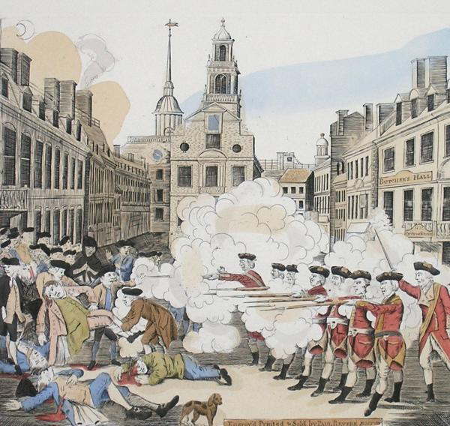

DOCUMENT 7: Diary Entry of John Adams Concerning His Involvement in the Boston Massacre Trials March 5, 1773 (The third anniversary of the Boston Massacre):
"I. . .devoted myself to endless labour and Anxiety if not to infamy and death, and that for nothing, except, what indeed was and ought to be all in all, a sense of duty. In the Evening I expressed to Mrs. Adams all my Apprehensions: That excellent Lady, who has always encouraged me, burst into a flood of Tears, but said she was very sensible of all the Danger to her and to our Children as well as to me, but she thought I had done as I ought, she was very willing to share in
all that was to come and place her trust in Providence.
"Before or after the Tryal, Preston sent me ten Guineas and at the Tryal of the Soldiers afterwards Eight Guineas more, which were. . .all the pecuniary Reward I ever had for fourteen or fifteen days labour, in the most exhausting and fatiguing Causes I ever tried: for hazarding a Popularity very general and very hardly earned: and for incurring a Clamour and popular Suspicions and prejudices, which are not yet worn out and never will be forgotten as long as
History of this Period is read...It was immediately bruited abroad that I had engaged for Preston and the Soldiers, and occasioned a great clamour....
"The Part I took in Defence of Cptn. Preston and the Soldiers, procured me Anxiety, and Obloquy enough. It was, however, one of the most gallant, generous, manly and disinterested Actions of my whole Life, and one of the best Pieces of Service I ever rendered my Country. Judgment of Death against those Soldiers would have been as foul a Stain upon this Country as the Executions of the Quakers or Witches, anciently. As the Evidence was, the Verdict of the Jury was exactly right.
"This however is no Reason why the Town should not call the Action of that Night a Massacre, nor is it any Argument in favour of the Governor or Minister, who caused them to be sent here. But it is the strongest Proofs of the Danger of Standing Armies."

From Adams, John. Diary and Autobiography of John Adams. L.H. Butterfield, Editor. Cambridge, MA: The Belknap Press of Harvard University Press, 1961.

DOCUMENT 8

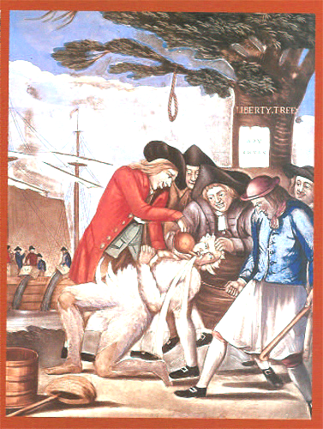

After the Tea Act of 1773, colonists began to react more violently to what they deemed oppressive British policies. Many felt their civil liberties were being infringed upon. Mob violence aimed at British representatives in the colonies, such as tax collectors, was common. This is a contemporary sketch of the tar and feathering of a tax collector circa 1773.
DOCUMENT 9
INTRODUCTION AND CONTENT
Phillis Wheatley was an internationally known American poet of the late 18 century. She was born around 1 753 in West Africa and was kidnapped and sold into slavery when she was seven years old. In 1761 she was purchased by John Wheatley, a Boston tailor. The Wheatley's taught her to read and write. At an early age she began writing poetry and had marry works published throughout the northern colonies. She was freed by John Wheatly in 1773.
The following document is a letter written from Wheatley to Rev. Samsun Occum, a Mohegan Indian and an ordained Presbyterian minister, to comment on his indictment of slave-holding Christian ministers. Her purpose, as mother of her works, was to point out the contradiction between the colonists' Constitutional conflict with Britain and met* determination to continue slavery.

DOCUMENT
Letter to Reverend Samson Occum From Phillis Wheatley
Rev'd and honor'd Sir,
I have this Day received your obliging kind Epistle, and am greatly satisfied with your Reasons respecting the Negroes, and think highly reasonable what you offer in Vindication of their natural Rights: Those that invade them cannot be insensible that the divine Light is chasing away the thick Darkness which broods over the Land of Africa; and the Chaos which has reign'd so long, is converting into beautiful Order, and reveals more and more clearly, the glorious Dispensation of civil and religious Liberty, which are so inseparably Limited!,, mat there is little or no Enjoyment of one Without the other Otherwise, perhaps, the Israelites had been less solicitous for their Freedom from Egyptian slavery, I do not say they would have been contented without it, by no means, for in every human Breast, God has implanted a Principle, which we call Love of Freedom; it is impatient of Oppression, and pants for Deliverance; and by the Leave of our modern Egyptians I will assert, that the same Principle lives in us. God grant Deliverance in his own Way and Time, and get him honour upon all those whose Avarice impels them to countenance and help forward tile Calamities of their fellow Creatures. This I desire not for then Hurt, but to convince them of the strange Absurdity of their Conduct whose Words and Actions are so diametrically, opposite. How well the Cry for Liberty, and the reverse Disposition for the exercise of oppressive Power over others agree, — I humbly think it does not require the Penetration of a Philosopher to determine.—
The Connecticut Gazette, March 11,1774
"Africans in America/Letter to Rev. Samson

DOCUMENT 10
Remember the Ladies
Women of the 18th century were treated very differently than they are today. Colonial women were not allowed to vote, serve on juries, own property, sign contracts or take part in politics. A woman's place in society was determined by who she married, not by her individual accomplishments. Because of limited educational and employment opportunities, women married early in life. Once married, a woman became totally dependent on her husband.
Unlike many women of her day Abigail Adams, wife of Massachusetts lawyer John Adams, was both knowledgeable and vocal about political issues concerning the colonists. John Adams respected her views and often sought her opinions on matters of government
The following letters were exchanged between Abigail and John Adams between March and April of 1776. The war between the colonies and Great Britain had been going on for a year. John Adams was in Philadelphia representing Massachusetts at the second Continental Congress, while Abigail was at their home in Braintree. Independence had not yet been declared, however there was growing support for doing so. On June 7,1776 Richard Henry Lee of Virginia introduced a resolution declaring the colonies to be free and independent states. On Jury 2,1776 Lee's resolution was adopted after a heated debate in which John Adams played a prominent role. Two days later, the Congress formalized this act by adopting the Declaration of Independence.

Abigail Adam to John Adams (March 31, 1776)
I long to hear that you have declared an independency -- and by the way in the new Code of Laws which I suppose it will be necessary for you to make I desire you would Remember the Ladies, and be more generous and favourable to them than your ancestors. Do not put such unlimited power into the hands of the Husbands. Remember all Men would be tyrants if they could. If perticuliar care and attention is not paid to the Laidies we are determined to foment a Rebelion, and will not hold ourselves bound by any Laws in which we have no voice, or Representation.
That your Sex are Naturally Tyrannical is a Truth so thoroughly established as to admit of no dispute, but such of you as wish to be happy willingly give up the harsh title of Master for the more tender and endearing one of Friend. Why then, not put it out of the power of the vicious and the Lawless to use us with cruelty and indignity with impunity. Men of Sense in all Ages abhor those customs which treat us only as the vassals of your Sex.

John Adams to Abigail Adams ( April 14, 1776)
As to your extraordinary Code of Laws, I cannot but laugh. We have been told that our Struggle has loosened the bands of Government every where. That Children and Apprentices were disobedient -- that schools and Colledges were grown turbulent -- that Indians slighted their Guardians and Negroes grew insolent to their Masters.
But your Letter was the first Intimation that another Tribe more numerous and powerfull than all the rest were grown discontented. -- This is rather too coarse a Compliment but you are so saucy, I wont blot it out.
Depend upon it, We know better than to repeal our Masculine systems. Altho they are in full Force, you know they are little more than Theory. We dare not exert our Power in its full Latitude. We are obliged to go fair, and softly, and in Practice you know We are the subjects. We have only the Name of Masters, and rather than give up this, which would compleatly subject Us to the Despotism of the Peticoat, I hope General Washington, and all our brave Heroes would fight…..

DOCUMENT 11
The Declaration of Independence A Portrait by John Trumball
In 1817, at the request of John Adams, Congress commissioned artist John Trumball to create four paintings that would hang in the Rotunda of the new American Capitol building. While he had planned to create a series of military scenes, Thomas Jefferson urged Trumball to depict what he believed would be a defining event in the nation's history. The first painting Trumball completed depicts the signing of the Declaration of Independence in Philadelphia, Pennsylvania. The painting features the committee that drafted the Declaration - John Adams, Benjamin Franklin, Thomas Jefferson, Robert Livingston and Robert Shennan - presenting the document to the President of the Continental Congress. After editing the committee's draft, Congress adopted a final version of the Declaration on Jury 4,1776, thereby solidifying the Americans' commitment to revolution.

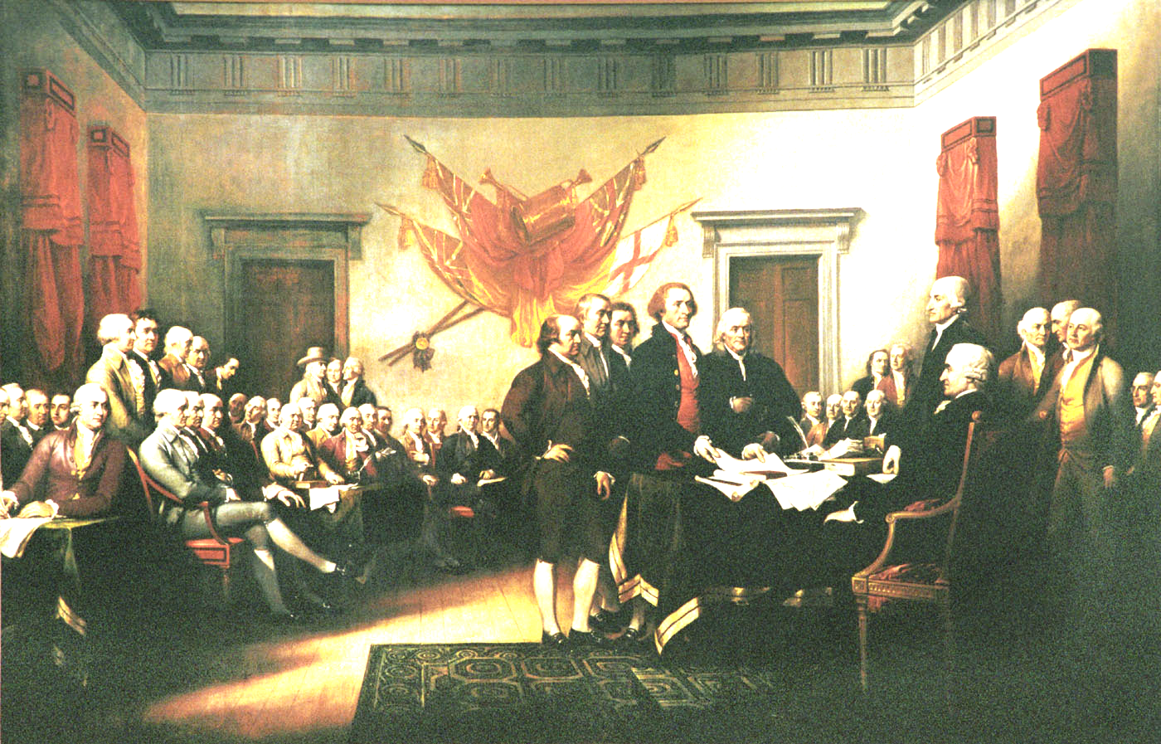

DOCUMENT 12

Gilder Lehrman Document Number: GLC03777
Title: Common Sense, addressed to the inhabitants of America [first edition, 1st issue]

In the following pages I offer nothing more than simple facts, plain arguments, and common sense.... I have heard it asserted by some, that as America has flourished under her former connection with Great-Britain, the same connection is necessary towards her future happiness, and will always have the same effect. Nothing can be more fallacious than this kind of argument. We may as well assert that because a child has thrived upon milk, that is never to have meat, or that the first twenty years of our lives is to become a precedent for the next twenty. But even this is admitting more than is true; for I answer...that America would have flourished as much, and probably much more, had no European power taken any notice of her. The commerce by which she hath enriched herself are the necessaries of life, and will always have a market while eating is the custom of Europe. But she has protected us, say some.... We have boasted the protection of Great Britain, without considering, that her motive was interest not attachment.... This new World hath been the asylum for the persecuted lovers of civil and religious liberty from every part of Europe.... As Europe is our market for trade, we ought to form no partial connection with any part of it. It is the true interest of America to steer clear of European contentions, which she never can do, while, by her dependence on Britain, she is made the make-weight in the scale of British politics. Europe is too thickly planted with Kingdoms to be long at peace, and whenever a war breaks out between England and any foreign power, the trade of America goes to ruin, because of her connection with Britain.... There is something absurd, in supposing a Continent to be perpetually governed by an island.... No man was a warmer wisher for a reconciliation than myself, before the fatal nineteenth of April, 1775 [the day of the battles of Lexington and Concord], but the moment the event of that day was made known, I rejected the hardened, sullen-tempered Pharaoh of England for ever; and disdain the wretch, that with the pretended title of FATHER OF HIS PEOPLE can unfeelingly hear of their slaughter, and composedly sleep with their blood upon his soul.... Where, say some, is the king of America? I'll tell you, Friend, he reigns above, and doth not make havoc of mankind like the royal brute of Great Britain.... So far as we approve of monarchy...in America the law is king.... A government of our own is our natural right.... Ye that oppose independence now, ye know not what ye do: ye are opening the door to eternal tyranny.... There are thousands and tens of thousands, who would think it glorious to expel from the Continent, that barbarous and hellish power, which hath stirred up the Indians and the Negroes to destroy us.... O! ye that love mankind! Ye that dare oppose not only the tyranny but the tyrant, stand forth! Every spot of the old world is overrun with oppression. Freedom hath been hunted round the Globe. Asia and Africa have long expelled her. Europe regards her like a stranger, and England hath given her warning to depart. O! receive the fugitive, and prepare in time an asylum for mankind

DOCUMENT 13 RESPONSE TO COMMON SENSE
Charles Inglis was an active loyalist cleric in Revolutionary New York. He had come to America years earlier to make his fortune. After losing his wife and twins in childbirth he moved from Pennsylvania to New York to a post in Trinity Parish. By 1776, war with Britain seemed imminent. Having read Paine's Common Sense Inglis, a loyal tory, felt it necessary to publish the response: "The True Interest of America Impartiality Stated, 1776" . He also published a series of letter in support of Britain in the NY Gazette signed a "New York Fanner". Although he was in the predominantly loyalist colony of New York his house was plundered before the port colony was secured by the British troops. After the Revolution, when New York was evacuated in 1783, he went to Halifax where as an Anglican Bishop.

Charles Inglis The True Interest of America Impartially Stated, 1776 The following are excerpts from his response to Paine's Common Sense.

I think it no difficult matter to point out many advantages which will certainly attend our reconciliation and connection with Great-Britain, on a firm, constitutional plat. This melancholy contest would last till one side conquered. Supposing Britain to be victorious; however high my opinion is of British Generosity, I should be exceedingly sorry to receive terms from her in the haughty tone of a conqueror. Or supposing such a failure of her manufactures, commerce and strength, that victory should incline to the side of America; yet who can say in that case, what extremities her sense of resentment and self-preservation will drive Great-Britain to? For my part, I should not in the least be surprised, if on such a prospect as the Independency of America, she would parcel out this continent to the different European Powers. Canada might be restored to France, Florida to Spain, with additions to each-other states also might come in for a portion. Let no man think this chimerical or improbable. The independency of America would be so fatal to Britain, that she would leave nothing in her power undone to prevent it—
The Americans are properly Britons. They have the manners, habits, and ideas of Britons; and have been accustomed to a similar form of government But Britons never could bear the extremes, either of monarchy or republicanism—— Besides the unsuitableness of the republican form to the genius of the-people, America is too extensive for it. That form may do well enough for a single city, or small territory; but would be utterly improper for such a continent as this. America is too unwieldy for the feeble, dilatory administration of democracy.
But a Declaration for Independency on the part of America, would preclude treaty entirely; and could answer no good purpose. We actually have already every advantage of Independency, without its inconveniences. By a Declaration of Independency, we should instantly lose all assistance from our friends in England.

DOCUMENT 14 Washington Letter to Continental Congress
Four days after arriving in Valley Forge to spend the winter, General George Washington wrote an eleven page letter to the President of the Continental Congress to describe the condition of the army. In this letter, he gave Congress an ultimatum. He stated that unless the support of Congress changes, the army will no longer exist Congress responded to this letter by sending a congressional delegation to Valley Forge to see the stale of the army for themselves.
Washington refers to the "Commys. departmt" which is an abbreviation for Commissary Department This is the department that provides the army with food, supplies, and clothing.
"Sir: Full as I was in my representation of matters in the Commys. departmt yesterday, fresh, and more powerful reasons oblige me to add, that I am now convinced, beyond a doubt that unless some great and capital change suddenly takes place that line, this Army must inevitably be reduced to one or other of these three things. Starve, dissolve, or disperse, in order to obtain subsistence in the best manner they can; rest assured Sir this is not an exaggerated picture, but {and] that I have abundant reason to support what I say. . . .
"... finding that the inactivity of the Army, whether for want of provisions, Cloaths, or other essentials, is charged to my Acct, not only by the common vulgar, but those in power, it is time to speak plain in exculpation of myself; with truth then I can declare mat, no Man, in my opinion, ever bad his measures more impeded than I have, by every department of the Army."
George Washington to the President of the Continental Congress Valley Forge, December 23, 1777

DOCUMENT 15 From the Diary of Albigence Waldo, Surgeon at Valley Forge, 1777
The following is an excerpt from the Diary of Albigence Waldo. He spent the winter of 1777 in Valley Forge. It is an excellent depiction of the daily life of regular colonial soldiers. It shows the hardships Waldo and his fellow soldiers endured along with the revolutionary ideology that held them together.
December 14
Prisoners and Deserters are continually coming in. The Army which has been surprisingly healthy hitherto, now begins to grow sickly from the continued fatigues they have suffered this Campaign. Yet they still show a spirit of Alacrity and Contentment not to be expected from so young Troops. I am Sick -discontented - and out of humour. Poor food - hard lodging - Cold Weather-fatigue - Nasty Cloaths - nasty Cookery - Vomit half my time - smoak'd out my senses - the Devil's int -I cant Endure it - Why are we sent here to starve and Freeze - What sweet Felicities have I left at home; A charming Wife - pretty Children - Good Beds - good food - good Cookery - all aggreable - all' harmonious. Here all Confusion - smoke and Cold - hunger and filthyness - A pox on my bad luck. There comes a bowl of beef soup - full of burnt leaves and dirt, sickish enough to make a Hector-spue - away with it Boys - Fli live like the Chameleon upon Air. Poh! Poh! crys Patience within me - you talk like a fooL Your being sick Covers you mind with a Melancholic Gloom, which makes every thing about you appear gloomy. See the poor Soldier, when in health - with what cheerfulness he meets his foes and encounters every hardship - if barefoot, he labours thro' the Mud and Cold with a Song in his mouth extolling Wat and Washington - if his food be bad, he eats it notwithstanding with seeming content -blesses God for a good Stomach and Whistles it into digestion. But harkee Patience, a moment - There comes a Soldier, his bare feet are seen thro' his worn out Shoes, his legs nearly naked from the tattefd remains of an only pair of stockings, his Breeches not sufficient to cover his nakedness, his Shut hanging in Strings, his hair dishevell'd, his face meagre; his whole appearance pictures a person forsaken and discouraged. He comes, and crys with an air of wretchedness and despair, I am Sick, my feet lame, my legs are sore, my body cover’d with this tormenting Itch - my Cloaths are worn out, my Constitution is broken, my farmer Activity is exhausted by fatigue, hunger and Cold, I fail fast I shall soon be no more! and all the reward I shall get will be - "Poor Will is dead." People who live at home in Luxury and Ease, quietly possessing their habitations, Enjoying then-Wives and families in peace, have but a very faint Idea of the unpleasing sensations, and continual Anxiety the Man endures who is in Camp, and is the husband and parent of an aggreeable family. These same People are willing we should suffer every thing for their Benefit and advantage, and yet are the first to Condemn us for not doing more!!

DOCUMENT 16
In 1778, Benedict Arnold was re-commissioned as a Major General in the Continental Army. However, due to a leg injury suffered at Saratoga he was unable to take a field command. Instead, George Washington assigned him to military command of Philadelphia, a city the British had recently evacuated. It is here that he met the loyalist Peggy Shippin whom he soon married. His association with a known loyalist left Arnold scorned by the large patriot population of Philadelphia. He was brought up on charges of misconduct and forced to defend himself to Congress. This humiliation, coupled with his constant anger at being passed up for promotion, and financial burdens led him to negotiate with the British Army. Sir Henry Clinton agreed to pay him 20,000 pounds in exchange for his services and West Point (which Arnold was commanding). Arnold accepted, but after a British soldier, John Andre, was caught with the plans, Arnold had to flee. This account was an attempt by Arnold to explain his reasons for treason to the American people.

To the INHABITANTS OF AMERICA,
I should forfeit, even in my own opinion the place I have so long held in yours, if I could be indifferent to your approbation, and silent on the motives which have induced me to join the Kings arms...lam only concerned in the address; to explain, myself to such of my country men, as want abilities, or opportunities, to detect the artifices by which they are duped...
... When I quitted the domestic happiness for the perils of the field, ...a redress of grievances was my only object and aim; however, I acquiesced in a step which I thought precipitate, the declaration of independence...
...I lamented, therefore, the impolicy, tyranny, and injustice, -which, with a sovereign contempt of the people of America, studiously neglected to take their collective sentiments of the British proposals of peace, and to negotiate, under a suspension of arms, for and adjustment of differences...
...In the firm persuasion, therefore, that the private judgment of an individual citizen of this country is as free from all conventional restraints, since as before the .insidious offers of France, I preferred those from Great Britain; thinking it infinitely wiser and safer to cast my confidence upon her justice and generosity, than to trust a monarchy too feeble to establish your independency, so perilous, to her distant dominions; the enemy of Protestant faith and fraudulently avowing an affection for the liberties of mankind, while she holds her native sons in vassalage and chains...
...it is the generous intention of Great Britain not only to leave the rights and privileges of the colonies unimpaired, together with their perpetual exemption from taxation, but to superadd such farther benefits as may consist with the common prosperity of the empire. In short, I fought for much less than the parent country is as witting to grant to her colonies as they can be to receive or enjoy.
...lam now led to devote my life to the re-union of the British empire, as the best and only means to dry up the streams of misery that have deluged this country...
B. Arnold Livington's Royal New York Gazette Oct. 21,1780
Reprinted in The London Chronicle Nov. 14,1780

DOCUMENT 17

The American Revolution posed a dilemma for the American colonies with regard to the issue of slavery. In reality, slaves often found themselves caught in the middle, being used as pawns in the larger colonial struggle for independence. In April of 1775, Lord Dunmore promised freedom to all slaves in Virginia who took up arms against the rebels in his home state of Virginia. Conversely, out of fear, colonial forces offered freedom in return for service in the Continental Army in hopes of preventing slaves from joining the British.
Peter Kiteridge was one of roughly five thousand free blacks and slaves who provided service to the Continental Army during the American Revolution. What is interesting to note and understand is what happened to him after the war.

"....Eight years past I removed to the place •where I now Jive and have until this time by my labor assisted by the kindness of the neighboring inhabitants been enabled to support myself and family. At present having arrived at the Jiffy eight year of my life and afflicted with an unusable arm as I apprehend -with incurable diseases where by the labor of my hands is wholly cut off, and it is the only means of my support. My family at this time consists of a wife and four children three of whom are so young as to be unable to support themselves and at the time of their mother is wholly occupied in taking care of myself and my little ones-thus gentlemen in this my extremity I am induced to call on you for assistance; not in the character of an inhabitant of the town of Westfield for l have no such claim but as a stranger accidentally falling within your borders, one who has not the means of subsistence, and one who must fail through want and disease unless sustained by your care."
Peter Kitridge, April 6,1806, to the selectman of the town of Newfield, Mass

