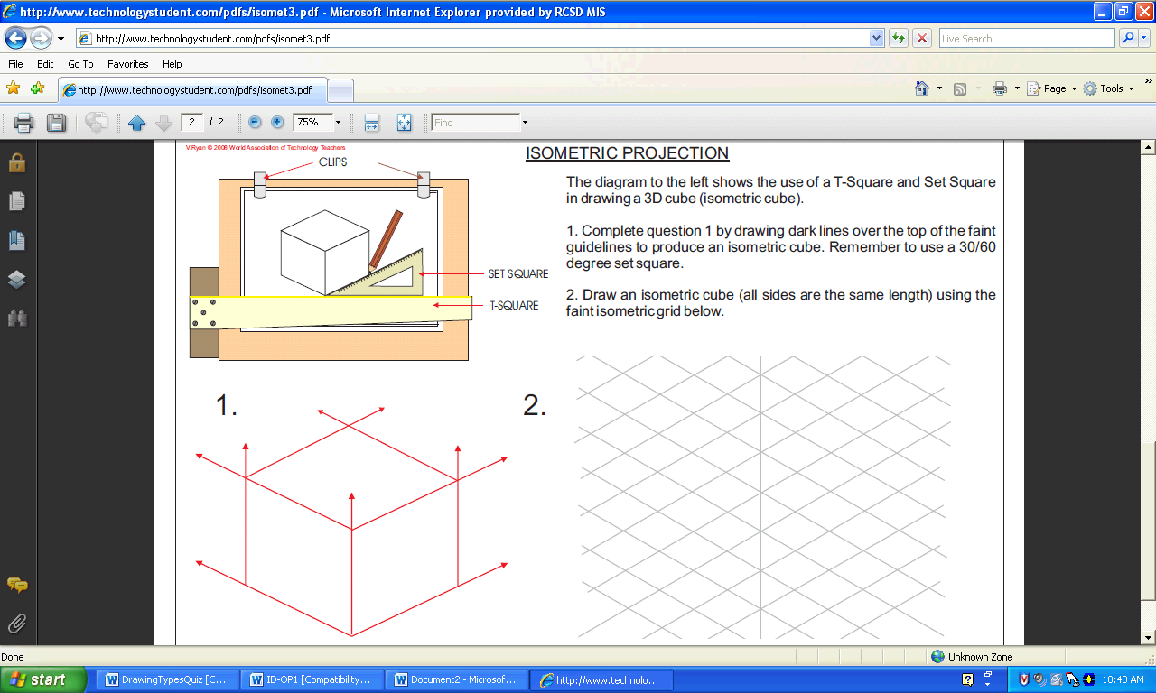**Isometric projection** is a method to visually represent three-dimensional objects in two dimensions in technical and engineering drawings. The term ***"isometric"*** comes from the Greek word for "equal measure", reflecting that the ***angles*** along each axis of the projection are equal.

**Note:** ¼” grid lines (not to scale)

* Start here

1” cube

(not to scale)

30o

30o

30-DEGREE

