**PROFESSIONAL DEVELOPMENT PLAN**

***Learning is more than an activity, it is an experience.***

***2017-2018***

[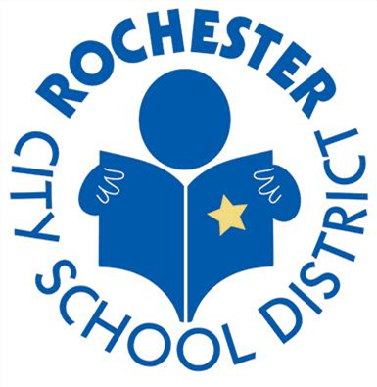](http://www.google.com/url?sa=i&rct=j&q=&esrc=s&source=images&cd=&cad=rja&uact=8&ved=0ahUKEwjio5aDx77TAhWF34MKHTsXCeUQjRwIBw&url=http://therochesterian.com/tag/rochester-city-school-district/&psig=AFQjCNHFsAclcbL1NavtDSgrG2v0nvNuzA&ust=1493173535297376)

**Every student by face and name.**

**Every school, every classroom.**

**To and through graduation.**

[](http://www.rcsdk12.org/Page/34743)

**Rochester City School District**

**Professional Development Team**

|  |  |  |  |
| --- | --- | --- | --- |
| **Executive Director of Professional Learning** | Sylvia Cooksey | **Rochester Teacher Association** | AnnaMaria Manso |
| **Director of Initiatives & Outcomes** | Savaria Calloway-Downs | **Rochester Teacher Center** | Dr. Susan Goodwin |
| **Teacher on Assignment** | Kelli Briggs | **Rochester Teacher Center** | Yolanda Montalvo |
| **Assoc. of Supervision and Administrators of Rochester** | Timothy Cliby | **Career in Teaching (RTA)** | Stefan Cohen |
| **Assoc. of Supervision and Administrators of Rochester** | Rebecca Boyle | **Executive Director of ELL & LOTE** | Abel Perez-Pherett |
| **Rochester Teacher Association** | Margaret Sargent | **Rochester Association of Para Professionals** | Carmen Shepherd |
| **Rochester Teacher Association** | Martha Keating | **Rochester Association of Para Professionals** | Dorothy Tisdale |
| **Rochester Teacher Association** | Aimee Renire | **Director of Risk Management** | Christopher Hoch |

**TABLE OF CONTENTS**

#### INTRODUCTION………………….……………………….………………………………….5

PHILOSOPHY, VISION AND MISSION, SUPERINTENDENT FOCUS

#### THE FRAMEWORK FOR PROFESSIONAL LEARNING………………….………….....6

**THEORY OF PRACTICE …………………………...……………………….………………...7**

LEADING INSTRUCTIONAL CHANGE

**OFFICE OF PROFESSIONAL LEARNING ALIGNMENT TO STRATEGIC GOALS**..**9**

**OFFICE OF PROFESSIONAL LEARNING - PLAN OF WORK…………………….10**

KEY MILESTONES

#### DISTRICT WIDE SPONSORED PROFESSIONAL LEARNING ………………….………… 15

ROCHESTER TEACHER'S CENTER

DATA ANALYSIS

NEW YORK STATE AUDIT EXPECTATIONS

NEW YORK STATE REQUIRED PROFESSIONAL DEVELOPMENT

2 HOUR COURSE IN SCHOOL VIOLENCE PREVENTION AND INTERVENTION

MENTORING PROGRAM

EXPANDED LEARNING

#### OFFICE OF PROFESSIONAL LEARNING…………….………………….…………………20

#### DISTRICT WIDE PROFESSIONAL DEVELOPMENT PLANS………….…………………....22

RCSD PROCESS FOR PLANNING PROFESSIONAL LEARNING

DEPARTMENT SCHEDULE OF PROFESSIONAL LEARNING

**EVALUATION OF PROFESSIONAL LEARNING…………….………………….…………27**

#### APPENDICES…………….………………….………………………….…………………..30

APPENDIX A: NYS PROFESSIONAL DEVELOPMENT STANDARDS

APPENDIX B: NYS IMPACTFUL PROFESSIONAL DEVELOPMENT RUBRIC AND

APPENDIX C: RCSD PROFESSIONAL LEARNING PLANNING GUIDE

APPENDIX D: SUPPLEMENT CHART FOR PD EVALUATION

**PROFESSIONAL DEVELOPMENT PLAN**

*“Professional development is not the hood ornament it is the engine that drives school improvement.”*

**Mission**

To provide a quality education that ensures our students graduate with the skills to be

successful in the global economy.

**Vision**

Every student by face and name.

Every school, every classroom.

To and through graduation.

#### Introduction

Professional Development in the Rochester City School District is experiencing a change in focus; a focus from traditional professional development to professional learning. This is a move towards high quality professional learning experiences where adults engage in more than an activity - they engage in an experience.

This plan reflects a paradigm shift as the Department of Professional Learning moves into a consultation role by providing support and resources to schools to support improving the academic performance of all Rochester students. This plan supports each school’s capacity for School-Based Decision Making and directly links professional learning to academic goals, District Goals and expectations outlined in the NYSED Diagnostic tool for School and District Effectiveness and individual professional interest goals. Collaborative professional learning, school leadership and a focus on instruction from both administrator and teacher (Annual Professional Performance Review- APPR) are the catalysts for embedded professional learning that leads to effective use of performance data (Data Driven Instruction) to achieve strong student learning (Common Core Learning Standards).

#### Philosophy

We believe that when every educator engages in effective professional learning every day every student achieves. Effective professional learning engages adult learners in authentic tasks and experiences directly linked to the needs of their students. Adult learning is most effective when experienced through collaborative job- embedded experiences. Through these experiences, the adult learner becomes part of the “engine that drives school improvement.”

Superintendent’s Focus Areas

|  |
| --- |
| Prioritizing Educational Equity: |
| “It is critical that we create a District where every person, in every department, is responsible and accountable for the education of all students at every school. We must be devoted to eliminating the opportunity and education achievement gaps for urban youth. We can do this by adhering to a theory of action that ensures strong dynamic interaction between great educators, rigorous and cognitively demanding content, engaged students and families, and community partners that bring coherent supports matched to the specific needs of Rochester children.” |
| Building Relational Capacity: |
| “By building shared goals, shared knowledge, and mutual respect, we will improve learning. We will increase engagement and motivation. Recognizing every person’s experience as unique, we can connect to each other through a deep understanding and acknowledgement of race, ethnicity, and culture. This will ensure that we are mindful, respectful, and inclusive.” |
| Nurturing Innovation: |
| “We need to consider fresh ideas, and help our schools, leaders, teachers, and students customize solutions for their unique needs. Innovation and customization are essential to ensure that every student gets to grade level, that we accelerate their learning, and get them to graduation.” |
| Creating Coherence: |
| “Fragmentation gets in the way of serving our children, our parents, our teachers, our schools or our community. The “system” needs to be coherent and user-friendly. Coherence does not mean we all must do the same things. It does mean that our work must produce powerful learning for all youth, with equitable and strong outcomes.” |
| Accountability for Action: |
| “The talent is here. The answers are in Rochester. But there’s a fifth element of my role as your superintendent. It starts with me holding myself accountable. Holding ourselves accountable for action, and working with a strong sense of urgency.” |

[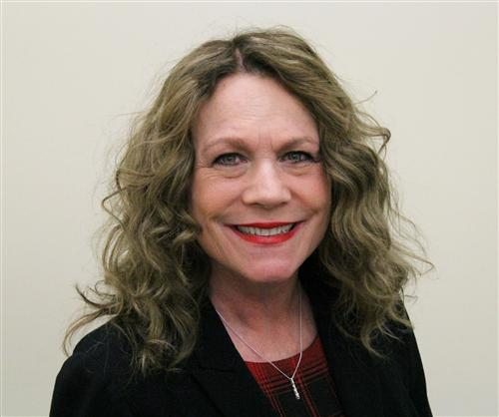](http://www.google.com/url?sa=i&rct=j&q=&esrc=s&source=images&cd=&cad=rja&uact=8&ved=0ahUKEwj2wKHC7LXTAhUs4IMKHWftAHEQjRwIBw&url=http://www.rcsdk12.org/Page/32&psig=AFQjCNH820nG3-nMxXkKA5TqMaxS_lnwHQ&ust=1492874330050739)



**Superintendent Barbara Deane- Williams**

“I believe that Rochester can lead urban school improvement by building administrative, teacher and student leadership capacity in-house with a focus on equity and instructional excellence.”

**THE FRAMEWORK FOR PROFESSIONAL LEARNING**

|  |  |
| --- | --- |
| **National Standards for Professional Learning** | **New York State Professional Standards Alignment** |
| LEARNING COMMUNITIES: Professional learning that increases educator effectiveness and results for all students occurs within learning communities committed to continuous improvement, collective responsibility, and goal alignment. | II. Content Knowledge and Quality Teaching  VI. Student Learning environment  VII. Parent, Family and Community Engagement |
| LEADERSHIP: Professional learning that increases educator effectiveness and results for all students requires skillful leaders who develop capacity, advocate, and create support systems for professional learning. | I. Designing Professional Development  IV. Collaboration |
| RESOURCES: Professional learning that increases educator effectiveness and results for all students requires prioritizing, monitoring, and coordinating resources for educator learning. | VIII. Data – Driven Professional Practice  IX. Technology |
| DATA: Professional learning that increases educator effectiveness and results for all students uses a variety of sources and types of student, educator, and system data to plan, assess, and evaluate professional learning. | VIII. Data – Driven Professional Practice |
| LEARNING DESIGNS: Professional Learning that increases educator effectiveness and results for all students integrates theories, research, and models of human learning to achieve its intended outcomes | III. Research-based Professional Learning |
| IMPLEMENTATION: Professional learning that increases educator effectiveness and results for all students applies research on change and sustains support for implementation of professional learning for long-term change. | I. Designing Professional Development  V. Diverse Learning |
| OUTCOMES: Professional Learning that increases educator effectiveness and results aligns its outcomes with educator performance and student curriculum standards. | X. Evaluation |

**Based on Learning Forward Standards**

The design of professional learning experiences that support individual school improvement efforts are grounded on National Standards for Professional Learning. These standards outline the characteristics of professional learning that leads to effective teaching practices, supportive leadership, and improved student results. The standards were developed by **Learning Forward**, previously the National Staff Development Council. The New York State Professional Development Standards (Full Standards are in Appendix A) are aligned to the national standards. The Learning Forward Standards make it clear from the beginning that collaboration among educators is essential to their professional learning, especially if it is to produce long-term changes in educator practice and student learning. The standards also stress that every educator has a role in planning, implementing, and evaluating effective professional learning.

**THEORY OF PRACTICE**

This plan is built on the following theory of practice, Design Thinking that links to improving student learning outcomes.

[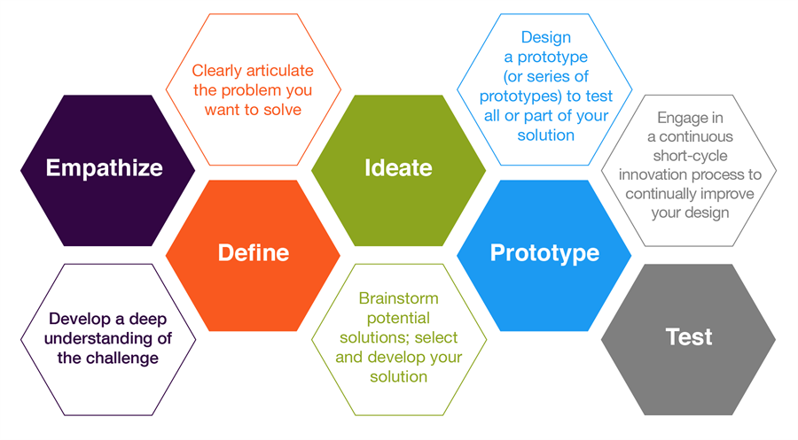](http://www.google.com/url?sa=i&rct=j&q=&esrc=s&source=images&cd=&cad=rja&uact=8&ved=0ahUKEwiq_Mbq0r_TAhWn44MKHTFGCf0QjRwIBw&url=http://citl.illinois.edu/paradigms/design-thinking&psig=AFQjCNFo_MigXaKtradwnydY3uucbpqhsA&ust=1493211055631504)

*Design Thinking is a* [*design*](https://www.interaction-design.org/literature/topics/design) *methodology that provides a solution-based approach to solving problems. It’s extremely useful in tackling complex problems that are ill-defined or unknown, by understanding the human needs involved, by re-framing the problem in human-centric ways, by creating many ideas in* [*brainstorming*](https://www.interaction-design.org/literature/topics/brainstorming) *sessions, and by adopting a hands-on approach in* [*prototyping*](https://www.interaction-design.org/literature/topics/prototyping) *and testing.*

**LEADING INSTRUCTIONAL CHANGE**

*“Professional development is not the hood ornament it is the engine that drives school improvement.”*

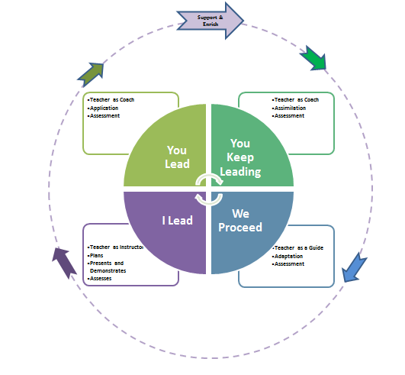

**Leading Instructional Change** will serve as the district protocol. This protocol is adapted from elements of engageny.org, the Common Core State Standards, Danielson’s Framework for Teaching 2011, and the Rigor/Relevance Framework (1C LE, 2012). The leading Instructional protocol provides central office, school leaders, and teachers with a common language around rigorous expectations and instructional expectations. **Leading Instructional Change** promotes teacher flexibility and allows students to take the lead in their own learning as they progress through the acquisition, application, assimilation and adaptation stages of rigor. Teachers act as instructors, facilitators and guides as students take ownership of learning new knowledge and concepts on their journey to becoming Career and College Ready.

**Strategic Plan Goals and Strategies**

Supporting each school’s capacity for School-Based Decision Making and directly linking professional learning to academic goals, the Regent’s Reform Agenda, District Goals and expectations outlined in the NYSED Diagnostic tool for school and District Effectiveness.

**OFFICE OF PROFESSIONAL LEARNING**

**PLAN OF WORK 2017-2018**

|  |  |  |  |
| --- | --- | --- | --- |
| **Strategic Goal** | **Focus Area** | **Objective** | **Objectives** |
| 1. **Student Achievement and Growth** | **Prioritizing Educational Equity** | **100 % Implementation of Common Core**  **Statement of Practice 3.3:**  Teachers ensure that unit and lesson plans are appropriately aligned to the CCLS coherent curriculum introduce complex materials that stimulate higher order thinking skills and build deep conceptual understanding and knowledge around specific content.  **Statement of Practice 4.2:**  Teachers use instructional practices and strategies organized around annual, unit and daily lesson plans to meet established student goals and promote high levels of student engagement and inquiry.  **Statement of Practice 4.5:**  Teachers use a variety of data sources including screening, interim measures and progress monitoring to inform lesson planning, develop explicit teacher plans and foster student participation in their own learning process |  |
|  |  |  |  |
|  |  |  |  |
|  |  |  |  |

|  |  |  |  |
| --- | --- | --- | --- |
| **Strategic Goal** | **Focus Area** | **Objective** | **Objectives** |
|  |  | **Implementation of Common Core**  **Statement of Practice 3.3:**  Teachers ensure that unit and lesson plans are appropriately aligned to the CCLS coherent curriculum introduce complex materials that stimulate higher order thinking skills and build deep conceptual understanding and knowledge around specific content.  **Statement of Practice 4.2:**  Teachers use instructional practices and strategies organized around annual, unit and daily lesson plans to meet established student goals and promote high levels of student engagement and inquiry.  **Statement of Practice 4.5:**  Teachers use a variety of data sources including screening, interim measures and progress monitoring to inform lesson planning, develop explicit teacher plans and foster student participation in their own learning process |  |
|  |  |  |  |
|  |  |  |  |
|  |  |  |  |

|  |  |  |  |
| --- | --- | --- | --- |
| **Strategic Goal** | **Focus Area** | **Objective** | **Objectives** |
|  |  | **Implementation of Common Core**  **Statement of Practice 3.3:**  Teachers ensure that unit and lesson plans are appropriately aligned to the CCLS coherent curriculum introduce complex materials that stimulate higher order thinking skills and build deep conceptual understanding and knowledge around specific content.  **Statement of Practice 4.2:**  Teachers use instructional practices and strategies organized around annual, unit and daily lesson plans to meet established student goals and promote high levels of student engagement and inquiry.  **Statement of Practice 4.5:**  Teachers use a variety of data sources including screening, interim measures and progress monitoring to inform lesson planning, develop explicit teacher plans and foster student participation in their own learning process |  |
|  |  |  |  |
|  |  |  |  |
|  |  |  |  |

**DISTRICT WIDE SPONSORED PROFESSIONAL LEARNING**

**ROCHESTER TEACHER’S CENTER**

The Department of Professional Learning works collaboratively with The Rochester Teacher’s Center to fund and provide professional learning experiences to district staff. This includes instructors for multi-session courses and facilitators for Collegial Learning Circles. These professional learning experiences will be aligned to APPR expectations (Domains and rubrics for highly effective ratings). Additional activities include: Dr. DeGruy’s Post Traumatic Slave Syndrome, Knowing Our Students: Their Heritage, Culture & Realities as well as development of K-2 Curriculum.

In collaboration with the Rochester Teacher Center, The Department of Professional Learning will assist in supporting teacher and leaders’ effectiveness to improve the quality of teaching and learning through a wider knowledge base about curriculum and pedagogies; that ensure students are an important part of the instructional process and making it equitable for all.

The Department of Professional Learning works collaboratively with The Rochester Teacher’s Center to fund and provide professional learning experiences to district staff. This includes instructors for multi-session courses and facilitators for Collegial Learning Circles. Course instructors/participants produce or experience APPR (domains and rubrics for highly effective ratings) Examples, Teaching English Language Learners and Math Clinic: Standards- Based Math Teaching and Learning, amongst others.

**THE OFFICE OF PROFESSIONAL LEARNING**

The Office of Professional Learning, in partnership with the CTO and the RTC will provide district wide professional learning opportunities for district staff. The Office of Professional Learning will also coordinate professional learning opportunities for building based instructional coaches and administrators.

The District uses the TRUE NORTH LOGIC system to advertise, register, monitor and evaluate the professional learning opportunities for district staff. The Office of Professional Learning manages this program. The TRUE NORTH LOGIC system provides the opportunity for staff to search for course opportunities by content alignment, domain alignment, or by course type.

District coaches, lead teachers, teachers, and administrators provide many of the district’s professional learning experiences. All professional development facilitators will submit a professional learning lesson plan (Appendix B) for each session they are facilitating.

**DATA ANALYSIS**

New York State data analysis indicates two main areas in need of improvement: literacy and graduation rates. Additional data analysis from a variety of sources indicates the need for improvement in the following supporting areas: providing good first teaching, culturally responsive teaching, and collaborative teaching. All of these focus areas will be integrated with the District Improvement Plan.

**ASPIRING PRINCIPALS PROGRAM**

In partnership with the NYC Leadership Academy (NYCLA) this program seeks visionary, passionate leaders eager to assume Principal roles and dramatically increase outcomes and opportunities for RCSD students, families and schools. The Aspiring Principals Program (APP) prepares exceptional leaders to transform our nation’s most challenging schools. This nationally recognized leadership development model equips future Principals with the skills and experience to create thriving schools that advance educational outcomes for all students.

**RAP MENTOR PROGRAM**

The mentoring program was designed to provide support to first year Teaching Assistants and Paraprofessionals to enhance their instruction and orient them to the school community. The Department of Professional Learning provides ongoing professional learning to the mentors and their mentees.

**NEW YORK STATE AUDIT EXPECTATIONS**

As part of the New York State School auditing process the following requirements are embedded into this plan. This plan is based on the Common Standards for professional development. The Office of Professional Learning monitors the quality of professional development from participant evaluations, professional development needs surveys, and a programmatic evaluation of district professional development. The district’s Career in teaching office provides a robust mentoring program for all teachers. Additionally, the Office of Professional Learning seeks outside programmatic evaluations. This information is on the Career in Teaching’s website. The Office of Professional Learning partners with School-Based Planning Teams to support a network and infrastructure that supports site-based professional development. District professional development is funded by New York State consolidated grants, local resources, and frequently applies for competitive grants. The Office of Professional Learning works diligently to ensure there is a stability of resources, even during economic downturns. The Title IIA expenditures are in Appendix D.

**Continuing Teacher and Leader Education (CTLE) for School Leaders, Teachers and Level III Teaching Assistants Requirements**

**Overview**

In March 2016, The NYS Board of Regents adopted a new Subpart, 80-6 of the Regulations of the Commissioner of Education to implement Chapter 56 of the Laws of 2015 relating to the registration process for holders of Permanent, Professional and level III Teaching Assistant certificates and the establishment of continuing teacher and leader education (CTLE) requirements for Professional and level III Teaching Assistant certificate holders.  

**Registration**

Beginning on July 1, 2016 individuals who hold a permanent or professional certificate in the classroom teaching service or educational leadership service (i.e., school building leader, school district leader, school district business leader) or a Level III Teaching Assistant certificate prior to July 1, 2016, shall apply for initial registration during the 2016-2017 school year during his/her month of birth and shall renew his/her registration in the last year of each subsequent five-year period thereafter. The registration will be completed through the State Education Department’s TEACH system.

Individuals that are issued their first Professional or Teaching Assistant Level III certification starting **July 1,2016**  and thereafter with an appropriate certificate requiring registration, will be automatically registered for their initial **5 year** registration period. The registration period will begin the first day of the month when the certification was issued until the end of the month prior to their birth month in the 5th year.

**CTLE Hours Requirements**

* Holders of professional certificates in the classroom teaching, educational leadership and Level III Teaching Assistant certificate holders are required to successfully complete 100 hours of acceptable CTLE during the registration period( 5 years) if they practice in a NYS school district or BOCES. Note that the CTLE hours replace the prior professional development hours’ requirement.
* The CTLE requirement may be completed at any time during the registration period. CTLE completed during a prior registration period may not be carried over to the next registration period.
* If a certificate holder stopes working during a 5 year registration period, she/he is required to complete a minimum of 20 hours of CTLE for every year that she/he was working in an applicable school during the 5 year registration period.
* Individuals that hold Professional English to Speakers of Other Languages certificates or Bilingual Extension Annotations are required to complete a minimum of **50 percent** of the required CTLE hours in language acquisition aligned with the core content area of instruction taught, including a focus on best practices for co-teaching strategies, and integrating language and content instruction for English language learners.
* All other Professional certificate holders must complete a minimum of **15 percent** of the required CTLE hours in language acquisition addressing the needs of English language learners, including a focus on best practices for co-teaching strategies, and integrating language and content instruction for English language learners.
* Level III Teaching Assistant certificate holders must complete a minimum of **15 percent** of the required CTLE hours dedicated to language acquisition addressing the needs of English language learners and integrating language and content instruction for English language learners.
* Classroom Teacher who achieves certification from the National Board for Professional Teaching Standards shall be deemed to have met the CTLE requirement for the registration period in which the National Board Certification was achieved; provided that the CTLE certificate holder continues to meet the applicable required CTLE requirements in language acquisition.

|  |  |  |  |
| --- | --- | --- | --- |
| **Certification Type\*** | **Registration Required** | **Required to Complete CTLE Hours** | **Hours Required per 5-year Registration** |
| PERMANENT Classroom Teacher/School Leader | Yes | Not subject to CTLE | Not subject to CTLE |
| PROFESSIONAL Classroom Teacher/School Leader | Yes | Yes | 100 hours |
| Level III Teaching Assistant | Yes | Yes | 100 hours |

* Any certificate holder not practicing in a NYS School District, Special Act District or BOCES may choose “Inactive” status for their registration

#### Reporting CTLE Hours

#### As of July 1, 2016 required certificate holders must maintain a record of completed CTLE, which include: the title of the program, the total number of hours completed, the number of hours completed in language acquisition addressing the need of English language learners, the sponsor's name and any identifying number, attendance verification, and the date and location of the program. These records must be retained for at least three years after the 5 year registration period for CTLE was completed and shall be available for review by the Department upon request.

#### CTLE activities must be offered in appropriate subject areas, as defined in law and regulation. Subpart 80-6 of the Regulations of the Commissioner of Education to implement Chapter 56 of the Laws of 2015 relating to the establishment of CTLE requirements for Professional and Level III Teaching Assistant certificate holders, which:

#### The District will provide these learning opportunities to meet the CTLE 100 hour requirement. The district will maintain records of completed hours using the True North Logic professional learning management system.

**2 HOUR COURSE IN SCHOOL VIOLENCE PREVENTION AND INTERVENTION**

This 2 hour course is provided to all RCSD staff members during building-based conference days. With leadership from the Office of School Safety and Security, administrators provide this training at the onset of each school year during the first Superintendent’s Conference day.

**MENTORING PROGRAM**

Rochester City School District has a nationally recognized Career in Teaching (CIT) program. Our complete CIT plan can be found on the CIT webpage. In addition to the mentoring activities in the district provides New Teacher Orientation. Ten hours are allocated for New Teacher Orientation, ten hours for specific learning based on mentor input, and ten hours for teaching and learning.

#### Expanded Learning

Expanded learning time empowers teachers, by ensuring they have the time to meet regularly for structured collaboration, consistently analyze student data, and share instructional practices. Teachers in expanded-time schools are also strengthening instruction through time dedicated to professional learning and peer observation embedded in the school day.

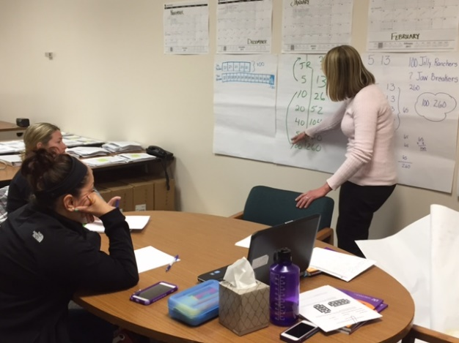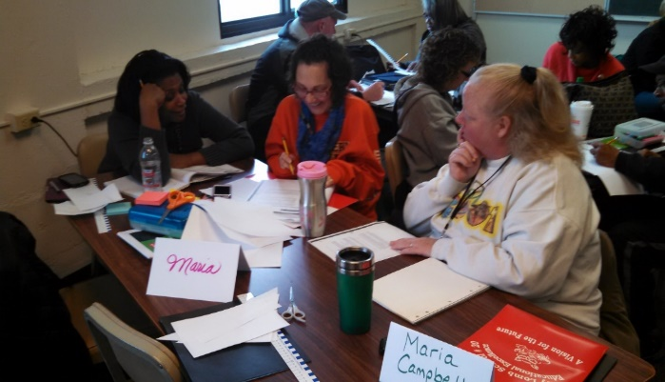

**OFFICE OF PROFESSIONAL LEARNING**

**PROGRAM STAFFING**

#### Executive Director of Professional Learning

The Instructional Director provides direction for professional learning at the district level. This includes coordinating professional development within the Division of Teaching and Learning. The Instructional Director will manage professional learning from each department within the Division of Teaching and Learning to create a strategic plan that incorporates a coordination of efforts and resources to maximize offerings. Furthermore, the Instructional Director will collaborate with schools to support, monitor and plan professional learning.

#### Director of Professional Learning Initiatives and Outcomes

The Director of Initiatives and Outcomes will serve as a member of the leadership team in the Office of Professional Learning and work collaboratively to support district stakeholders across the system in the development, design and facilitation of professional learning with a focus on measuring outcomes and impact. The Director will support initiatives and develop processes and structures to measure effectiveness of said initiatives. This will include an integration of protocols and gateways for accessing *professional learning* system wide via True North Logic our professional development management system (PDMS). The Director must demonstrate a passion for urban education, reform and leadership. He/she must have a working knowledge of the Framework for Teaching, Common Core State Standards, Adult Learning Theory, Professional Learning Standards and data analysis. The Director must understand the role data analysis plays in targeting efforts. The Director must understand and be able to develop logic models and use strategic planning to accomplish targeted objectives. Excellent communication and interpersonal skills are essential.

#### Professional Learning Support, Process and Context – Teacher on Assignment

These individuals are additional support for each zone to maximize the planning and delivery of embedded professional learning. They will focus on training Coaches, Team Leaders and Department Chairs on teaming, the change process, group dynamics, facilitating skills, coaching, using data to inform professional learning and strategic planning. They will serve as a direct support to schools with a zone to better plan for clustering, coordination of school visitations and partnering with BOCES to monitor regional (zone) support.

#### Professional Learning Instructional Technology Resource – Teacher on Assignment

This individual serves as an instructional and helpdesk support for applications including, but not limited to, TRUE NORTH LOGIC, Beachscape, GALE Virtual Library, and GoToWebinars. This Instructional Technology Resource provides assistance for these systems, plan, create, and implement related professional development sessions and crafting online learning modules to support current as well as future professional development initiatives.

#### Professional Development Provider (PDP)

These individuals provide professional development during and collaboratively work with department directors to build and support school improvement at assigned schools or district wide. They will develop and facilitate content specific, cross curricula and interdisciplinary professional learning that will promote and sustain collaborative learning communities as well as contribute to a positive district/school culture. Training emphasis will include culturally responsiveness, working with students with ELL and specialized services classifications and complete knowledge of “*I lead, you lead, you keep leading, and we proceed*.” Professional Development Providers will develop an understanding of the following concepts:

1. What it means to be a culturally responsive
2. Why it is important to be a culturally responsive teacher in this district (connecting to APPR)
3. What one can expect from a culturally responsive teacher/environment and again, how those expectations are connected to Common Core and APPR
4. What it means to be a culturally responsive
5. Why it is important to be a culturally responsive teacher in this district (connecting to APPR)
6. What one can expect from a culturally responsive teacher/environment and again, how those expectations are connected to Common Core and APPR

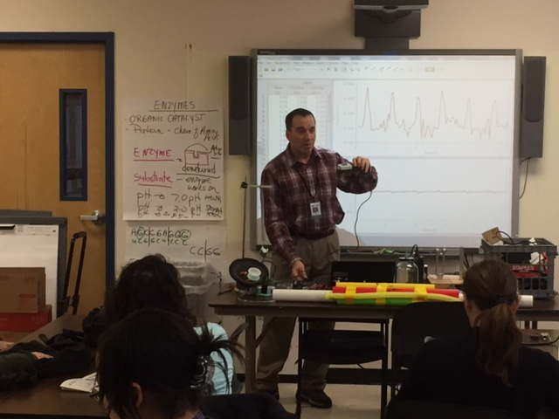

**District Wide Professional Development**

|  |  |  |  |  |  |  |  |  |  |  |
| --- | --- | --- | --- | --- | --- | --- | --- | --- | --- | --- |
| **Professional Development Planning Guide** | | | | | | | | | | |
| **Student Performance Data**  **Or Rationale(s)** | **Adult Expected Outcomes** | **Student Expected Outcomes** | **Resources** | **Professional Learning Experience(s)**  **/Method(s)** | **Initial Outcomes** | **Intermediate Outcomes** | **Results** | **People Responsible** | **Time Frame** | **Methods for Monitoring/**  **Evaluating** |
| The data shows _; | therefore, adults need to identify and implement | so that students will be able  to_ . | We have accessible to us; | therefore, adults will participate in  _/ . | Initially adults will  . | Midway through the experience/meth od adults will and/or _. | Students will  . | will take the lead on this experience/meth od. | From to | Progress and competition will be measured by  . |

The Professional Development Planning Guide is utilized by the district for the process of developing professional learning across all subject areas and departments. See Appendix for example

Effective professional learning focuses on student content standards and educator performance standards, uses data, integrates multiple designs for educator learning, and provides sustained support for long-term change. (***Minds in Motion,*** Professional Learning Resource Guide, 2011 Office of Professional Learning, RCSD

Minds in Motion 2011, Professional Learning Resource Guide, the Office of Professional Learning, RCSD

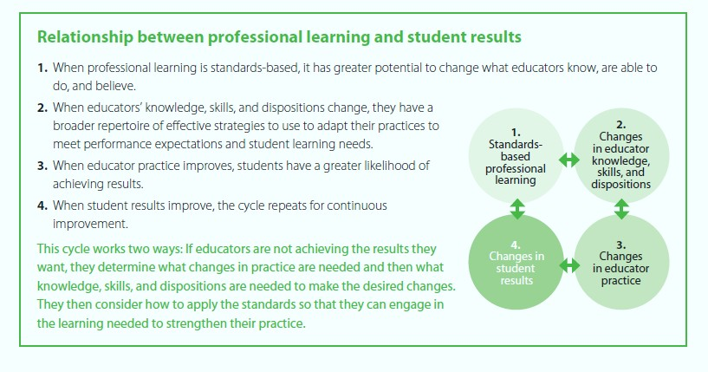

**EVALUATION OF PROFESSIONAL LEARNING**

The Office of Professional Learning recognizes the need to evaluate professional development for impact on a change in practice leading to increased student achievement. In order to do so, the department needs to consider both the purpose of evaluation and operationalizing practices of assessment as intrical parts of professional learning experiences.

1. TRUE NORTH LOGIC will be customized to collect post class data of teacher content knowledge, mid-term application data of new learning and end of year student data for at least 20% of classes posted by each department
2. Analysis of Pre and Post assessments for a sampling of courses from each content area to determine if the gains in knowledge are statistically significant
3. Calibration Testing will be administered to administrators (who have passed the proficiency test) up to three times per year with a renewal assessment to maintain their status as a proficient observer
4. Impact of PD on delivery of sessions (Appendix B) with Professional Development Rubric
5. APPR (Annual Professional Performance Review) for teachers and administrators to be evaluated on effectiveness in their area

**\*\*Refer to Appendix D for measure of evaluations on above\*\***

|  |  |  |  |
| --- | --- | --- | --- |
| **Level** | **Purpose** | **Questions Addressed** | **Monitoring Tools / Data Points** |
| Level 0  Design of the comprehensive professional program or a component of that program  *(Planning Data)* | * To determine the focus or goal of the comprehensive   professional development program   * To design the comprehensive professional development program action plan * To adapt the design of the program or action plan | * Are the intended results clear? How appropriate is the program’s timeline? * How effectively is the program designed to meet teacher needs that are determined based on the analysis of student data? * How effectively is the program aligned with student learning priorities that are identified in the School Improvement Plan and / or school system initiatives? * What resources and structures are the best match to support teachers’ learning of specific knowledge and skills? * Does the program reflect a variety of models of professional development? * Is the program designed to include formative monitoring at all 6 levels of evaluation? * How can all school leaders support the implementation and facilitation of the program? | Student performance data analysis; Analysis of teacher  needs based on student needs; Stakeholder focus groups; The Comprehensive Professional Development Program |
| Level 1  Participant Reaction  *(Satisfaction Data)* | * To adapt program design and delivery | * How satisfied were the participants with the experience? * Was the experience relevant to the roles of the participants? * Were the processes used appropriate for participants as learners? * Did the processes used achieve the intended outcomes? | Evaluation Surveys; Exit Cards; Plus / Delta;  Stakeholder Focus Groups |
| Level 2  Participant Learning  *(Learning Data)* | * To check for understanding and learning * To adapt program design and delivery | * Did the participants learn the desired knowledge and skills? * What did they learn? Why? (May also yield level 3 data) * What didn’t they learn? Why? (May also yield level 3 data) | Written responses to questions; Exit cards; Pre / post  assessments; Teacher work samples |
| Level 3  Organizational Support and Structure *(Resource*  *Management Data)* | * To determine the effective use of resources * To improve the organizational structures and support * To adapt program design and delivery | * How effectively are the resources and structures utilized to support teachers as they learn new knowledge/skills? * How could the use of resources and structures be modified to improve support for teachers as they learn new knowledge/skills? * How effectively do school leaders support and facilitate the implementation of new knowledge/skills? | Focused questionnaires; Periodic Surveys and request  of student artifacts and data; Guided teacher reflection; Feedback protocols; Force Field Analysis; Plus/Delta; Minutes from team/department/cohort meetings |
| Level 4  Application of New Knowledge and Skills *(Application Data)* | * To determine quality and   consistency of classroom application   * To adapt program design and delivery | * What are the changes in teacher practice as a result of the professional development program? * How effectively and consistently did the participants use the new knowledge and skills? * What are the participants able to do well? Why? (May also yield level 3 data) * What aren’t the participants able to do well? Why? (May also yield level 3 data) | Periodic Surveys and request of student artifacts and  data; Walkthroughs focused on new knowledge and skills; Interviews with students about teacher use of new knowledge/skills; Student surveys focused on teacher use of new knowledge/skills; Focused peer visits Supervisory observations focused on new knowledge and skills; Lesson Plans |
| Level 5  Impact on Student Learning/Performance  *(Student Data)* | * To determine the impact on student learning * To adapt program design and delivery | * How did student learning / performance change as a result of the comprehensive professional development program? | Student work samples; Student grades; Focused student  surveys and student interviews; Periodic Surveys and request of student artifacts and data  Portfolios of student work; Formative & summative assessments |

**Appendix A:**

New York State Professional Development Standards

Standard I: **Designing Professional Development:**  Professional development design is based on data; is derived from the experience, expertise and needs of the recipients; reflects best practices in sustained job-embedded learning; and incorporates knowledge of how adults learn.

Standard II: **Content Knowledge and Quality Teaching:**  Professional development expands educators’ content knowledge and the knowledge and skills necessary to provide developmentally appropriate instructional strategies and assess student progress.

Standard III: **Research-based Professional Learning:** Professional development is research-based and provides educators with opportunities to analyze, apply and engage in research.

Standard IV: **Collaboration:**  Professional development ensures that educators have the knowledge, skill and opportunity to collaborate in a respectful and trusting environment.

Standard V: **Diverse Learning:**  Professional development ensures that educators have the knowledge and skill to meet the diverse learning needs of all students.

Standard VI: **Student Learning Environments:**  Professional development ensures that educators are able to create safe, secure, supportive, and equitable learning environments for all students.

Standard VII: **Parent, Family and Community Engagement:**  Professional development ensures that educators have the knowledge, skill, and opportunity to engage and collaborate with parents, families, and other community members as active partners in children’s education.

Standard VIII: **Data-driven Professional Practice:**  Professional development uses disaggregated student data and other evidence of student learning to determine professional development learning needs and priorities, to monitor student progress, and to help sustain continuous professional growth.

Standard IX: **Technology:**  Professional development promotes technological literacy and facilitates the effective use of all appropriate technology.

Standard X: **Evaluation:** Professional development is evaluated using multiple sources of information to assess its effectiveness in improving professional practice and student learning.

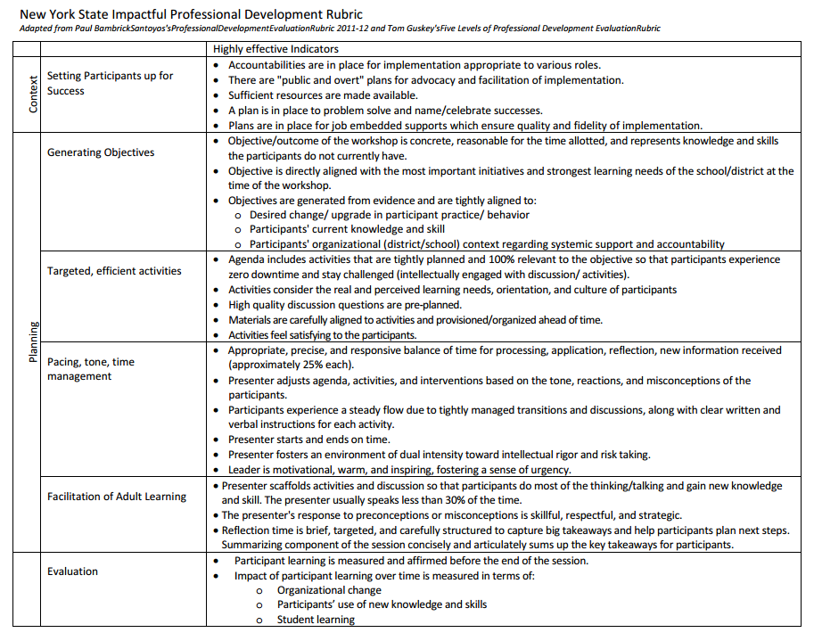**Appendix B:**

**Appendix C:**

**Professional Learning Planning Guide**

**Appendix D:**

|  |  |  |  |  |  |  |
| --- | --- | --- | --- | --- | --- | --- |
|  | **Resources** | **Actions** | | **Initial Changes** | **Intermediated**  **Changes** | **Results** |
| **TRUE NORTH LOGIC** | * TRUE NORTH LOGIC system * Administrator * Data reports * PL models | * Educator content knowledge will be   collected   * Each department will have 20% of   classes posted with  a customization model | | * Heightened awareness for   Educators and  Administrators from data collected   * To plan accordingly and implement a   course correction  action if necessary to improve student  data | * To take the course correction action   and follow-through  with additional PL courses to improve  student data   * Offer support from departments to   educators to  improve practices through data  collected   * Educator understands where   the content  knowledge needs to improve with the  analysis of data | * Student achievement improves * Educators knowledge improves professionally * Deep learning takes place with students from continuous   learning from the educator   * Visible results shared with educators to set goals |
| **Analysis of**  **Pre and Post Assessments** | * Content area educator   assessments   * Instructional Coaches * PL Department | * Students will be assessed for pre   and post year  assessments | | * The pre-assessment will be administered   to receive a baseline  for students   * Students and educators will understand their areas of improvements or needs of enrichment * Educators will use data to drive   instruction for | * Educators will use data to establish   checkpoints for  students   * Students will understand their data to set goals for themselves * Educators will use post-assessments to   see if gains in  knowledge are significant | * Educator’s ability to evaluate data to drive instruction for pre   and post assessments   * Rigorous planning from educators * Student’s needs identified and met through the use of the data |
| **Calibration /**  **Proficiency Testing** | * Teachscape * Administrator * Danielson Framework * PL models | | * Administrators will test on the   Danielson  Framework   * Administrators will continue to be assessed throughout the year | * Administrators knowledge and   expertise will be  examined   * Administrators will understand there area of improvements | * Administrators will begin to rethink   how they evaluate   * Supervisors will have pre and post   discussions in more  effective manner   * Administrators will require theirs skills   to be measured with  a master scorer and analyze the  discrepancies if needed | * Feedback will be provided to administrators on their work * Application of the Danielson Framework will be applied in   all evaluating   * Administrators will be given suggestions for area of   improvements   * Additional training/support will be provided to administrators for those who are still in need of passing the test * Reports are generated for the observer to analyze on each   administrator to assist with PL   * Renewal assessments will be * given to administrators throughout the year in order to renew their proficiency status |
|  |  |  | |  |  |  |