Name:__________ | Date:____________
Period:___________ | Page:___________
Solving Equations with Distributive Property Notes
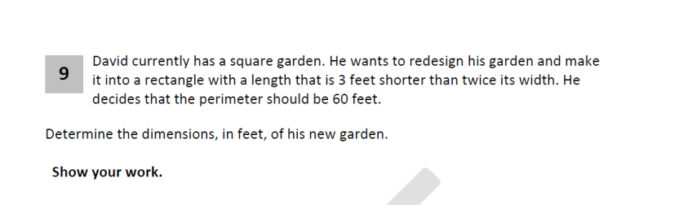
Problem of the day

Plan Solve Check

Essential Question | Steps for solving multiple steps equations
- ____________________________________  How do you use the distributive property to simplify an expression? | 1._________________________  2. ________________________  3.________________________  4.__________________________  5._________________________

Example 1 2( x – 1) = 4x+ 6 1 ._________________________
2. ________________________
3.________________________
4.__________________________
5._________________________

Example 2 30 = 5 (x + 2) 1._________________________
2. ________________________
3.________________________
4.__________________________
5._________________________

Example 3 10(x – 8) = 4x + 2x - 2 + 10 1._________________________
2. ________________________
3.________________________
4.__________________________
5._________________________

Example 4 -(4– 8x) = 20 – 2x

Name: _____________________________ | Using the Distributive Property to Solve
Lesson #6 | Work Period

Directions: SOLVE & Check

- 16 - 8 = 4(x + 6)

- 10(x – 8) = 4x + 2x - 2 + 10

- 2 = 2(m – 2)
3(3 - 10n) = -51

- 40 = (q + 2)10

- -5(a + 2) - 2 = -12

- ½(4g + 8) = 3g – 9

- -(4 - 8x) = 20

- 0.4(3x + 27.5) = 0.2x

- How do you know if you will be using the distributive property in an equation?

- When do you apply the distributive property? 1st step, before/after combining like terms or last step?
Name: _____________________________ | Using the Distributive Property to Solve
Lesson #6 | Homework

Directions: SOLVE each equation

- 3(n + 3) = 0
- 4 (– 8 + b) = 0
- -2(x – 3) = x
- (3c + 7)3 = 2(c + 7)

