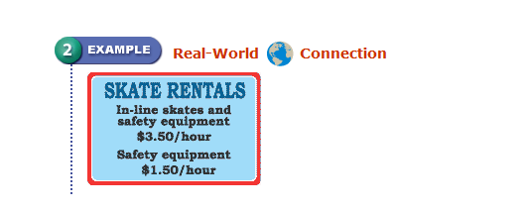
Distributive Property
Problem of the day

You can buy used in-line skates from your friend for $40, or you can rent some. Either way, you must rent safety equipment. How many hours must you skate for the cost of renting and buying skates to be the same?

Plan Solve Check

Essential Question | What does it mean?
- ____________________________________

How do you use the distributive property to simplify an expression?
New Concept
Distributive Property- multiply across the parentheses

Let's consider the problem 3(x + 6)
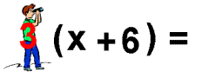
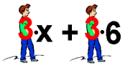

=

- Distribute 3(a+2) -3(a+2)

Let’s try together

1) 4(x - 2) 2) 2(2 + x)

Use the same strategy if the number appears after the parentheses
(x+2)5 is the same as 5(x+2)

-(x+2) is the same as -1(x+2)

7 - (x+2) is the same as ______________________

7 + (x+2) is the same as __________________________

Name: _____________________________ | Using the Distributive Property
Lesson #6 Introduction | Work Period
Directions: Practice writing each problem in simplest form.
Use all 3 methods for each question: area model, distributive (mailman), and the vertical method.
- -5(2 + x)

- x(5 + 2)

- x(y – 25)

- 7(x – 10)

- -2(x + y)

- -2(x - 3)

- -(5-2x)

- 3(5x + 2x)

- 0(x + 2)

- 8(0 + 7)

- (-12 + x)(-5)

- 5x - (2 - x)

- 2(x+4) + 3(9+x)

- -5(3 + x) – 9(x+2)

Name: _____________________________ | Using Distributive Property

Lesson #6 Introduction | Homework

Directions: Simplify

- 3(n + 3)
- 4 (- 8 + b)
- -2(x - 3)
- (3c + 7)3
- -(u + 30)
- -3 (-12 - p
- 2(-x + 3)
- (12f - 18)(-10)

