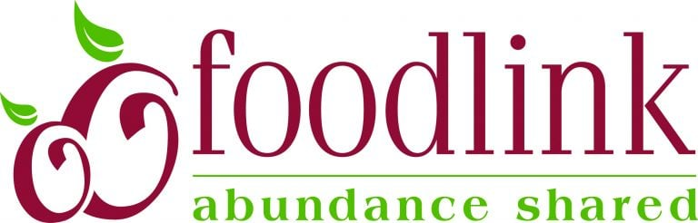

**John James Audubon School #33 – Emergency Food Pantry Intake Form**

***For students/families that attend School #33:*** *If you and your family are struggling with having enough food to eat, our new Emergency Food Pantry right here in our school is here for your needs. As part of our partnership with Foodlink, School #33 is asked to report the overall number of households, children, adults, and seniors served through the pantry every month.* *However, the identifying information (parent and student names, zip codes) recorded here is kept confidential and is not shared outside of the school – this is for internal record-keeping purposes only.*

|  |  |
| --- | --- |
| __________________________________________________________ Parent/Guardian Name | __________________________________________________________ Student(s) Name |
| **How many live in your household? (e.g., 1 adult, 3 children, 1 senior)**  ________ Adults ________ Children _______ Seniors (65+) | **What zip code do you live in? (e.g., 14605)** ______________ |
| **It’s important that you are able to pick-up food directly from the pantry. Please confirm who will be available to pick-up your order:**  ❑ I am able to pick-up  ❑ Someone else will pick-up for me (Name: _____________________)  ❑ I absolutely cannot pick-up and need assistance  **Please provide contact information so that we can follow-up with you and set an appointment!: _______________________________________** | |



**John James Audubon Escuela #33 – Formulario de Ingreso Despensa de Alimentos de Emergencia**

***Para estudiantes / familias que asisten a la Escuela #33:*** *Si usted y su familia tienen dificultades en conseguir suficiente comida para comer, nuestra nueva despensa de alimentos de emergencia aquí en nuestra escuela existe para satisfacer sus necesidades. Como parte de nuestra asociación con Foodlink, se solicita a la Escuela 33 informar el número total de hogares, niños, adultos y adultos mayores atendidos por la despensa todos los meses. Sin embargo, la información de identificación (nombres de padres y estudiantes, códigos postales) registrada aquí es confidencial y no se comparte fuera de la escuela; es solo para fines de guardar registros internos.*

|  |  |
| --- | --- |
| __________________________________________________________ Nombre del Padre/Encargado | __________________________________________________________ Nombre del Estudiante |
| **¿Cuantos viven en mi núcleo familiar? (ej. 1 adulto, 3 niños, 1 anciano)**  ________ Adultos ________ Niño(s) _______ Ancianos (65+) | **¿En qué código postal vive? (ej. 14605)** ______________ |
| **Es importante que usted pueda recoger los alimentos directamente de la despensa. Favor confirmar quien estará disponible para recoger**  **su orden:**  ❑ Yo puedo recoger  ❑ Alguien más va recoger por mi (Nombre: _____________________)  ❑ Definitivamente yo no puedo pasar a recoger y necesito ayuda  **Por favor dar información de contacto para poder hacer seguimiento con usted y concretar una cita: _______________________________________** | |

**Guidance for Making Emergency Food Pantry Referrals**

* The most important part of the referral process: Intake forms should only be completed with families’ explicit permission. If you believe that a student/family may be experiencing food insecurity, ***please discuss it with the parent or guardian first***. Please refer to the script on the back-side of this sheet for suggested language.
* If you and a parent or guardian decide to initiate an intake form for the pantry, there are two ways they can be submitted:
  + A paper form. Copies can be found in mail room, front office, with the Parent Liaison, with the Community School Site Coordinator (CSSC), and with our School Social Workers. Forms should be returned to Mary Peoples or Lindsey Feigenbaum.
  + An electronic form: <http://bit.ly/School33FoodlinkIntake>
* Please make note of the following parameters of food pantry access:
  + Our food pantry is meant to be for emergencies – as we start out, we intend to let families access the cabinet no more than once a month.
  + Our food pantry operates under a client choice model, meaning that our families get to choose the food that fits their family’s needs, while receiving guidance from the Parent Liaison or CSSC. We guide families to select a balance of shelf-stable food items based on a formula for three meals, for three days, for their household size.
  + We hope to extend additional services to families during long weekends and holiday breaks.
  + For the time being, only parents and guardians of School #33 students will be allowed to access the pantry.
* Potential signs of food security (informed by our School Social Workers)
  + Taking extra food to store in pockets, bags, or desks
  + Students noting that they are preserving food for their siblings
  + A pattern of students expressing hunger more frequently on Mondays/early in the week

**Suggested Language for discussing Food Pantry Referrals with Families**

We provide language and guidance on referring families to our pantry because the recommendation may not come across as intended. That may be especially true when a strong relationship with the parent or guardian has not yet been established. No parent wants to feel that they are having trouble supporting their family, or letting that be known to others. It is extremely important that we strike the balance between offering all of the resources we can to those we believe may be struggling, and maintaining an asset-based approach that upholds dignity for our families.

*Here is some general language that may be helpful to use*

* Our school has several opportunities for parent support that are meant to be used. This year we opened up a Food Pantry here in the building that is available to families. If at any time you might want to explore the pantry, I can help you submit an intake form, or you can speak with our Parent Liaison, Ms. Peoples.
* The resources we have in our school, like our new food pantry and our clothing closet, exist for folks to use as needed.
* (in providing the Community Partner Resource Guide) You are welcome to use any of these opportunities – feel free to contact me at any time for more information on how to access them