Vocal Music: Ms. Kristen Baskewicz & Mr. John Bunce Jr.

Thursday, July 30, 2026

Welcome Back!
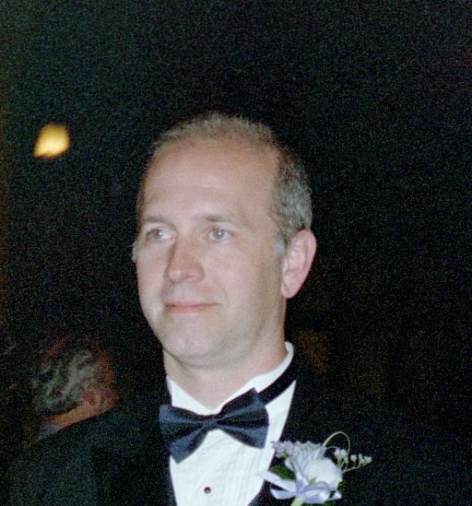
My name is John Bunce. I’m one of several music teachers at John Williams School #5. I am really looking forward to working with your child this year. As of Tuesday, September 4th we do not know who will be teaching strings or band. I have included contact information in this note and welcome any contact from you during regular school hours. Please fill out the bottom part of this letter and have your child (ren) return it when they come to school next week. Please fill one out for each of your children if you have more than one child attending school here. Thank you for your assistance in this matter.

Sincerely,

Mr. Bunce

School phone: 325-2255 X: 2110 (available from 8:00 a.m. till 3:30 p.m.)
Email: john.bunce@rcsdk12.org

(cut at the line above and return to Mr. Bunce by Wednesday, September 12 2007)

Parent’s Name (please print): ________________________________________________

Parent’s Signature: ________________________________________________________

Child’s Name (please print): ________________________________________________
Phone number: ❏ (cel) _________________ ❏(home) __________________________
Best time to call:_____________ ❏ a.m. ❏ p.m
Email: __________________________________________________________________

Child’s teacher (please check the box before your child’s teacher’s name):
(K) ❏Mrs. Stetson ❏Mrs. Joseph ❏Mrs. Visconte (1) ❏Ms. Herne ❏Mrs. Williams ❏Ms. Gilroy (2) ❏Mrs. Wade ❏Ms. Curtis ❏Mr. Williamson ❏Ms. Volpe ❏Mrs. Beckley (3) ❏Ms. Hansen ❏ Ms. Fedele ❏Mrs. Perlet (4) ❏Ms. Nunes
(5) ❏Mrs. Olivieri ❏Mrs. Gengler ❏Mrs. Rossi ❏Ms. Sheridan ❏xxx. xxxxxxx
❏Ms. Silvio ❏ Ms. Duerr ❏Ms. Walton ❏Ms. Snowden
(6) ❏Mr. Mazzota ❏Mrs. Yildirim ❏Ms. Moucha ❏Mrs. Mack

