**Module 5 Lesson #2**

**Conditional Probabilities**



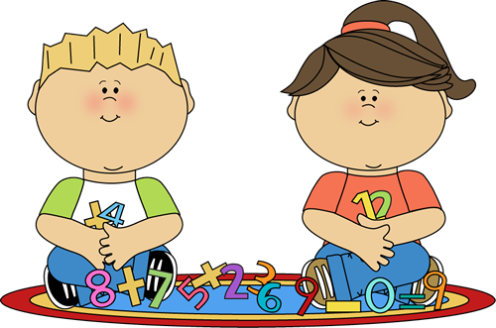

Learning Targets

I can calculate conditional probabilities.

**Calculating Conditional Probabilities _____________________**

**Example 1:** In this study, 52 graduating high school seniors were surveyed as to their post-graduation plans and their results were recorded by gender.

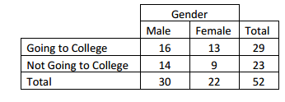

The following letters stand for the following events:

M = Male

C = Going to College

F = Female

N = Not Going to College

If a person is picked at random, find:

a) $P(F)$

b) $P(C)$

Does $P\left(C given F\right)=P\left(F given C\right)?$

c) $P(M∩C)$

d) $P(F∪C)$

e) $P(C given F)$

**Example 2:** Historically, a given day at the beginning of March in upstate New York has an 18% chance of snow and a 12% chance of rain. If there is a 4% chance that it will snow and rain on a day, then calculate the probability of each of the following:

NOTE:

a) P(rain given snow)

b) P(snow given rain)

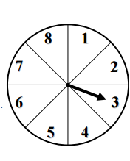**Example 3:** A spinner is spun around a circle that is divided up into eight equally sized sectors. Find,

a) P(perfect square given even)

b) P(odd given prime)

c) What is more likely: getting a multiple of four given we spun an even or getting an odd given that we spun a number greater than 2? Support your answer

**Example 4**

Students at Rufus King High School were discussing some of the challenges of finding space for athletic teams to practice after school. Part of the problem, according to Kristin, is that female students are more likely to be involved in an after-school athletics program than male students. However, the athletic director assigns the available facilities as if male students are more likely to be involved. Before suggesting changes to the assignments, the students decided to investigate.

Suppose the following information is known about Rufus King High School: $40\%$ of the students are involved in one or more of the after-school athletics programs offered at the school. It is also known that $58\%$ of the school’s students are female. Also, 23.2% of students are female and participate in after school athletics. The students decide to construct a hypothetical 1000 two-way table to organize the data.

**Participation in After-School Athletics Programs (Yes or No) by Gender**

|  |  |  |  |
| --- | --- | --- | --- |
|  | **Yes—Participate in After-School Athletics Programs** | **No—Do Not Participate in After-School Athletics Programs** | **Total** |
| **Female** |  |  |  |
| **Male** |  |  |  |
| **Total** |  |  | 1000 |

The following letters stand for the following events:

M = Male F = Female

Y = Participates N = Does not Participate

a. Find $P(F)$ **b. $P(Y)$**

b. $P(Y∩M)$ d. $P(N given M)$

**Example 5:** Use the table below to find each probability:

|  |  |  |  |
| --- | --- | --- | --- |
|  | Under $20,000 | $20,000 to $30,000 | Over $30,000 |
| Less than high school | 69 | 36 | 2 |
| High School | 112 | 98 | 14 |
| Some college | 102 | 193 | 143 |
| College degree | 13 | 178 | 245 |

1. P(has less than high school education)
2. P(earns over $30,000 and has less than h.s. education)
3. P(earns over $30,000 given has only h.s. education)
4. P(has h.s. education or less given earns over $30,000)