**Module 4 Lesson 5**

**Compound Interest**

**Applications of Exponential Functions**



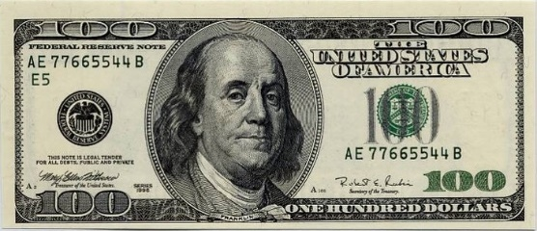



Learning Targets:

* I can compute the total amount accrued with interest being compounded n times per year.
* I can solve exponential equations involving the natural number e.
* I can write an exponential regression equation given a set of data.

**Why is $e$ important?**

**Natural base exponential functions have base $e$. These functions are useful for describing continuous growth or decay.**

**Exponential Growth and Decay Models Involving Compound Interest**

**Growth: $A\left(t\right)=a{(1+\frac{r}{n})}^{nt}$ $A=Pe^{rt}$**

**Decay: $A\left(t\right)=a{(1-\frac{r}{n})}^{nt}$ when n gets really large**

**(compounded continuously)**

$a: inital amount$

$t: number of time periods$

$n: number of compounds per year$

$$r: rate in decimal form$$

**You put $\$1000$ in a college savings account for $5$ years. The account has an annual interest rate of $6\%$ and is compounded n times per year.**

|  |  |  |  |
| --- | --- | --- | --- |
| **Comp “n” per year** | **n** | **Formula** | **Total Amount** |
| **Annually** |  |  |  |
| **Semi-Annually** |  |  |  |
| **Quarterly** |  |  |  |
| **Monthly** |  |  |  |
| **Weekly** |  |  |  |
| **Daily** |  |  |  |
| **Continuously** |  |  |  |

Examples:

1. A total of $12000 is invested at an annual percentage rate of 9%. Find the balance in the account if
   1. It is compounded annually for 5 years.
   2. It is compounded monthly for 5 years.
   3. It is compounded continuously for 5 years.
2. Jose invests $500 at an interest rate of 10% compounded quarterly for 5 years. Maria invest $500 at an interest rate of 10% compounded continuously for 5 years. Assuming that the money will be untouched for the duration of the 5 year period,
   1. Who ends up with more money at the end of the 5 years?
   2. By how much money did the winner’s total exceed the other person’s total?
3. Given an investment modeled by: $A=1500{\left(1+\frac{0.035}{12}\right)}^{12t}$. Which of the following statements are true (circle all that apply).
   1. The investment is compounded every $12$ years.
   2. The investment is compounded $12$ times per year.
   3. The interest rate is $35\%$
   4. The interest rate is $3.5\%$
   5. The initial investment is $\$1,500$
   6. $A$ represents the amount accrued
   7. $A$ represents the Principal.
4. Emily wants to buy a car for $12,000 but does not have enough money to pay for it all at once. She goes to the bank to get a loan instead. Compute the future value of her loan if she finances her car for 4 years at 2.87% without accounting for monthly payments.

How much will she pay in interest?

**Exponential Models**

Ex. The number of fruit flies in an experimental

population after $t$ hours is given by



$Q\left(t\right)=20e^{0.03t}$ $t≥0$

1. Find the initial number of fruit flies in the population.
2. How large is the population of fruit flies after 72 hours?
3. When will there be 29 fruit flies? (Use a Calculator to approximate this answer).

**Exponential Regressions**

Example 1:

The best temperature to brew coffee is between ${195}^{0}$ and ${205}^{0}.$ Coffee is cool enough to drink at ${185}^{0}.$ The table below shows temperature readings from a sample cup of coffee. How long does it take for a cup of coffee to cool enough to drink? Use an exponential model rounded to the nearest thousandth.

|  |  |
| --- | --- |
| Time (min) | Temp ( $℉)$ |
| 0 | 203 |
| 5 | 177 |
| 10 | 153 |
| 15 | 137 |
| 20 | 121 |
| 25 | 111 |
| 30 | 104 |

Example 2:

The table below shows the number of new stores in a coffee shop chain that opened during the years $1986$ through 1994.

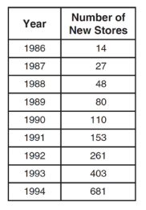

Using $x = 1$ to represent the year $1986$ and $y$ to represent the number of new stores, write the exponential regression equation for these data. Round all values to the nearest thousandth.