NAME:______________________ QUIZ PREP 13.1, 13.2, 13.3

1. If the length of the arc of a sector is $\frac{17π}{6}$ and the  central angle is $\frac{2π}{5}$, find the length of the radius. | 2. If $θ$lies in quadrant II and $sinθ=\frac{3}{5}$,  find $cosθ.$
3. If the minute hand of a clock measures 6 inches,  how long is the arc traced by this hand from  1:00 to 1:30? | 4. Find the exact value of $\cos{{150}^{0}}$ ?
5. If $θ={315}^{0}$, find the following:  Reference angle___________  Positive coterminal angle_______________  Negative coterminal angle______________ | 6. Find the exact value of $\sin{{120}^{0}}$.
7. Express ${240}^{0}$ in radian measure.  Express $\frac{2π}{3}$radians in degree measure. | 8. The coordinates of a point on the unit circle  are $(\frac{\sqrt{2}}{2} ,- \frac{\sqrt{2}}{2} )$. If the terminal side of  angle $θ$ in standard position passes  through the given point, find $m∢θ.$  Choices:  - ${135}^{0}$  - ${150}^{0}$  - ${300}^{0}$  - ${315}^{0}$
9. In circle O, the length of radius is 5 cm and  the length of arc AB is 5 cm. Find the measure of  angle AOB.  Choices:  - 1 radian  - $60$ degrees  - $π$ radians  - more than $60$ degrees | 10. If $β$ lies in quadrant IV and $cosβ=\frac{7}{25}$,  find $tanβ.$
11. 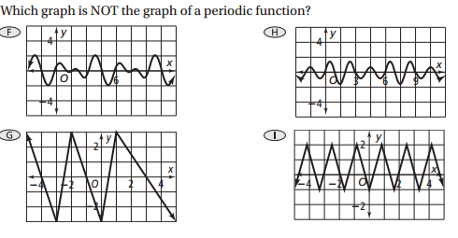 | 12. 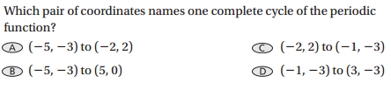  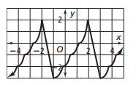

13. Draw $\frac{-11π}{9}$ in standard position, state the reference angle and give a coterminal angle in both radians and degrees. | 14. Draw $345°$ in standard position, state the reference angle and give a coterminal angle in both radians and degrees.
15. Given $\left(\frac{-\sqrt{3}}{2}, \frac{1}{2}\right)$ is a point on the terminal side of an angle in standard position drawn on a unit circle. What is the cosine of the angle. | 16. Find the reference angle for $215°.$
17. Find the reference angle for $\frac{-14π}{9}.$ | 18. Name two angles in standard position where $\cos{θ}=-\frac{\sqrt{2}}{2}$.
19. Find the exact value of $\sin{270°}$ | 20. Find the exact value of $\cos{\frac{-π}{2}}$
21. A base of a Ferris wheel at Darian Lake is one foot above the ground. Draw a labeled sketch of one cycle of the car on the wheel that starts in the 6 o’clock position if the diameter is 30 feet. | 22. If the Ferris wheel fell off its supports in an ice storm and rolled 175 feet down the road, what is the number of radians the wheel turned?

