[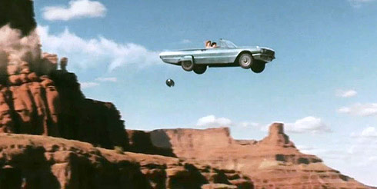](http://www.youtube.com/watch?v=4z88U915uq8)

1. In the classic chick flick, “Thelma and Louise”, the pair of women deliberately drive their car off the edge of a cliff for some reason men will never understand. The cliff is about 100 m high and they are driving about 30 m/sec.

Thelma ending

<http://www.youtube.com/watch?v=4z88U915uq8>

1. 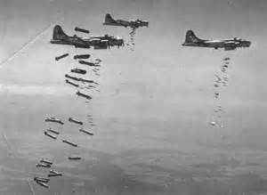 In bombing missions in WWII , bombs were released under the airplane and were shaped to minimize air resistance. If an airplane was moving 50 m/sec and was 1000. Meters high, how far ahead of the target should the bomb be dropped?
2. [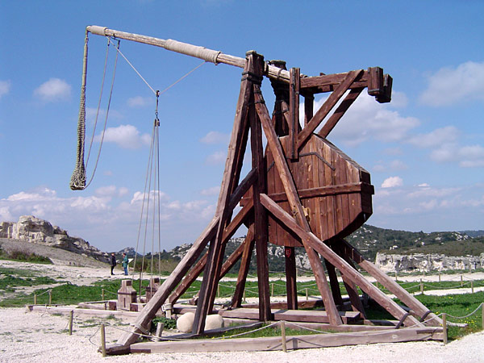](https://www.youtube.com/watch?v=nomeW2FDDtM)In medieval times, trebuchets were used to throw burning fireballs and rocks at an enemy. A good trebuchet can throw at about 50 meters/sec. How far away would the weapon have to be from the enemy to be effective?

Piano man

<https://www.youtube.com/watch?v=-wVADKznOhY>

trebuchet pumpkin

<https://www.youtube.com/watch?v=nomeW2FDDtM>

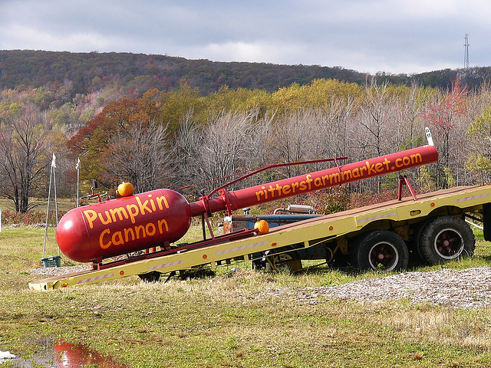

1. Modern farmers may amuse themselves in a heavy harvest season with novelty devices for vegetables such as this pumpkin cannon. Which can fire the pumpkins at over 200 m/sec. If the cannon fires at 30 degrees, how far will the pumpkin go?

trebuchet pumpkin

<https://www.youtube.com/watch?v=nomeW2FDDtM>