General Chemistry Reference Tables

Table A Table C
Standard Temperature and Pressure Selected Polyatomic Ions
Name | Value | Unit
Standard Pressure | 101.3 kPa  1 atm | Kilopascal  Atmosphere
Standard Temperature | 273 K  0°C | kelvin  degree Celsius
NH₄⁺ ammonium | NO₂⁻ nitrite
CO₃⁻² carbonate | NO₃⁻ nitrate
HCO₃⁻ hydrogen  carbonate | OH⁻ hydroxide
ClO⁻ hypochlorite | PO₄⁻³ phosphate
O₂⁻² peroxide | SO₄⁻² sulfate

Table B Table D
Selected Units Important Formulas

Density | D = density  $D=\frac{m}{v}$ m = mass  v = volume
Number of Moles | $$\text{of} \text{moles} =\frac{\text{given} \text{mass}(g)}{\text{gram}−\text{formula} \text{mass}}$$
Temperature | K = °C + 273
Symbol | Name | Quantity
m | meter | length
g | gram | mass
Pa | pascal | pressure
K | kelvin | termperature
mol | mole | amount of substance
J | joule | energy, work, quantity of heat
s | second | time
L | liter | volume
M | molarity | solution concentration

Table E
Solubility Curves

Table F
Heats of Reaction at 101.3 kPa & 298 K

Reaction | ∆H (kJ)
C₃H_{8(g)} + 5O_{2(g)} 3CO_{2(g)} + 4H₂O_{(l)} | -2219.2
C₆H₁₂O_{6(s)} + 6O_{2(g)} 6CO_{2(g)} + 6H₂O_{(l)} | -2804
N_{2(g)} + 2O_{2(g)} 2NO_{2(g)} | +66.4
2H_{2(g)} + O_{2(g)} 2H₂O_{2(l)} | -571.6
N_{2(g)} + 3H_{2(g)} 2NH_{3(g)} | -91.8
2C_{(s)} + 3H_{2(g)} C₂H_{6(g)} | -84.0
2C_{(s)} + 2H_{2(g)} C₂H_{4(g)} | +52.4
2C_{(s)} + H_{2(g)} C₂H_{2(g)} | +227.4
NaOH_{(s)} Na⁺_{(aq)} + OH⁻_{(aq)} | -44.51
NH₄NO_{3(s)} NH₄⁺_{(aq)} + NO₃⁻_{(aq)} | +25.69
H₂O
H₂O

Formula | Name
NaOH_{(aq)} | sodium hydroxide
KOH_{(aq)} | potassium hydroxide
Ca(OH)_{2(aq)} | calcium hydroxide
NH_{3(aq)} | ammonia (aqueous)
Formula | Name
HCl_{(aq)} | hydrochloric acid
HNO_{3(aq)} | nitric acid
H₂SO_{4(aq)} | sulfuric acid
H₃PO_{4(aq)} | phosphoric acid
H₂CO_{3(aq)}  or  CO_{2(aq)} | carbonic acid
CH₃COOH  or  HC₂H₃O_{2(aq)} | ethanoic acid  (acetic acid)

*Minus sign indicates an exothermic reaction

Table G Table H
Common Acids Common Bases

Table I
Common Acid-Base Indicators
Indicator | Approximate pH range for color change | Color change
methyl orange | 3.2 – 4.4 | red to yellow
bromthymol blue | 6.0 – 7.6 | yellow to blue
phenolphthalein | 8.2 – 10 | colorless to pink
litmus | 5.5 – 8.2 | red to blue
bromcresol green | 3.8 – 5.4 | yellow to blue
thymol blue | 8.0 – 9.6 | yellow to blue

Table J Table K
Organic Prefixes Homologous Series of Hydrocarbons
Name | General Formula | Examples  Name Structural Formula
Alkanes | C_{n}H_{2n+2} | ethane | 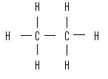
Alkenes | C_{n}H_{2n} | ethane | 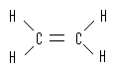
Alkynes | C_{n}H_{2n-2} | ethyne | 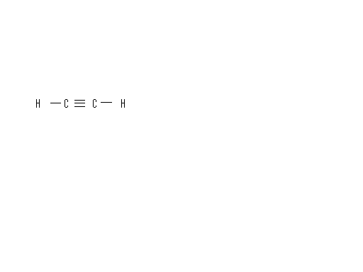
Prefix | Number of Carbon Atoms
meth- | 1
eth- | 2
prop- | 3
but- | 4
pent- | 5
hex- | 6
hept- | 7
oct- | 8

Table K Table L
Symbols Used in Nuclear Chemistry Selected Radioisotopes
Name | Notation | Symbol
alpha particle |  | α
beta particle (electron) | $${}_{−1}^{0}{}e \text{or} {}_{−1}^{0}{}β$$ | β
gamma radiation |  | γ
neutron | $${}_{0}^{1}{}n$$ | n
proton | $${}_{1}^{1}{}H \text{or} {}_{1}^{1}{}p$$ | p
positron | $${}_{+1}^{0}{}e \text{or} {}_{+1}^{0}{}β$$ | β⁺
Nuclide | Half-life | Decay Mode | Nuclide Name
¹⁴C | 5730 y | β⁻ | carbon-14
⁶⁰Co | 5.26 y | β⁻ | cobalt-60
¹³⁷Cs | 30.23 y | β⁻ | cesium-137
¹³¹I | 8.07 d | β⁻ | iodine-131
³⁷K | 1.23 s | β⁺ | potassium-37
⁸⁵Kr | 10.76 y | β⁻ | krypton-85
⁹⁰Sr | 28.1 y | β⁻ | strontium-90
²²²Rn | 3.82 d | α | radon-222
²³⁵U | 7.1 x 10⁸ y | α | uranium-235

