**Name __________________________________ Review Sheet: Summative Assessment 2.2**

1. In the spaces to the right of each definition, write the name of the life process defined and the number of the proper example. *Choices: digestion, excretion, growth, homeostasis, metabolism, reproduction, respiration, synthesis, transport*

**Examples**

1. Cellulose is made by putting 1,000s of glucose molecules together.

2. Glucose in the intestine reaches a muscle cell.

3. The breakdown of proteins into simple amino acids.

4. The exhaling of carbon dioxide and water vapor.

5. Body temperature is maintained regardless of outside temperature.

6. Each of your cells is respiring, excreting, digesting, transporting, synthesizing, etc.

7. A child grows 4 cm in a year.

8. The deer population of an area doubles over time.

9. Glucose is converted into carbon dioxide and water.

|  |  |  |
| --- | --- | --- |
| **Definition** | **Life Process** | **Example #** |
| A. The removal of metabolic wastes. |  |  |
| B. The process that occurs by an increase in cell size or cell number. |  |  |
| C. The production of complex substances from simpler ones. |  |  |
| D. The absorption and distribution of substances within an organism. |  |  |
| E. The production of new organisms that are essentially the same as their parents. |  |  |
| F. The release of energy in an organism as the result of the oxidation of food materials. |  |  |
| G. Maintenance of a constant internal environment. |  |  |
| H. Changing food materials from the environment into a usable form. |  |  |
| I. **All** of the chemical reactions that occur in your cells and body. |  |  |

1. Label the pictures below which show how life is organized.

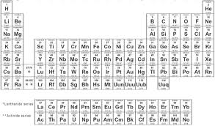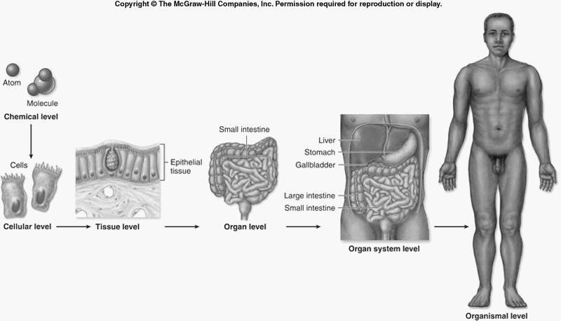

**T.M.I.**

1. Review of New York State’s *Diffusion Through a Membrane* Lab

How do we know that iodine (SIS) diffused into the cell?

How do we know that glucose diffused out of the cell?

Why are some molecules able to diffuse through the membrane but others are not?

* Part 1: Making an Artificial Cell

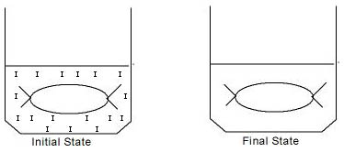

* Part 2: Red Onion Cell Plasmolysis

[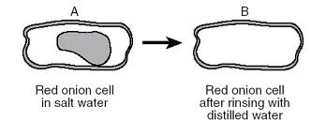](http://www.google.com/imgres?q=diffusion+through+a+membrane+red+onion&hl=en&safe=strict&gbv=2&biw=1600&bih=703&tbm=isch&tbnid=_Et09Hic4RwQPM:&imgrefurl=http://www.ekcsk12.org/faculty/jbuckley/leclass/practicemidterm5.htm&docid=QebNxrKdUkpt9M&imgurl=http://www.ekcsk12.org/faculty/jbuckley/leclass/practi7.gif&w=495&h=206&ei=gJ-yTt_UPJSCtgf-0cDQAw&zoom=1)

Finish the diagram and then label the cell walls, cell membranes, and cytoplasm.

What effect does salt have on cells?

[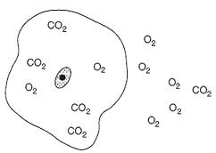](http://www.google.com/imgres?q=diffusion+through+a+membrane+red+onion&hl=en&safe=strict&gbv=2&biw=1600&bih=703&tbm=isch&tbnid=-IM1B5PKR_kYtM:&imgrefurl=http://www.oocities.org/me6581/quiz2.htm&docid=evRR0AT_Ql5shM&imgurl=http://www.oocities.org/me6581/Q4.gif&w=303&h=216&ei=gJ-yTt_UPJSCtgf-0cDQAw&zoom=1)

* Diffusion takes place until molecules are at an equal concentration

throughout. Show how the molecules on the right would move

using arrows.

* Label the two diagrams below using the appropriate terms: active transport, diffusion, requires energy (ATP), requires NO energy (ATP).

[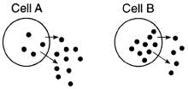](http://www.google.com/imgres?q=active+transport+through+a+membrane&hl=en&safe=strict&gbv=2&biw=1600&bih=703&tbm=isch&tbnid=sSEiuKizbWRXTM:&imgrefurl=http://www.ekcsk12.org/faculty/jbuckley/lelab/diffusionlabquiz.htm&docid=VoAyhWKWGIsfGM&imgurl=http://www.ekcsk12.org/faculty/jbuckley/lelab/diffusionlabquiz_files/image006.gif&w=275&h=130&ei=N6CyTragN5DrtgeR3pDBAw&zoom=1)[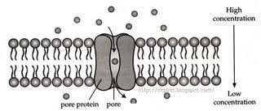](http://www.google.com/imgres?q=diffusion+through+a+membrane&hl=en&safe=strict&gbv=2&biw=1600&bih=703&tbm=isch&tbnid=Kbaexa0Nt5es6M:&imgrefurl=http://biology-stmark.blogspot.com/2010/04/31-movement-of-substances-across-plasma.html&docid=fge4-VGiIKW2-M&imgurl=http://3.bp.blogspot.com/_oCXP3wyQN9w/SdjV-0lFkhI/AAAAAAAABeA/8R6tyLcUpp4/s400/Facilitated+diffusion.jpg&w=400&h=172&ei=25-yTtiNApO4twfAuYjGAw&zoom=1)

1. Enzyme Actions

Six Things You Must Know About Enzymes!

1. They speed up reaction rates.
2. They are specific for a substrate (think lock and key).
3. They have only 1 job…make or break?
4. They are not changed and can be used over and over again.
5. They are affected by temperature, concentration, and pH.
6. They can be denatured (lose shape). Then they don’t work!

[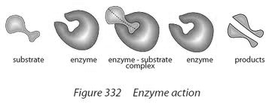](http://www.google.com/imgres?q=enzyme+action&hl=en&safe=strict&gbv=2&biw=1600&bih=703&tbm=isch&tbnid=i0rqZiZsC9VNlM:&imgrefurl=http://unis2010bio11enztymes-group2.wikispaces.com/&docid=t-NZqBPLmINkAM&imgurl=http://unis2010bio11enztymes-group2.wikispaces.com/file/view/enzyme_action.png/169671413/enzyme_action.png&w=499&h=189&ei=oqOyTqeJCMeutweBicDAAw&zoom=1)

1. Summary of Aerobic Cellular Respiration

Summary of Cellular Respiration

|  |  |
| --- | --- |
| Chemical Equation | http://4.bp.blogspot.com/_GsPuGchS5Fg/SM7dOZVmbXI/AAAAAAAAABs/XcxzOqlyhgg/s320/cellular+resp+equation.gif |
| Purpose |  |
| Materials Used |  |
| Materials Produced |  |
| Time Frame |  |
| Location |  |
| Why is it Necessary? |  |
| Why is it called “aerobic”? |  |
| When do human cells go through anaerobic respiration? |  |

1. How do carbohydrates provide energy for life functions? Explain using the following life functions: digestion, absorption, circulation, diffusion, respiration.

__________________________________________________________________________________________

__________________________________________________________________________________________

__________________________________________________________________________________________

__________________________________________________________________________________________

__________________________________________________________________________________________

1. Question that make us reminisce over Mr. Hanss not being here…

* What would normal blood glucose look like when graphed over a 24-hour period?
* What would the blood glucose levels of an untreated diabetic look like?
* What are some body systems involved in blood glucose regulation? Explain.

__________________________________________________________________________________________

__________________________________________________________________________________________

__________________________________________________________________________________________

__________________________________________________________________________________________

__________________________________________________________________________________________

__________________________________________________________________________________________

__________________________________________________________________________________________

1. Draw an animal cell and label the following organelles: cell membrane, nucleus, ribosomes, vacuole, cytoplasm, and mitochondria. Then, write the function (job) of each structure. Add in a cell receptor just for fun!