Name _________________________________________________ Date __________________

**Lab # 27: Agent of erosion: Running water**

**# of mins: _______ Score =**

The shape of a river channel is affected by the velocity of the water. The velocity of the water varies in different parts of a river channel. Generally, faster flowing water cuts or erodes a deeper channel. Slower moving water erodes less and may even deposit sediments.

**Define the following terms:**

Tributary: _________________________________________________________________________________

__________________________________________________________________________________________

V-shaped valley: ___________________________________________________________________________

__________________________________________________________________________________________

Discharge: ________________________________________________________________________________

__________________________________________________________________________________________

Stream channel shape: _______________________________________________________________________

__________________________________________________________________________________________

**Label Figure 1 below using pg. 189 in the review book according to the directions:**

1. Label with an **X** the regions of the stream where the velocity is the greatest.
2. Draw arrows of different lengths to represent the stream’s velocity at different locations. The length of the arrow is proportional to the stream’s velocity.
3. Label on the river channel the 2 locations where erosion would occur and the 2 locations where deposition would occur.

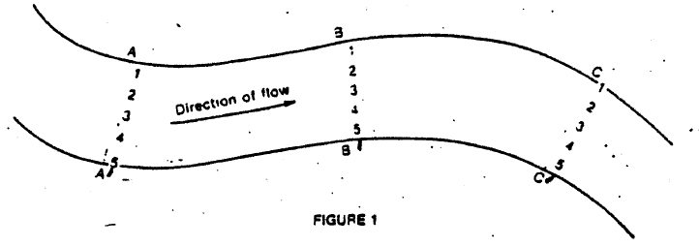

1. Draw cross-sectional views of the river channel in the area below along lines A-A’, B-B’, and C-C’.

|  |  |  |
| --- | --- | --- |
| A-A’ | B-B’ | C-C’ |

Explain why erosion occurs on the outside of a curve or meander. ____________________________________

____________________________________________________________________________________________________________________________________________________________________________________