Name ________________________________________ Date _____________

Lab #1: Construction and Analysis of Graphs

Score = _____ # of minutes = _____

**Introduction**: Constructing and interpreting graphs are important parts of any earth science course. You must be able to determine if there is a relationship between variables (independent and dependent) and what type exists. Determining the rate of change (change in value/time) is also a skill you must learn.

**Reminders and examples**:

1. The independent variable (IV) is placed on the x-axis and the dependent variable (DV) on the y-axis.
2. When interpreting a graph, determine what is happening to the independent variable (IV) in reference to the dependent variable (DV). For example, is the IV increasing and the DV decreasing?
3. **Examine each graph below. Then determine the relationship between the variables, time and temperature. The first one is done for you.**

Temperature (oC)

Temperature (oC)

Temperature (oC)

Temperature (oC)

Time (months)

Time (months)

Time (months)

Time (months)

1. As the time increased the temperature increased.

D)

C)

B)

**Part A: Base your answers to the following questions on Graph A. It represents the flight of two weather balloons that were released from different locations.**

**Questions**:

1. Was the altitude of the balloons increasing or decreasing as shown by lines A and B? ________________________
2. During the first four minutes (time 0 to time 4), how many meters did A rise?

________________________

1. During the first four minutes, how many meters did B rise?

_________________________

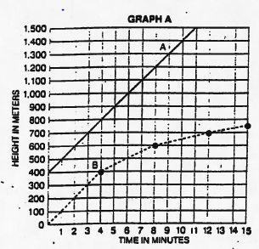

1. During the first four minutes, what was the rate of change for balloon A? ______________________
2. During the first four minutes, what was the rate of change for balloon B? ______________________
3. What was the rate of change along line A from time 4 minutes to time 8 minutes? ________________
4. What was the rate of change along line B from time 4 minutes to time 8 minutes? ________________
5. What is the relationship between time and altitude for balloon A? ____________________________

_________________________________________________________________________________

__________________________________________________________________________________

**Part B: A cup of water was left sitting on a table. Temperature was measured and recorded at one-minute intervals. Plot the given data below on graph B. Be sure to completely label each axis. Answer the questions that follow.**

|  |  |  |  |  |
| --- | --- | --- | --- | --- |
| **Time (min)** | **Temperature (oC)** | **Time (min)** | **Temperature (oC)** | |
| **0** | **36** | **8** | **24.5** |
| **1** | **32.5** | **9** | **24** |
| **2** | **30.5** | **10** | **23.5** |
| **3** | **29** | **11** | **23.2** |
| **4** | **28** | **12** | **23** |
| **5** | **27** | **13** | **23** |
| **6** | **26** | **14** | **23** |
| **7** | **25.5** | **15** | **23** |

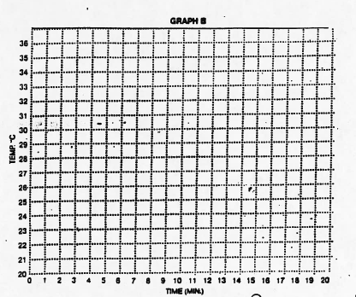

**Questions:**

9. What is the relationship between time and temperature for graph B? _____________________________________

______________________________________________________________________________________________

10. Calculate the rate of change from time 0 to time 4. Show your work.

11. Calculate the rate of change from time 4 to time 8. Show your work.

12. Is time or temperature the independent variable? ________________________________

**Part C: Base your answers to the following questions on graph C, which shows the mass and volume for 5 samples of the mineral pyrite, and your knowledge of density. The formula to calculate density is mass/volume.**

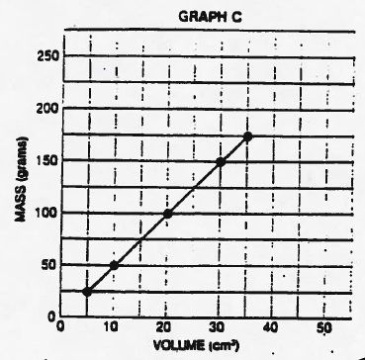

**Questions**:

13. According to graph C, what is the density of pyrite? [Hint use the formula above. Don’t forget the units.] Show your work.

14. If a sample of pyrite has a volume of 50 cm3, what would its mass be? ____________________

15. The density of pyrite and the density of water (1.0 g/cm3) were plotted on the same graph. Which diagram below best represents how the graph should appear?

