Integrated Algebra Name_________________________________________Date_________Per____
Evaluating Expressions
I: Factorials
Factorial Notation is used when you need to work with a series of factors, each being one less than the previous factor.
Instead of writing out 5 · 4 · 3 · 2 · 1,
we use factorial notation and write
5! = 120.
(Note: 0! = 1 and 1! = 1)
Expand 8! | Write as a factorial  $$1∙2∙3∙4∙5∙6∙7∙8∙9$$
Write as a factorial  $$4∙3∙2∙1$$ | Miss Flanagan wrote that  $6!=6∙5∙4∙3∙2∙1∙0$  Explain why she is incorrect.
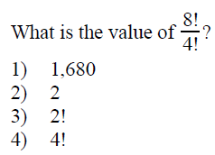 | 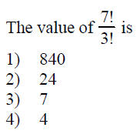
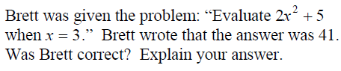

II. Absolute Value
Absolute value is a number’s distance from zero.
Remember that distance is always a positive quantity (or zero).
$$|5|$$ | $$|-12|$$
$$-|12|$$ | $$-|-12|$$
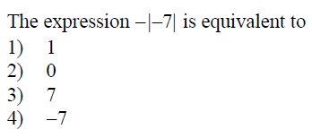 | 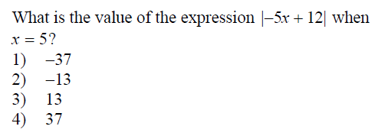
Mr. Wilson asked his A2 and Trig kids to solve for x in the following:
$$\left|x\right|=4$$
Frank answered x = 4. Bishop answered x = -4. Who is correct? Are they both correct? Explain why using a complete sentence.

Create and solve an absolute value problem.

III. Mixed review
1) | 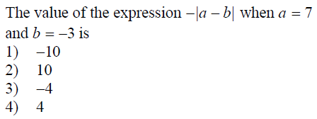 | 2) | 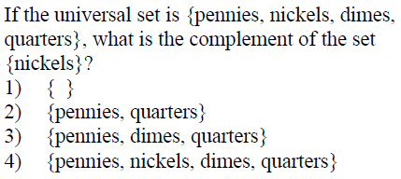
3) | 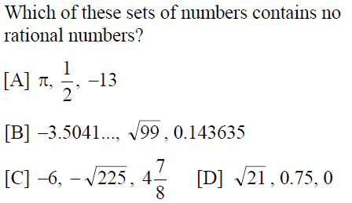 | 4) | The number 0.8 belongs to which of these  sets? natural numbers, whole numbers,  integers, rational numbers, irrational numbers,  and real numbers. Name all that apply.

