Name ______________________________ Module 3

Volume of Prisms and Cylinders

**Learning Target**: I can use volume formulas for prisms and cylinders.

**Opening Exercise**

Find the number of cubes in each prism.

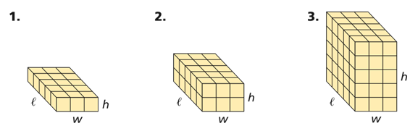

**Volume of Prisms and Cylinders**

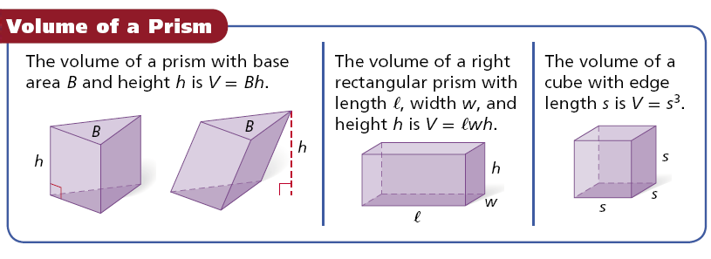

1. Find the volume of the prism.

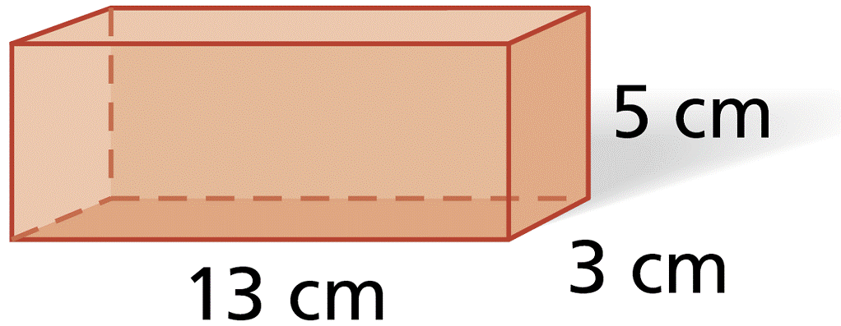

2. Find the volume of a cube with edge length 15 in.

3. Find the volume of a triangular prism with a height of 9 yds. whose base is a right triangle with legs 7 yds. and 5 yds. long.

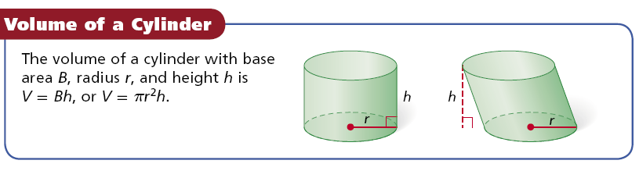

4. Find the volume of the cylinder. Give your answers in terms of *π*.

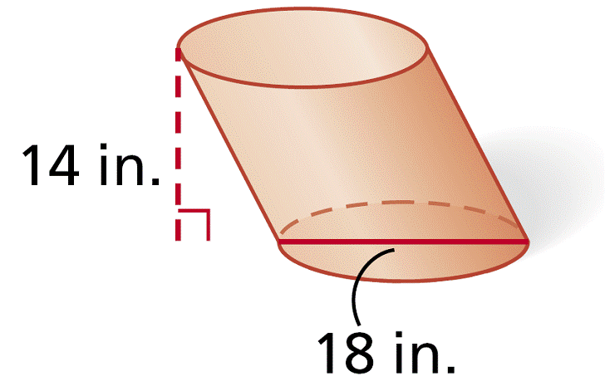

5. Find the volume of a cylinder with a diameter of 16 in. and a height of 17 in. Express your answer to the nearest tenth.

**Effect of changing dimensions on volume.**

6. The edge length of the cube is tripled. Describe the effect on the volume.

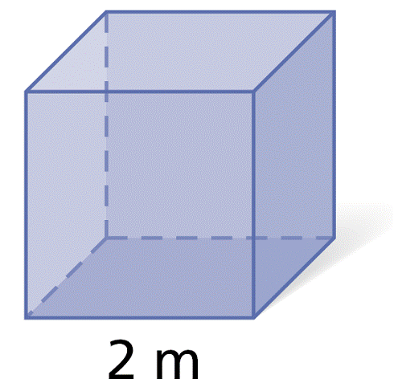

7. Two circular cylinders are similar. The ratio of the areas of their bases is 16:49. Find the ratio of the volumes of the similar solids.

**Cavalieri’s Principle**

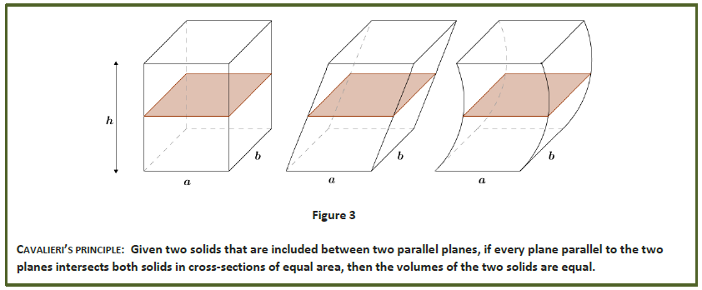

Two stacks of coins of equal height are shown below. Are the two volumes different? Why?

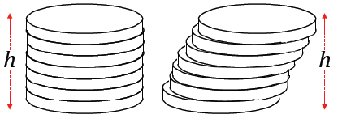

*By Cavalieri’s principle, each cross-section between two stacks of cards or coins is the same, and the heights of each solid are the same, so the two volumes are equal.*

8. Two cylinders each with a height of 50 inches are shown. If $x=y$, which cylinder has greater volume? *Justify your reasoning*.

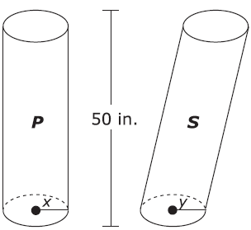

Name ______________________________ Module 3

Volume of Prisms and Cylinders Problem Set

1. A packing carton in the shape of a triangular prism is shown in the diagram below. What is the volume, in cubic inches, of this carton?

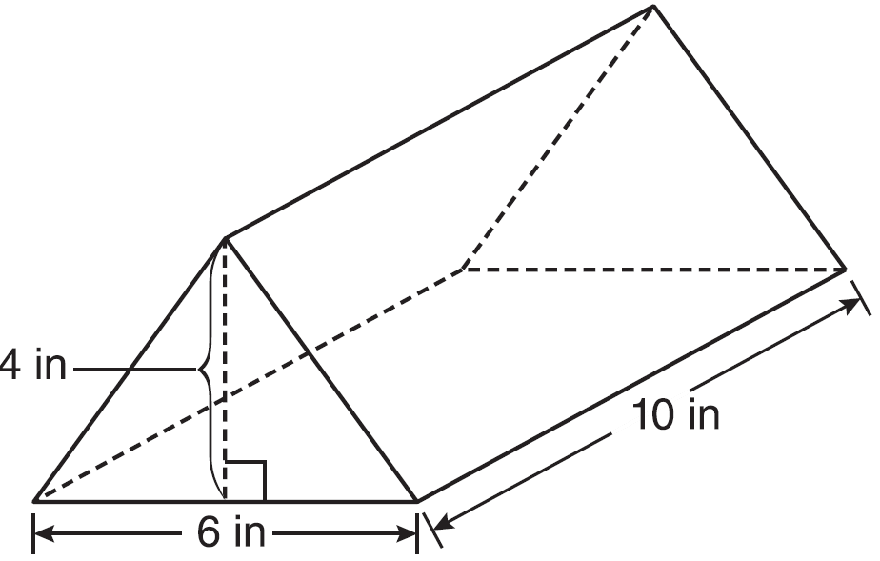

2. Tim has a rectangular prism with a length of 10 centimeters, a width of 2 centimeters, and an unknown height. He needs to build another rectangular prism with a length of 5 centimeters and the same height as the original prism. The volume of the two prisms will be the same. Find the width, in centimeters, of the new prism.

3. A rectangular prism has a volume of $3x^{2}+18x+24$*.* Its base has a length of $x+2$ and a

width of 3. Which expression represents the height of the prism?

4. A box in the shape of a cube has a volume of 64 cubic inches. What is the length of a side of the box?

5. If the length of a rectangular prism is doubled, its width is tripled, and its height remains the same, what is the volume of the new rectangular prism?

(1) double the original volume

(2) triple the original volume

(3) six times the original volume

(4) nine times the original volume

6. Determine the volume in terms of $π$, in cubic centimeters, of the cylinder below.

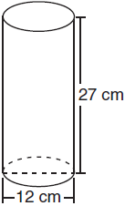

7. What is the volume in terms of $π$, in cubic centimeters, of a cylinder that has a height of 15 cm and a diameter of 12 cm?

8. A right circular cylinder has a volume of 1,000 cubic inches and a height of 8 inches. What is the radius of the cylinder to the *nearest tenth of an inch*?

9. The volume of a cylinder is 12,566.4 cm3. The height of the cylinder is 8 cm. Find the radius of the cylinder to the *nearest tenth of a centimeter*.

10. In the accompanying diagram, a rectangular container with the dimensions 10 inches by 15 inches by 20 inches is to be filled with water, using a cylindrical cup whose radius is 2 inches and whose height is 5 inches. What is the maximum number of full cups of water that can be placed into the container without the water overflowing the container?

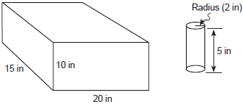

11. A fish tank with a rectangular base has a volume of 3,360 cubic inches. The length and width of the tank are 14 inches and 12 inches, respectively. Find the height, in inches, of the tank.

12. The volume of a rectangular pool is 1,080 cubic meters. Its length, width, and depth are in the

ratio 10:4:1. Find the number of meters in each of the three dimensions of the pool.

13. Jed bought a generator that will run for 2 hours on a liter of gas. The gas tank on the generator is a rectangular prism with dimensions 20 cm by 15 cm by 10 cm as shown below. If Jed fills the tank with gas, how long will the generator run? Show how you arrived at your answer.

[Note: 1000 cm3 = 1 liter]

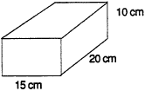

14. The dimensions of a brick, in inches, are 2 by 4 by 8. How many such bricks are needed to have a total volume of exactly 1 cubic foot?

Name ______________________________ Module 3

Volume of Prisms and Cylinders Exit Ticket

1. The diagram shows the base of a cylinder. The height of the cylinder is 14 cm. If each square in the grid is 1 cm×1 cm, make an approximation of the volume of the cylinder. Explain your reasoning.

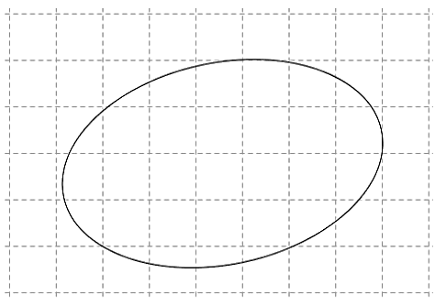

2. Two circular cylinders are similar. The ratio of the areas of their bases is 9:4. Find the ratio of the volumes of the similar solids.