**Slide 1:**

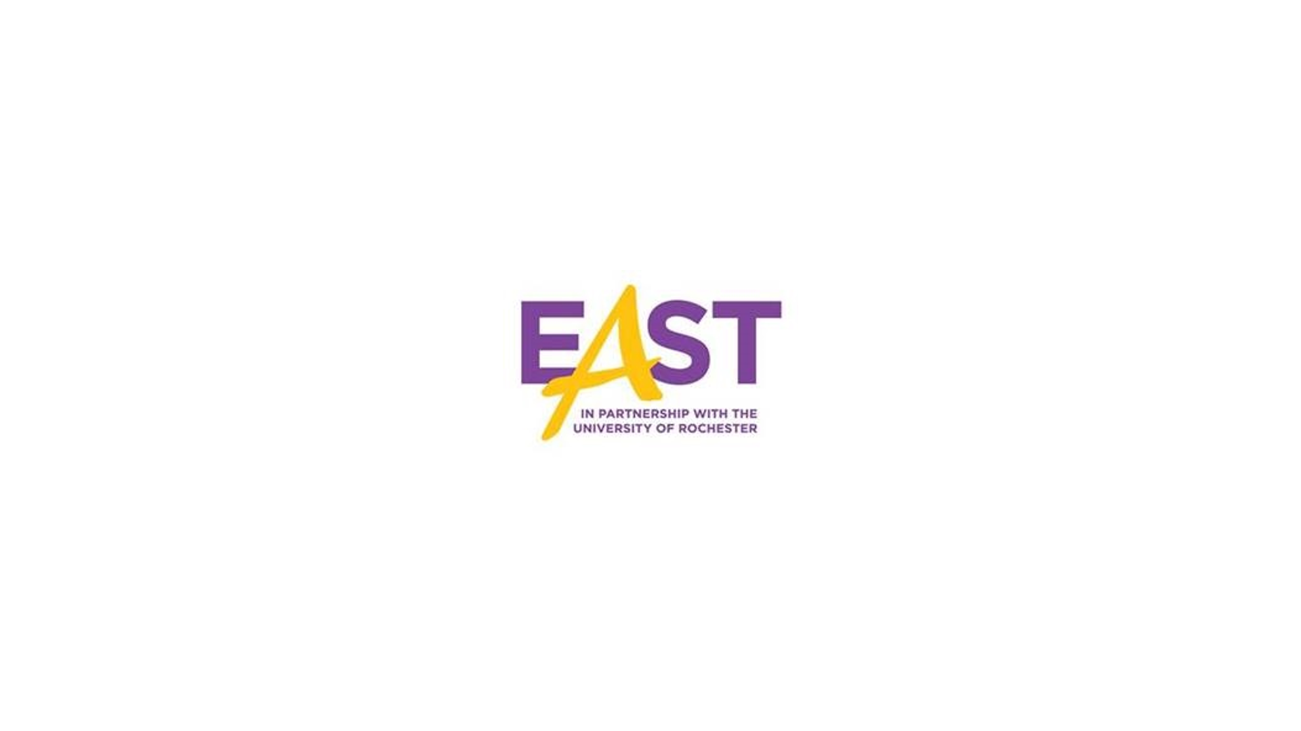

**Slide 2:**

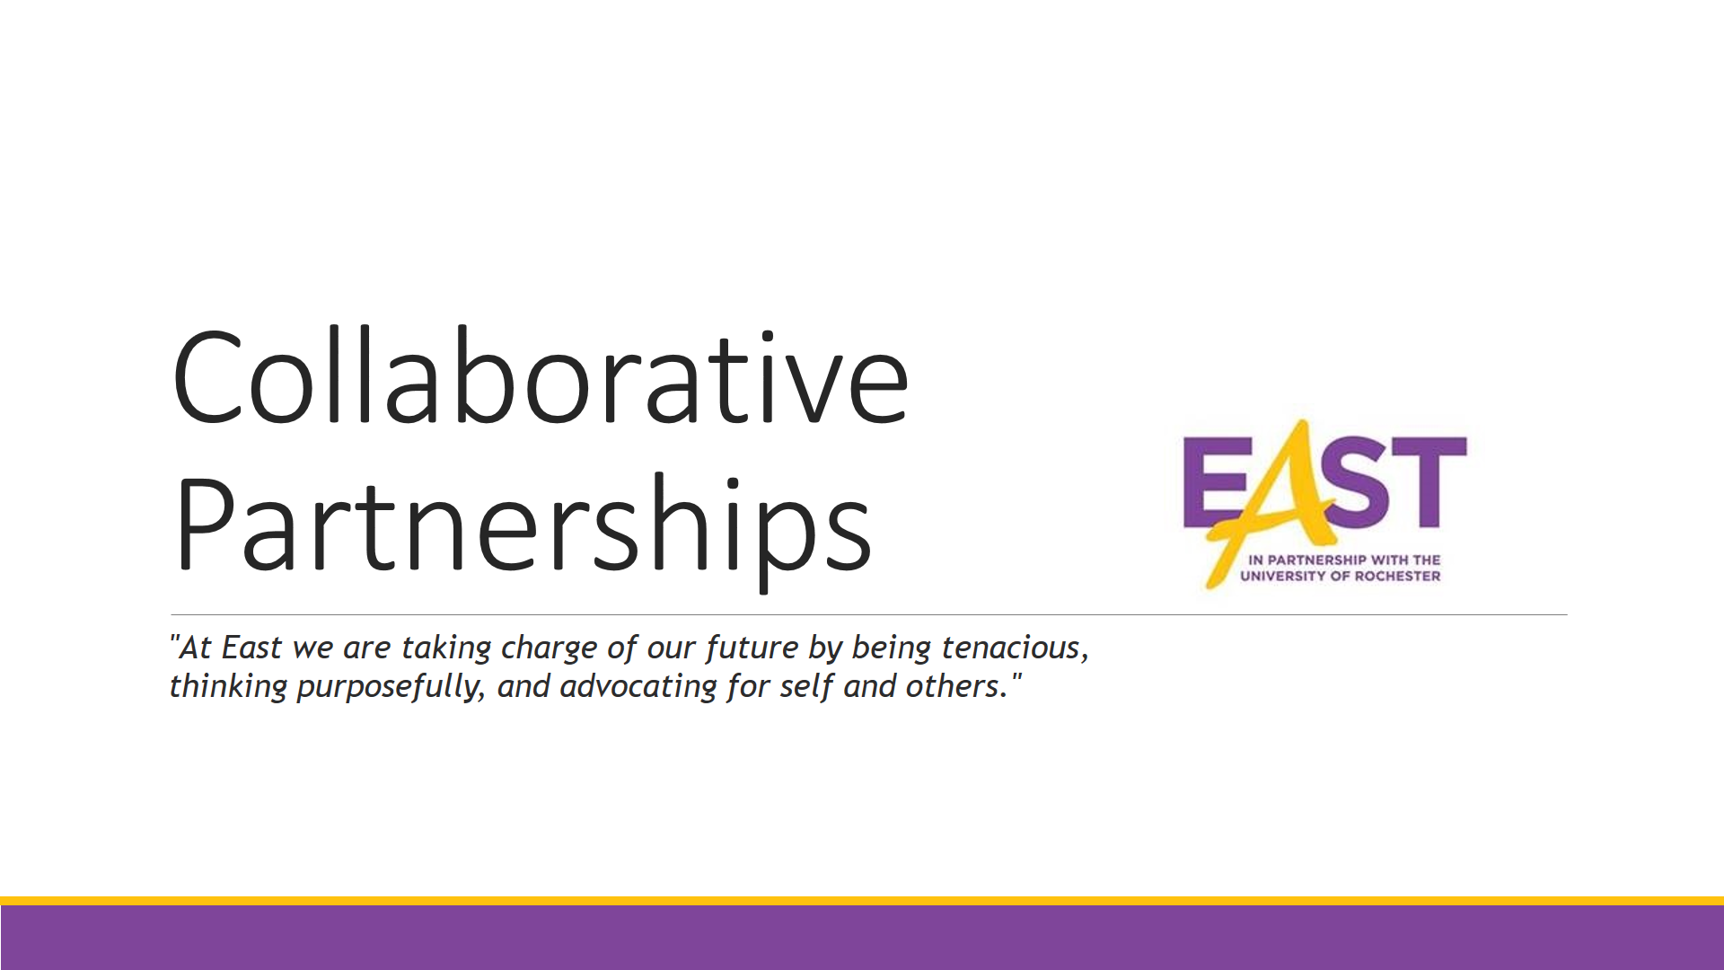

**Collaborative Partners**

Hello Everyone. Welcome to East. My name is Jason Taylor, and thanks for being here with me as we take a brief look at East’s collaborative partners. This short video will you help you to know what service providers work with East in order to support your scholar. At East there are number of local agencies and organizations that provide a variety of both academic and non-academic services to assist in each scholar’s success.

**Slide 3:**

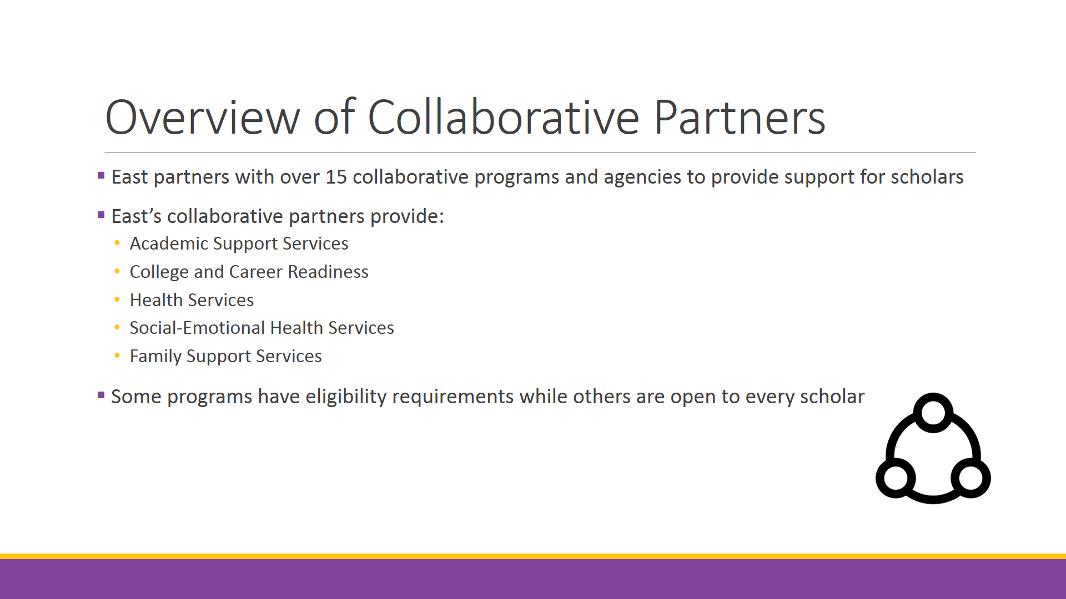

**Overview of Collaborative Partners**

To be more specific, we have over 15 collaborative agencies that provide a number of important services at East. Because this is only a brief overview, the agencies are presented here based upon a few categories in which they provide services, such as academic support, college and career readiness, physical health, social-emotional developmental health, and family support. However, most agencies provide services in multiple categories, so, again, they are only being presented in this way as an effort to be brief.

**Slide 4:**

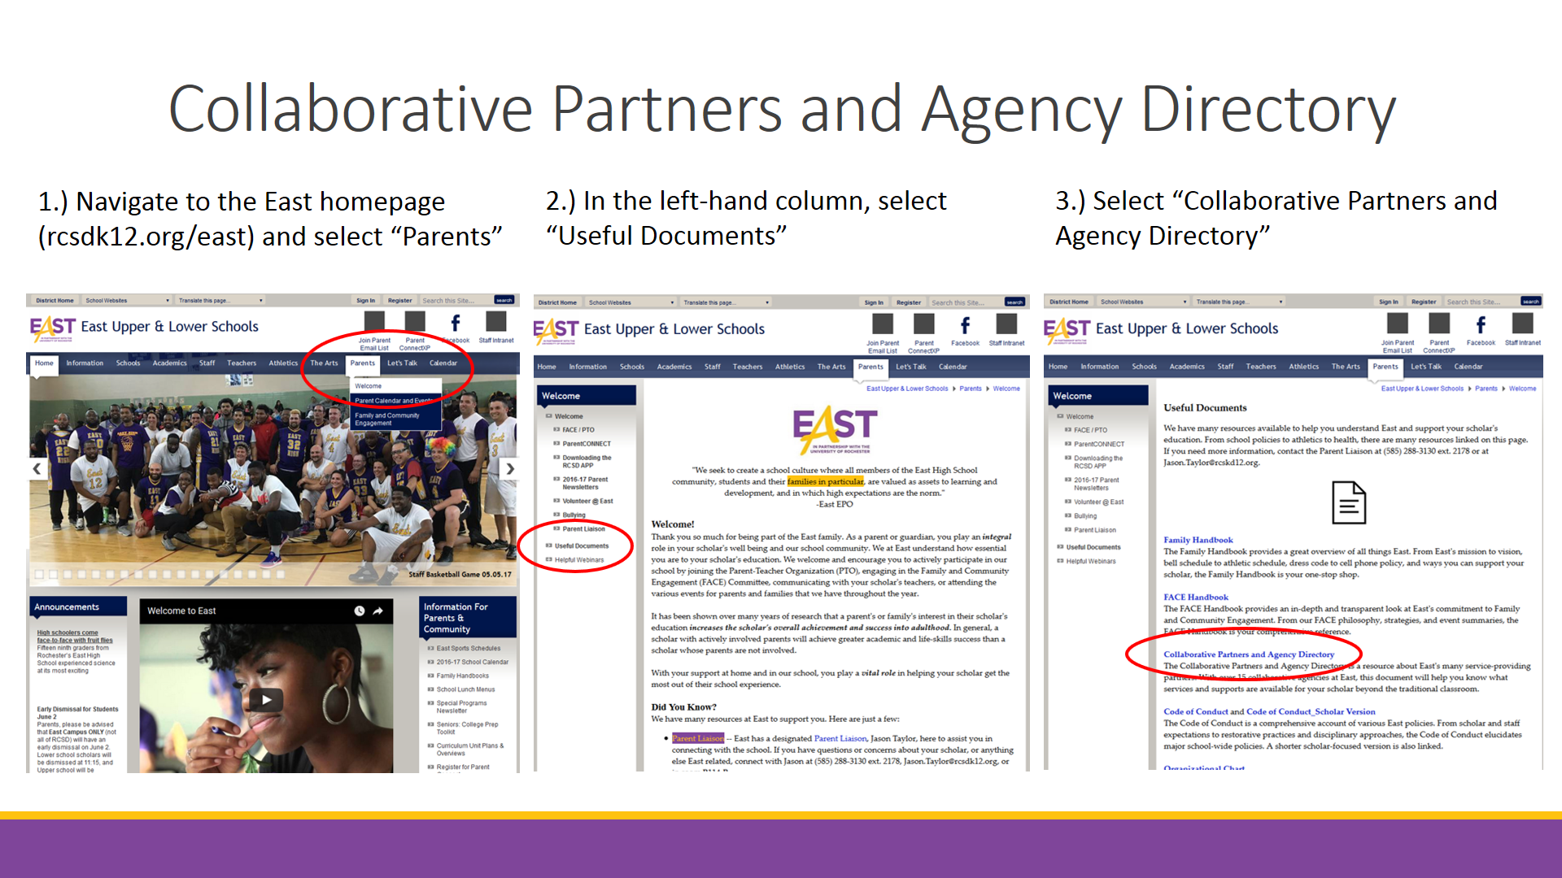

**Collaborative Partners and Agency Directory**

In order to find a full list of all of East’s collaborative partners, the services they provide, and whether or not your scholar meets their potential eligibility requirements, you can access our Agency Directory online. This document has *everything* you need to know about East’s collaborative partners. You can access it by first going online to the East webpage and selecting “Parents” in the main navigation bar. Then, on the Parent’s welcome page, select “Useful Documents” from the left-hand navigation bar. Lastly, select Collaborative Partners and Agency Directory for the comprehensive list.

**Slide 5:**

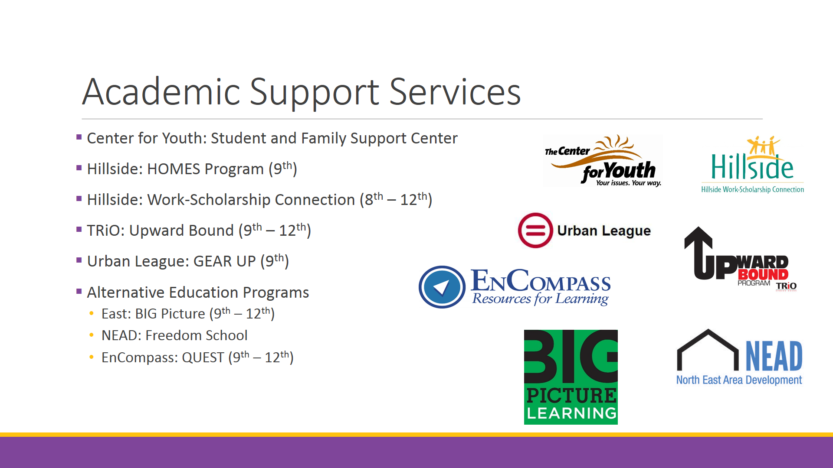

**Academic Support Services**

For now, let’s take a brief look at some of East’s collaborative partners. Succeeding in every class can be a challenge, so East has a number of service providers that can help your scholar with academic success. There is help available with one-on-one tutoring and mentoring, test preparation, and healthy study skills and habits. The best way to find out which program is right for your scholar is to view their services in the Collaborative Partners document.

In addition, East also has alternative educational programs that are designed to help scholars who may be behind track for graduation. These programs are also available in the Collaborative Partners document.

**Slide 6:**

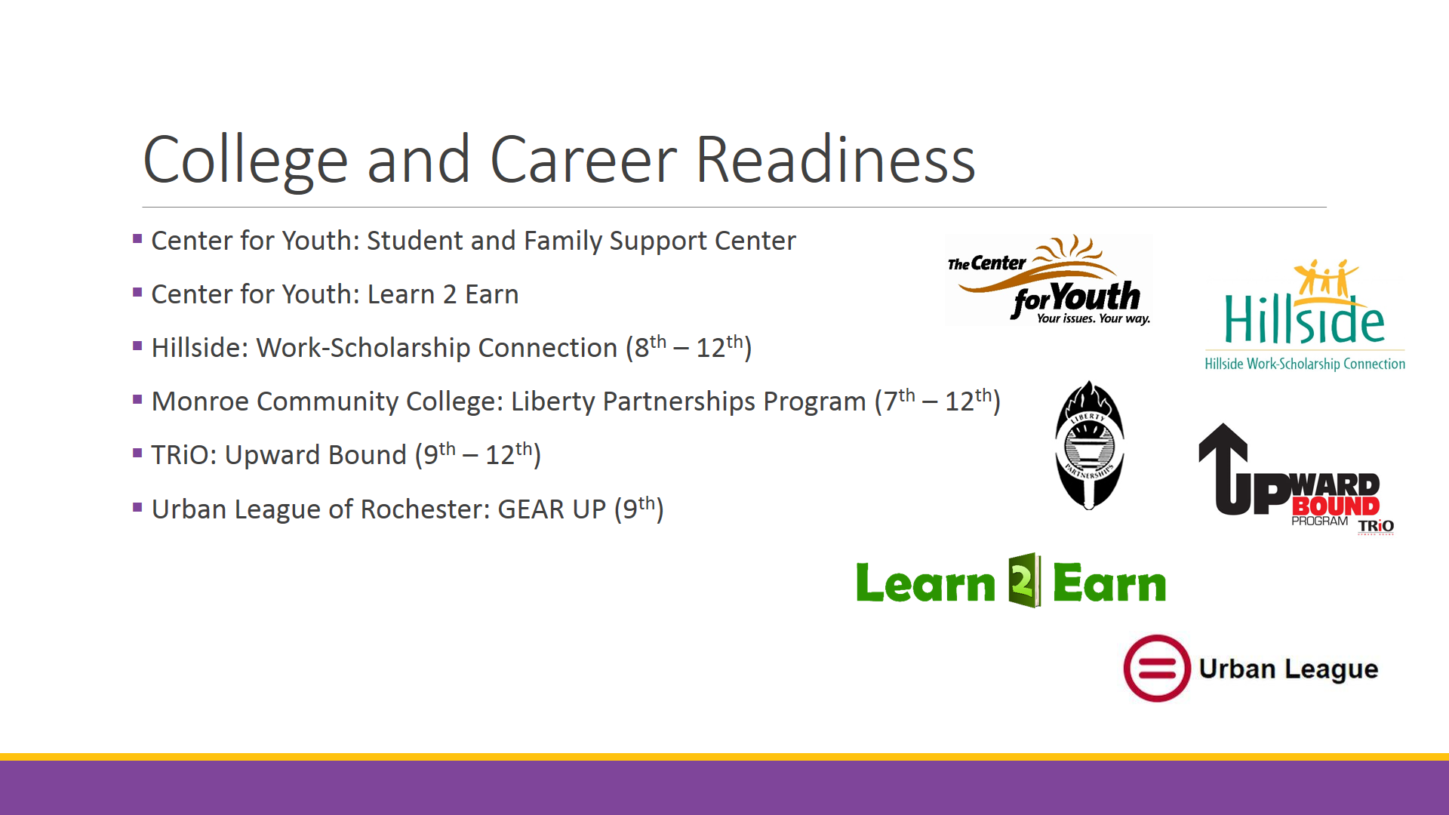

**College and Career Readiness**

As for preparing for post-high school plans, whether your scholar is off to a college or starting their career, it’s never too early to start planning. Thankfully, there are many service providers at East that can provide help with job searches, writing resumes and cover letters, interview practice, applying for scholarships and financial aid, searching for colleges, going on college tours, and SAT and ACT preparation. Again, check out the Collaborative Partners document to see which service provider or providers are the best for your scholar.

**Slide 7:**

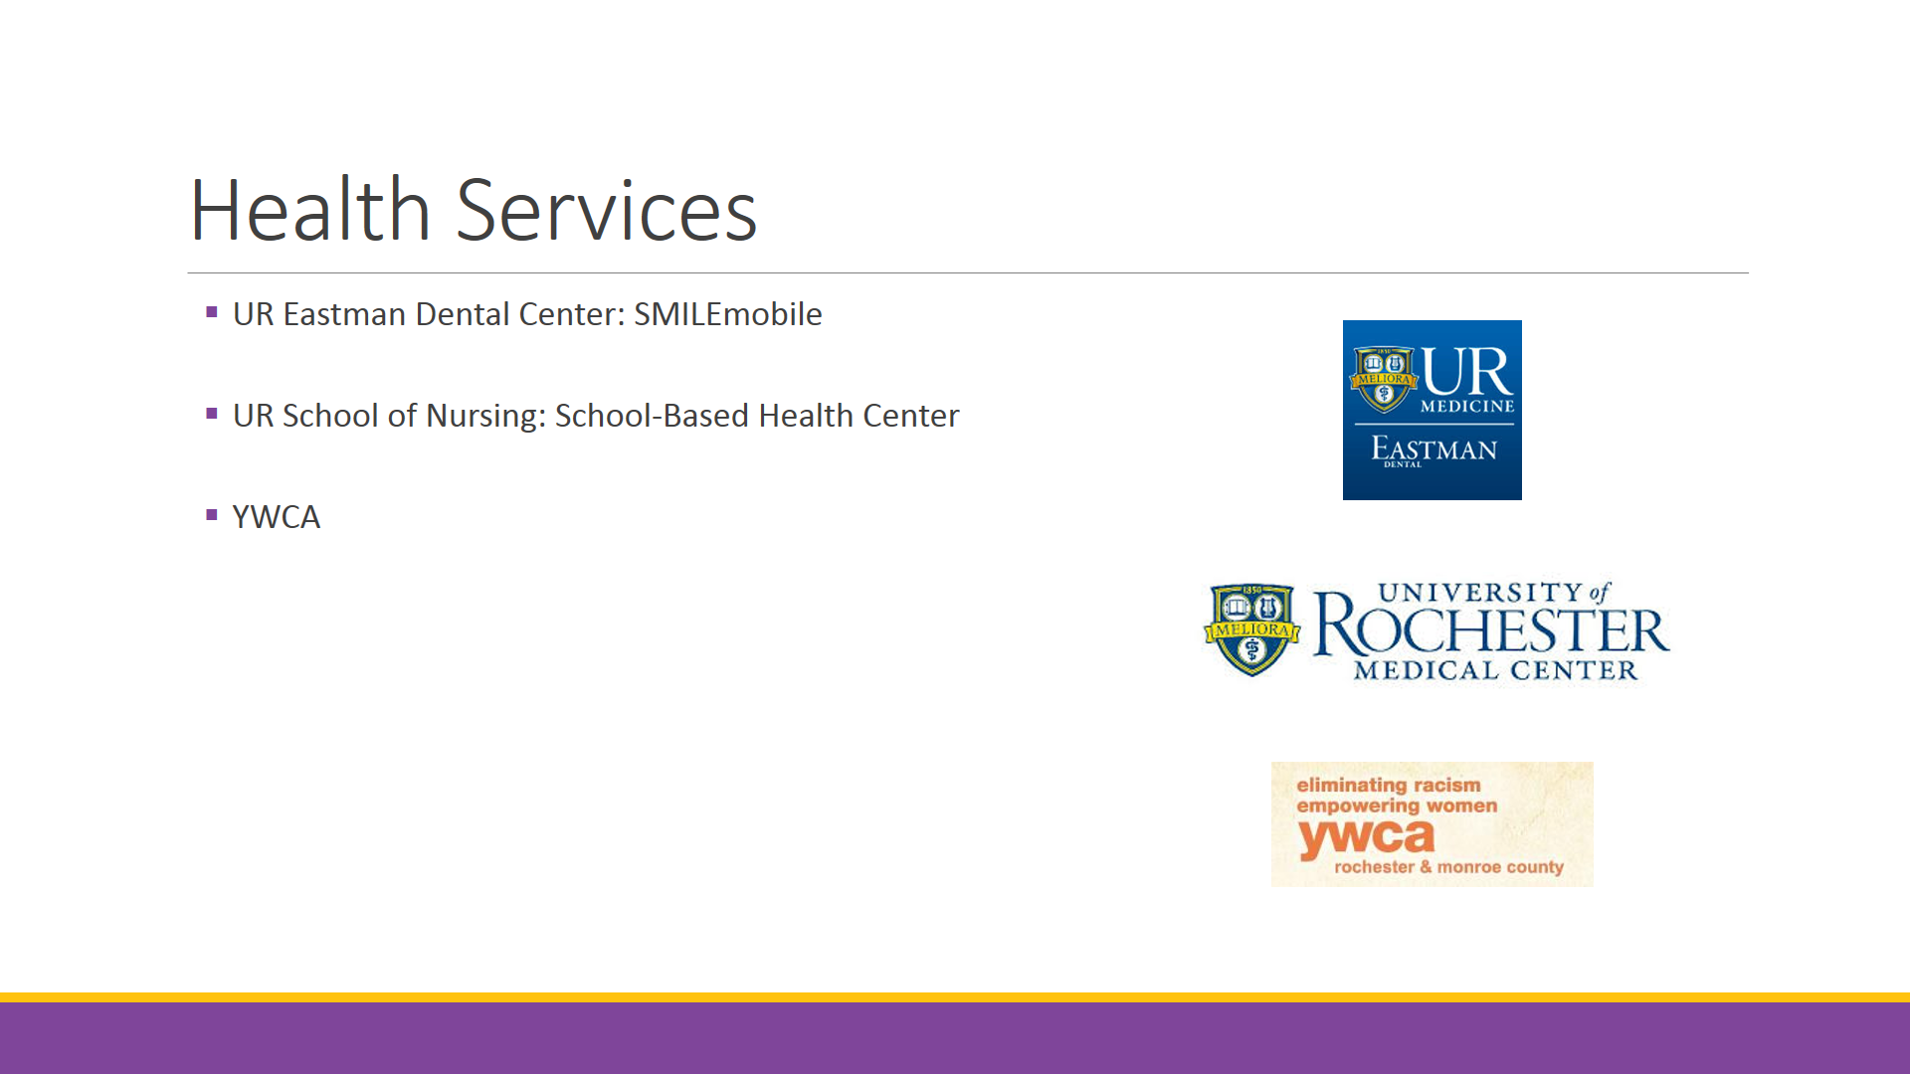

**Health Services**

One of the many things that makes East unique is its comprehensive physical and social-emotional health services. Your scholar may be eligible to receive *free* dental care *right at East*. Applications to use this incredible SMILEmobile service are available for pickup in the main office. Also, there’s a professional health center at East where your scholar can receive expert health care like they’d find at a doctor’s office. Lastly, the YWCA partners with East and offers, among other things, services to pregnant and parenting teens.

**Slide 8:**

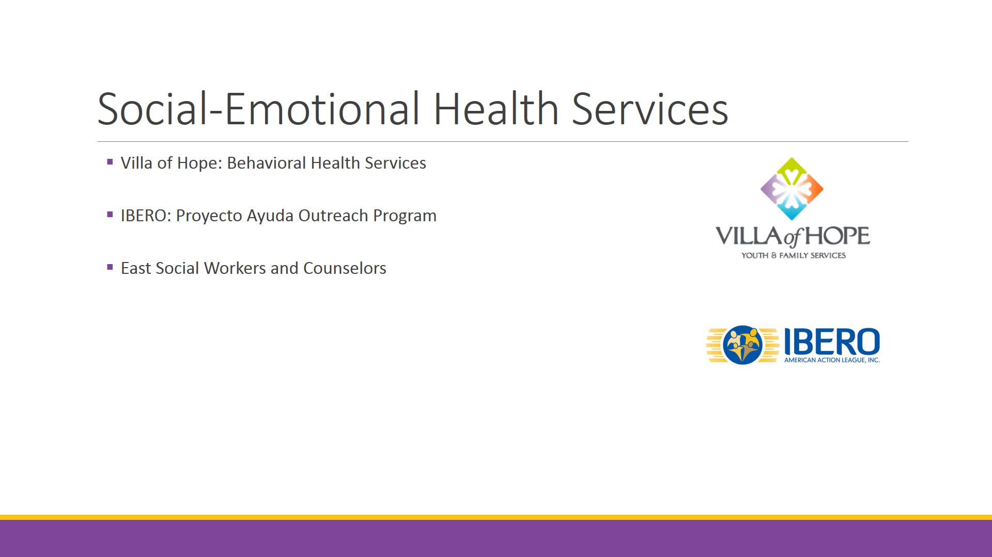

**Social-Emotional Developmental Health**

East also has partners that are available to provide social and emotional assistance to your scholars. For example, the Villa of Hope can help with emotional, behavioral, or relationship-based problems while Ibero’s Proyecto Ayuda Outreach can help with substance abuse issues.

**Slide 9:**

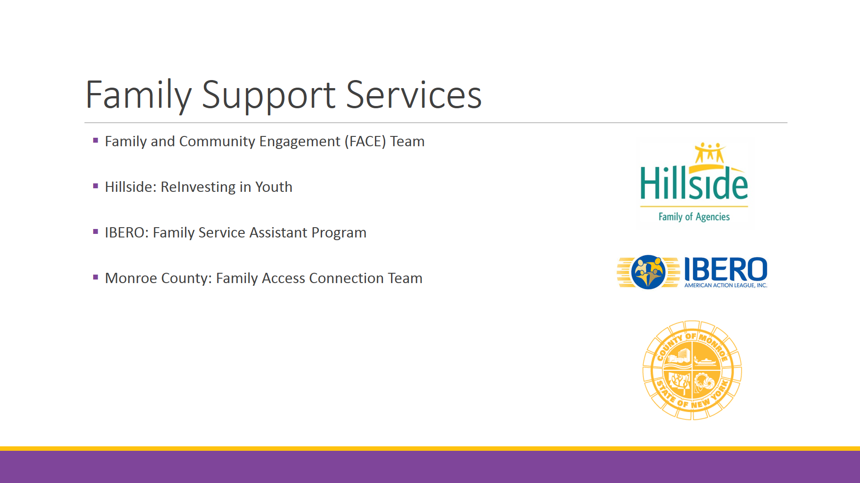

**Family Support Services**

Our last service-providing category is family support services. As a parent, you play an integral role in the success of your scholar’s education, and at East we have a number of ways to help you to do just that. From help with attending school functions, to building support networks, to helping your scholar navigate, as needed, the justice system, your active and caring involvement in your scholar’s education is something we are here to support through these service providers.

**Slide 10:**

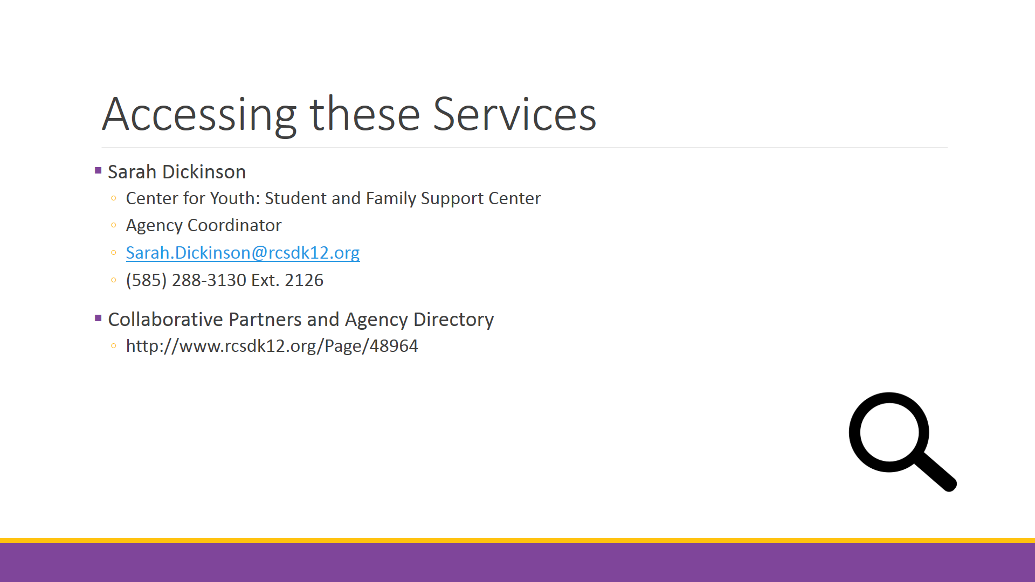

**Accessing these Services**

So that was a whirlwind tour through just *some* of East’s collaborative partners. They are all here to help your scholar succeed. Remember that you can learn more about each of these service providers by going online to access the Collaborative Partners and Agency Directory, or by contacting Sarah Dickinson, agency coordinator with the Center for Youth.

I hope this video helped you to learn not only what services are provided at East, but also how you can access these services. My name is Jason Taylor, and I’m the Parent Liaison. Don’t hesitate to reach out if you have any questions. Thanks for listening, and byby.