We are welcoming our future 7th graders with TWO summer science projects.

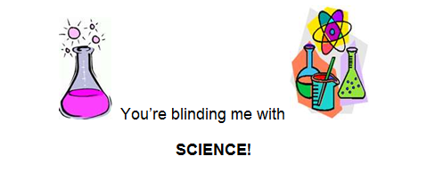

The assignments are to be completed and turned in to your science teacher by Friday, September 7th 2012.

**Assignment #1: Famous Scientist Paper**

Choose one scientist from the list on back and write a short research paper about that person. This paper can be typed or handwritten.

Your paper must contain all of the following:

* Picture or description of your scientist
* His or her birth date and birth place & date of death
* Why they are famous
* His or her accomplishments
* Give an example of how his or her contribution lead to changes in scientific thinking

Choose at least 3 additional facts from the following to include in your paper:

o Picture of their work

O Quote from your person

o Events that happened in history while your person lived

o Family information

o Where they attended school

**Assignment #2: Solitude and Reflection in the Natural World**

You need to find at least 30 minutes of your summer to sit alone in the natural world and just be an observer. Use your senses (smell, touch, sight, sounds, and taste (actually, skip this one ☺)) as you sit alone in a forest or field. Our city has many parks and you might need to visit one for this assignment. Let your family know where and when you go!

Record your observations and reflections on the capture sheet included. This will be turned in to your science teacher by Friday, September 7th 2012.

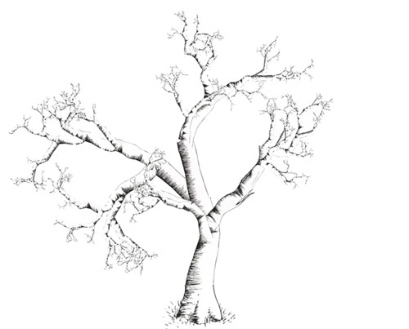

**Scientists to choose from:**

Mae Jemison George Washington-Carver Charles Henry Turner

Benjamin Bannekar Archibald Alexander Aprille Ericsson

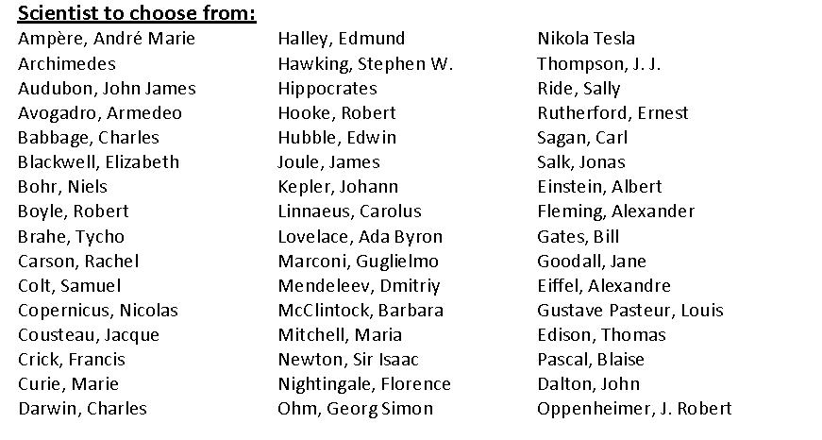

Name:_________________________ Return to Ms. Ortenzi by 09/07/12

**Assignment #2: Solitude and Reflection in the Natural World**

As you sit alone in nature, open your mind and senses to the natural world. Try not to think about other stuff, just enjoy the moment where you are right now.

Breathe. Take a few cleansing deep breaths and begin to notice what is around you. Breathe and relax.

After five or ten minutes, record some of your thoughts and observations in the data table below.

I observed the following (anything with your five senses):

|  |  |  |
| --- | --- | --- |
|  |  |  |
|  |  |  |
|  |  |  |

I reflected on (or thought about) the following:

|  |  |
| --- | --- |
|  |  |
|  |  |

Record anything else you would like to share about the experience here:

|  |
| --- |
|  |