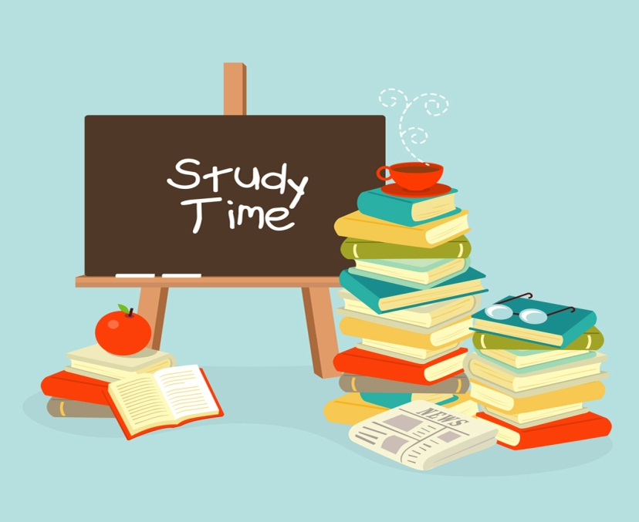
New York State School Report Card
Flower City School 54
TO: Parents of Sixth Grade
FROM: Miss Smith, Teacher ROOM: 110
RE: How to reach academic success for your child
Please come to discuss ways in which you can help your child achieve academic success.
We will talk about test-taking strategies and study skills that will improve your child’s progress.
DATE: TUESDAY, FEBRUARY 14, 2012
TIME: 5:00PM TO 6:00PM

