Instructions for completing the ParentCONNECTxp Registration Screen.

1. Complete the “Registration Information“ section with your information.

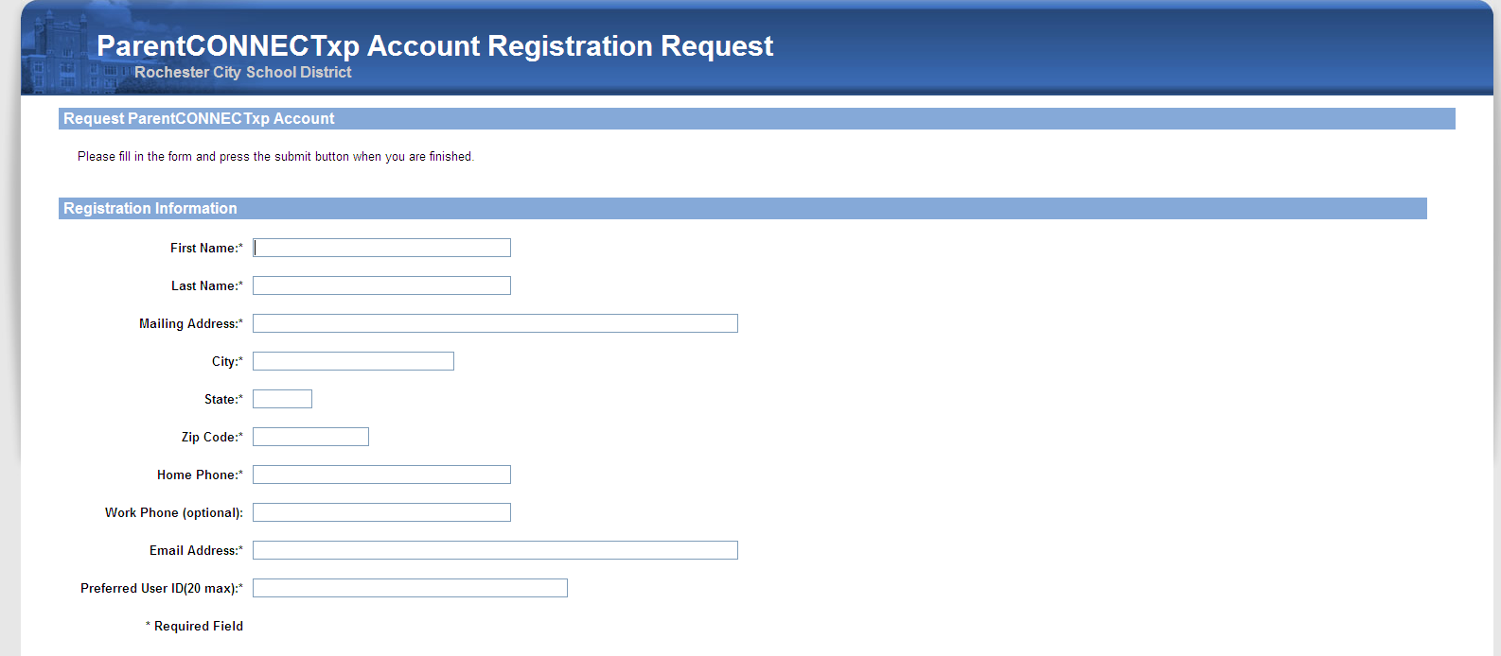

3. Complete the Student Information section with your student’s information. You will need to fill in the information and click “add to List” for each child.

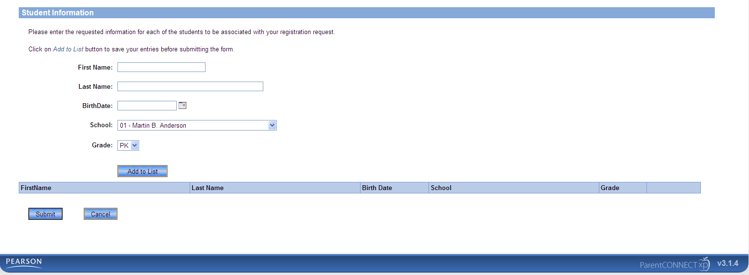

4. When you have finished entering your information, click the submit button.

Your information will be processed and sent to you within 5 business days.