Name _______________________________________________________ Period _______

Modeling the Collision of Air Masses

**Predict** what will happen when the center piece between the two masses of water is taken away . . .

**Write**: **Draw**:

**Observe** what happens to the water . . .

**Write**: **Draw**:

**Explain** why that happened . . .

**Write**: **Draw**:

Use the word bank to fill in the chart below.

Represented a warm air mass Flowed underneath

Represented a cold air mass Flowed above

Cold water More dense

Hot water Less dense

|  |  |
| --- | --- |
| **Blue Water** | **Red Water** |
|  |  |

**Make another prediction:**

1. In this P.O.E., we saw what happened when two water masses of different temperatures collided (ran into each other). What do you think happens when two **air** masses of different temperature collide?

____________________________________________________________________________________________________________________________________________________________________________________________________________________________________________________________________________________________________________________________________________________________________________

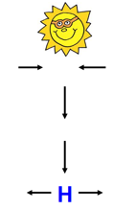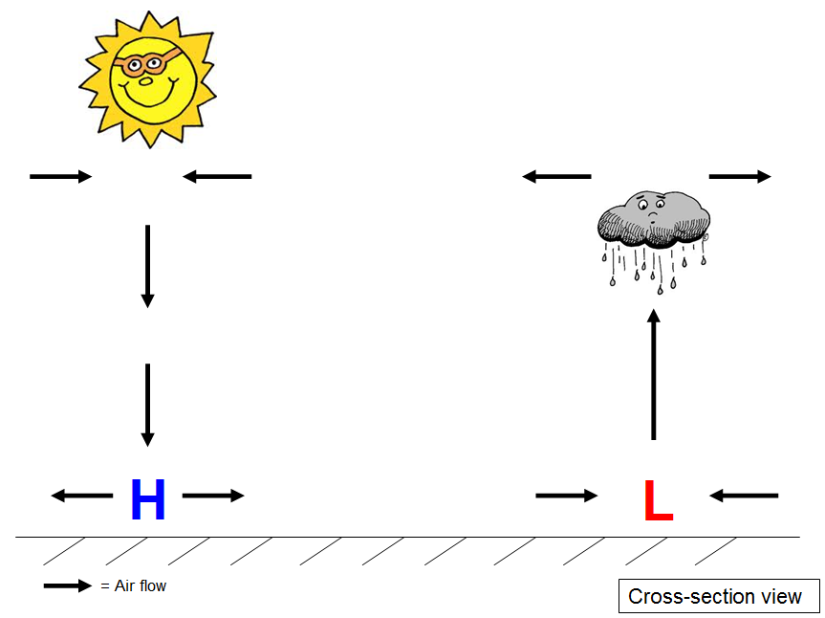Areas of **high-pressure** air are dry with **clear**, calm weather. **Low-pressure** air is generally moist with **cloudy**, unstable weather. **Local winds** move from areas of **high pressure to areas of low pressure.** An **air mass** forms when a body of air remains nearly stationary over a large section of Earth’s surface. The air takes its **temperature and humidity** from the region over which it forms. In the United States **air masses move from west to east**. This fact allows weather forecasts to be made. When an air mass moves over an area that is what causes local weather changes!

1. Identify the type of weather associated withan area of **high pressure**.

1. Identify the type of weather associated with an area of **low pressure**.

1. In which direction do local winds move?

1. In which direction do large air masses move?

1. What causes local weather changes?

**So, what happens when two air masses crash into each other?**

When two air masses meet, they do not mix together. A boundary (line) forms between these two air masses. This boundary is called a front. Weather **fronts** are the **boundaries between different air masses**. **Cold fronts** are composed of cooler air which is moving towards a specific area. **Warm fronts** are composed of warmer air that is moving towards a specific area. Precipitation is likely to occur at the boundaries when warm, moist air rises above the cooler air. When a front passes there is a change in weather. It causes cloud formation, winds, precipitation, and air pressure and temperature changes.

1. What is a front?

1. Identify two types of fronts named in the reading above.

**Front Simulation**

1. Log on to google classroom.
2. Click on the link underneath “Front Simulation”.
3. Read the purple box.
4. Click the X on the purple box when you are done reading.
5. Click the red dot next to the word “Animation” to watch what happens when a warm front comes into a region.
6. Observe what is happening. Pay attention to the words in the yellow box.
7. Answer the questions below about the warm front. (You can play the simulation again if you need to, or click on the numbers to see the steps one at a time.)
8. Click on the blue Cold Front.
9. Click the red dot next to the word “Animation” to watch what happens when a cold front approaches a region.

Words from the Video:

boundary = border; the line in between two things

likely = probable or probably

gradually = slowly

lasting = staying a long time

1. Observe what is happening. Pay attention to the words in the yellow box.
2. Answer the questions below about the cold front. (You can play the simulation again or click on the numbers to see the steps again.)
3. Answer the questions about comparing warm and cold fronts.

in relation to: compared to

(above, below, next to, etc.)

**Warm Front Questions:**

1. Describe how the warm air mass moves in relation to the cold air mass.

1. Describe what happens to the weather (clouds and precipitation).

**Cold Front Questions:**

1. Describe how the cold air mass moves in relation to the warm air mass.

1. Describe what happens to the weather (clouds and precipitation).

**Comparing Warm and Cold Fronts**

1. Which type of front causes longer lasting precipitation?

1. Which type of front causes quick, stormy weather with heavy precipitation?

1. Which type of front causes the weather to be humid and moist (wet)?

1. Which type of front brings in cooler air?

**Cold Fronts**

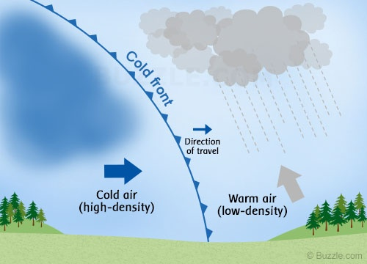A **cold front** forms when a cold air mass runs into a warm air mass. Since the cold air mass is more dense than the warm air mass, it pushes the warmer air up. The moisture in the warmer air quickly condenses (turns to water) along the top of the cold air mass. This forms tall thick clouds along the front. This produces **quick and severe precipitation.**

When you are looking at a weather map, the blue line with triangles is the symbol for a cold front.

1. Identify the type of weather associated with a cold front. _____________________________________________________________________
2. When you look at a weather map, what is the symbol for a cold front?

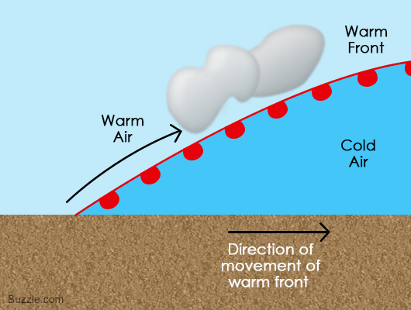**Warm Fronts**  
A **warm front** forms when warm air mass runs over a cold air mass. The less dense warm air rises over the denser cold air. However, it does not rise as quickly as when a cold front collides with a warm front. This causes long thin clouds to form along the front. This produces **long periods of precipitation** that can last hours. This precipitation is usually gentler than a cold front. When you are looking at a weather map, the red line with half-moons is the symbol for a warm front.

1. Identify the type of weather associated with a warm front. _____________________________________________________________________
2. When you look at a weather map, what is the symbol for a warm front?

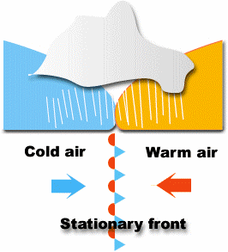**Stationary Fronts**

A **stationary front** forms when a cold and a warm front meet, but move very slowly relative to one another. The denser cold air sinks slowly under the warmer air mass. Clouds form very slowly. Stationary fronts can last for several days; this brings cloudy and wet weather for a longer period of time. They can last for a number of days until another air mass moves in with enough force to move the stuck air masses. When you are looking at a weather map, the interchanging line (every other shape is a blue triangle or red half-moon) is the symbol for a stationary front.

1. Identify the type of weather associated with a stationary front. _____________________________________________________________________
2. When you look at a weather map, what is the symbol for a stationary front?