Name Period

What will the weather be like tomorrow? Is it going to rain? Will it be sunny? Weather moves from place to place… but where does weather come from? Where does weather start?

Most weather comes from **air masses**. An air mass is a **huge body of air over a certain area**. Areas under an air mass have the same **temperature** and **humidity**. Humidity is how wet or how much moisture is in the air.

An air mass starts over an ocean or over a large section of land. As an air mass is over an ocean or land, it will pick up the temperature and humidity of the area it is over. For example:

* 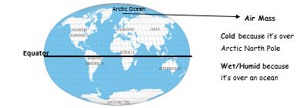If an air mass is over a cold ocean, like the Arctic Ocean, the air mass will take up moisture and coldness from the Arctic Ocean. This makes the air mass cold and humid.
* If an air mass if over hot land like Africa, the air mass will take up the dryness and heat from Africa. This makes the air mass warm and dry.

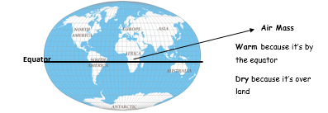

The temperature and humidity of an air mass is determined by where it is formed. When the air mass moves over a new location, it will bring that temperature and humidity to the new location. That’s how you get different weather conditions on each day!

1. What is an air mass?

1. Identify the two factors that air masses take from the area under which they form/
2. Identify the temperature of an air mass that forms above the North and South Poles.

1. Identify the temperature of an air mass that forms above the Equator.
2. Identify the humidity of an air mass that forms above land.

1. Identify the humidity of an air mass that forms above water.

Fill in the notes while Miss Kramer goes over them on the SMART board.

**Air Mass**:

**An air mass takes on the temperature and humidity of the area above which it formed. There are two different words we use to describe the temperature of an air mass.**



**Tropical:**

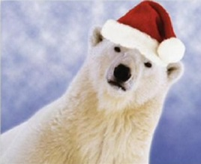

**Polar:**

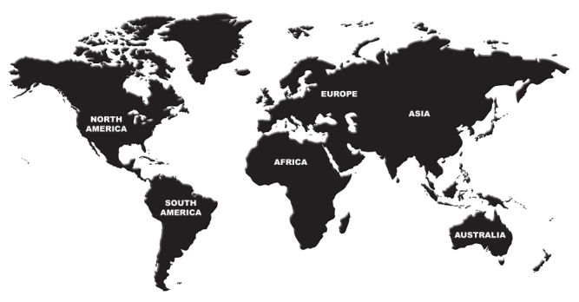**There are also two different words we use to describe the humidity of an air mass.**

**Continental:**

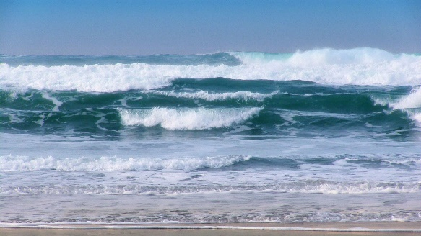**Maritime**:

There are four different types of air masses. Complete the table below to determine the names of the four types of air masses.

|  |  |  |
| --- | --- | --- |
|  | **Tropical (T)** | **Polar (P)** |
| **Maritime (m)** |  |  |
| **Continental (c)** |  |  |

1. What is the air like if there is a Maritime Tropical (mT) air mass above us? **Hint: talk about temperature and humidity**

1. What is the air like if there is a Continental Tropical (cT) air mass above us? **Hint: talk about temperature and humidity**

1. What is the air like if there is a Maritime Polar (mP) air mass above us? **Hint: talk about temperature and humidity**

1. What is the air like if there is a Continental Polar (cP) air mass above us? **Hint: talk about temperature and humidity**

**Station 1:**

**Look at the picture at this station to answer the following questions.**

1. What **temperature** do you think the air mass would be over this location?

1. What **humidity** do you think the air mass would be over this location?
2. What type of air mass would you expect at this location?
   1. Maritime Tropical (mT)
   2. Maritime Polar (mP)
   3. Continental Tropical (cT)
   4. Continental Polar (cP)

**Station 2:**

**Look at the picture at this station to answer the following questions.**

1. What **temperature** do you think the air mass would be over this location?

1. What **humidity** do you think the air mass would be over this location?
2. What type of air mass would you expect at this location?
   1. Maritime Tropical (mT)
   2. Maritime Polar (mP)
   3. Continental Tropical (cT)
   4. Continental Polar (cP)

**Station 3:**

**Look at the picture at this station to answer the following questions.**

1. What **temperature** do you think the air mass would be over this location?

1. What **humidity** do you think the air mass would be over this location?
2. What type of air mass would you expect at this location?
   1. Maritime Tropical (mT)
   2. Maritime Polar (mP)
   3. Continental Tropical (cT)
   4. Continental Polar (cP)

**Station 4:**

**Look at the picture at this station to answer the following questions.**

1. What **temperature** do you think the air mass would be over this location?

1. What **humidity** do you think the air mass would be over this location?
2. What type of air mass would you expect at this location?
   1. Maritime Tropical (mT)
   2. Maritime Polar (mP)
   3. Continental Tropical (cT)
   4. Continental Polar (cP)

Conclusion Questions: Complete each table for each type of air mass.

**Maritime Polar:**

|  |  |  |  |
| --- | --- | --- | --- |
| **Found over water or land?** | **Formed in cold climate or warm climate?** | **Symbol** | **What will the weather be like when a maritime polar air mass moves over a region?** |
|  |  |  |  |

**Maritime Tropical:**

|  |  |  |  |
| --- | --- | --- | --- |
| **Found over water or land?** | **Formed in cold climate or warm climate?** | **Symbol** | **What will the weather be like when a maritime tropical air mass moves over a region?** |
|  |  |  |  |

**Continental Polar:**

|  |  |  |  |
| --- | --- | --- | --- |
| **Found over water or land?** | **Formed in cold climate or warm climate?** | **Symbol** | **What will the weather be like when a continental polar air mass moves over a region?** |
|  |  |  |  |

**Continental Tropical:**

|  |  |  |  |
| --- | --- | --- | --- |
| **Found over water or land?** | **Formed in cold climate or warm climate?** | **Symbol** | **What will the weather be like when a continental tropical air mass moves over a region?** |
|  |  |  |  |