September 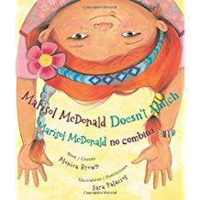
Marisol McDonald Doesn’t Match by Monica Brown and Sara Palacios
This book demonstrates how one little girl expresses her individuality and does not care what other people think. Just to mention a few things, she wears clothes that do not match. She prefers peanut butter and jelly burritos, and weird combinations of games during recess.

