Great News … the district’s technical community has completed the installation of the technology necessary to provide secure, reliable ‘Home Access’ to Chancery and PowerTeacher Gradebook.

Chancery SMS
Using your home system, simply point your Internet Explorer browser to:
https://sms.rcsdk12.org/chancerysms

PowerTeacher Gradebook
Using your home system, simply point your Internet Explorer browser to:
https://ptgprod.rcsdk12.org:8443/powerschool-gradebook/launchGradeBook.jnlp

Keep in mind that your home system is not your District system and the Help Desk is not prepared to assist with resolving your personal system issues. You must take accountability for ensuring your personal machine is aligned to the ‘Home System Configuration’ outlined below.

Report any issues you experience with to the Helpdesk during their normal hours of operation, Monday thru Friday 7:30 AM thru 4:30 PM.

Home Access Basics

You must have an established relationship with an ‘Internet Service Provider’ (ISP) to gain access from home.

For example Road Runner or Frontier DSL is an ISP service.

Sign on Process for Home Access to Chancery SMS
- Type the in the address for Chancery SMS access in the browser as identified above.
- The first security window will open up. This window will ask you if you wish to proceed. Then click ‘Yes‘.

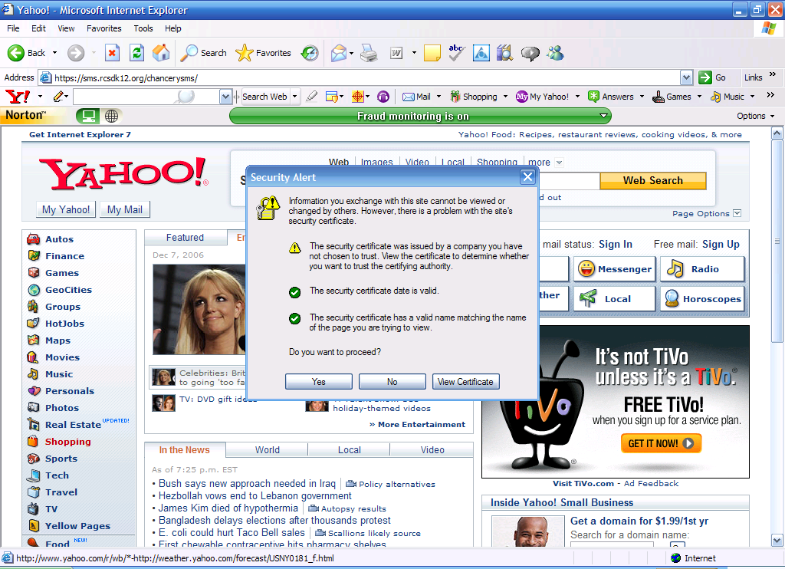

- After you click, yes, a window will open up for you to log into the district. Use the same sign on that you use when you sign onto your computer at work. Then click ‘OK’.
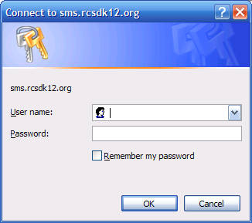
- The Chancery SMS sign on screen will open up. Use the same user-id and password that you use when you sign on to the Network at work. Then click ‘Log on’.
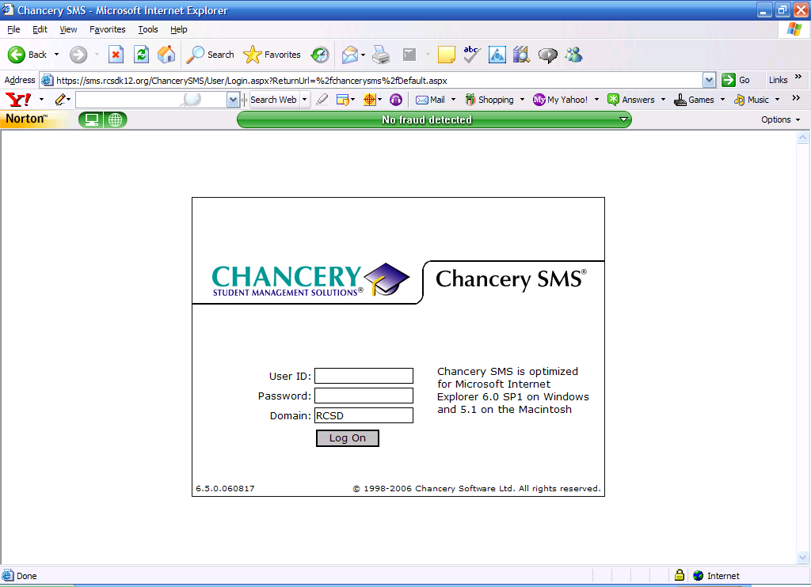

- Chancery SMS should open to your home page. You will be able to enter your grades as you would from school through PowerTeacher Gradebook if you customized your Home Page to ADD the PowerTeacher Gradebook link.

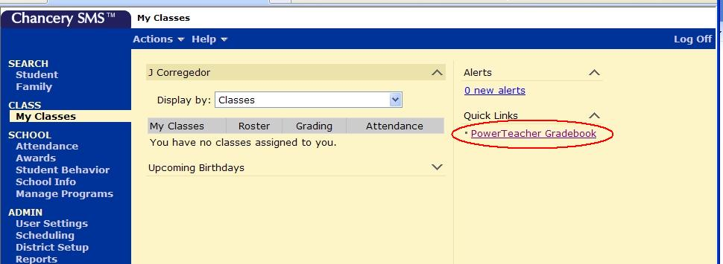
Home System Configuration

Internet Explorer Settings
- Accept cookies (default)
- Do not automatically store web pages on the hard drive
- Turn off autocomplete
- Enable active scripting (default)
- Disable Internet Explorer popup blocker (XP Only)
- Add SMS to trusted sites (XP Only)
- No Google bar, MSN bar or other IE add-ons & pop-up blockers

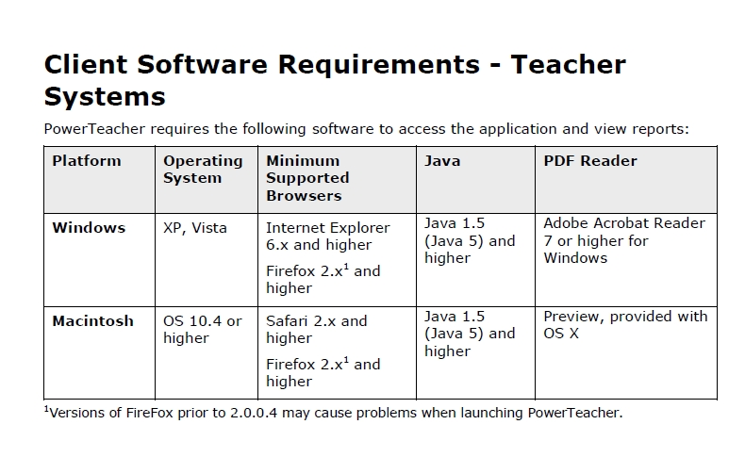

Important to Note: ‘Java’ is required for this application and our internal District computers have Java installed. However, people’s home PC’s have different configurations, so if, when attempting to open PowerTeacher Gradebook, you receive a message telling you that Java must be installed, please follow the below instructions and then try opening up PowerTeacher Gradebook once again.

Instructions for installing java....

Go to www.java.com<http://www.java.com> and click free java download.

