About pH
Name: |  | Period ______ | Date :
Bridge
 | Direction: Read passage below and answer the following paragraphs.  We hear the term acid rain all of the time in the news and the potential damage it may cause to vegetation. In our investigation on sugary drinks and our teeth, we found out that it was actually the carbonation that caused sodas to be acidic, which causes more damaged to our teeth than sugar does.  So, what is an acid?  If something is not an acid, what is it? |  |  |  | Objective:  To give students an introduction to the concept of pH as it relates to water
Essential Question:
What does a measure of pH tell us about a solution and how does it relate to water?

Mini Lesson
Share out responses from your bridge.

Directions: As a class we will read through the following information on pH, acids, and bases. Record questions for any part that is not clear through the reading. Once we have completed reading the information, speak with your partner about your questions. There will be a 5 minute class discussion following this to mak e sure we are clear before moving on to the work period task.

Remember polarity? What did it mean?
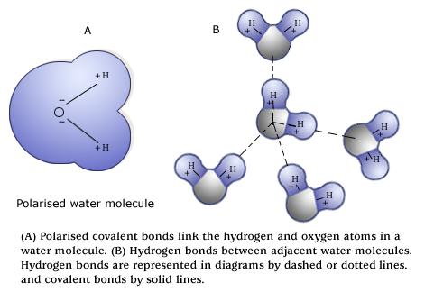
Dissociation of Water
When other things are added to water, the hydrogen bonds will often break. We call this dissociation. Water will form what we call ions: these are molecules that have an overall net charge.
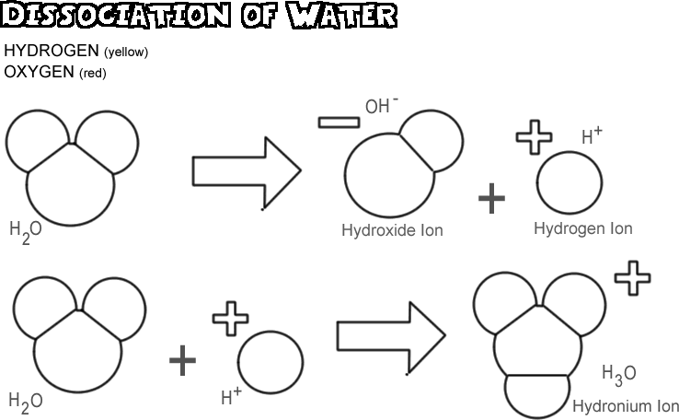

One of the water molecules will gain an H+ to become H₃O+ and one will lose the H+ to become OH-. We will simplify the hydronium (H₃O+) and just call it H+ to make it easier for us.

Acids
A solution is considered an acid, or acidic, when there are more H+ ions than water molecules or OH- ions. The more H+, the more acidic, but there will always be a little H2O and OH- in the solution.

Bases
A solution is considered a base, or basic, when there are more OH- ions than water molecules or H+ ions. The more OH-, the more basic, but there will always be a little H2O and H+ in the solution
Neutral
When there are an equal amount of H+ and OH- ions in a solution, we call it neutral. Pure water is neutral, obviously. Most organisms prefer neutral environments, but there are some exceptions and they have evolved to be able to survive in a small pH range as opposed to one specific pH.

Measuring pH

pH is measured on a scale from 1-14, with 7 being our neutral point since it is in the middle. The lower the number on the scale, the more acidic. Conversely, the higher the number on the scale, the more basic the solution. The further we get away from the neutral environment, the more damaging it can be to living things.

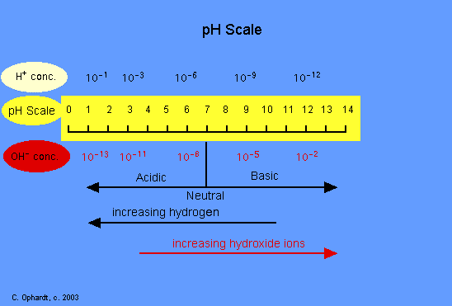

Work Period
Task: Create a visual representation of the pH scale using molecules in a solution. You need to include
- A pH scale from 1-14
- A visual of a strong acid, weak acid, neutral solution, a weak base and a strong base using H+ and OH- ions and H2O molecules.
- A key to show the reader your understand the ions and their different concentrations in each solution
- Correct placement of the solutions onto your pH scale

You may complete this however you choose: you can use an app on the Ipad (like whiteboard) or paint on the netbooks or you can do this as a hard copy of the assignment using the materials provided (paper, markers, stickers, masking tape, etc) and then turn that in OR take a CLEAR picture of it and electronically submit it. You could use a combination of the above as well.

This is due at the end of class….. no exceptions.

Summary
What does a measure of pH tell us about a solution and how does it relate to water?

Closing
Most living things do best in a “neutral” environment, although there are some exceptions to this rule. Using the properties of water that we talked about the last couple days and the information on pH, predict:

The effect of an acidic solution on a living thing:

The effect of a basic solution on a living things:

Name: | Period ______ | Date :
Independent Practice
Reading on acids and bases with questions for deeper understanding

Acids and Bases Are Everywhere
Every liquid you see will probably have either acidic or basic traits. Water (H₂O) can be both an acid and a base, depending on how you look at it. It can be considered an acid in some reactions and a base in others. Water can even react with itself to form acids and bases. It happens in really small amounts, so it won't change your experiments at all. It goes like this:
2H₂O --> H₃O⁺ + OH⁻

See how the hydrogen ion was transferred?
Most of the time, the positive and negative ions in distilled water are in equal amounts and cancel each other out. Most water you drink from the tap has other ions in it. Those special ions in solution make something acidic or basic. In your body there are small compounds called amino acids. The name tells you those are acids. In fruits there is something called citric acid. That's an acid too. But what about baking soda? When you put that in water, it creates a basic solution. Vinegar? Acid.

What makes an acid or a base?

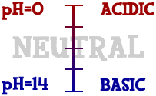
A chemist named Svante Arrhenius came up with a way to define acids and bases in 1887. He saw that when you put molecules into water, sometimes they break down and release an H⁺ (hydrogen) ion. At other times, you find the release of an OH⁻ (hydroxide) ion. When a hydrogen ion is released, the solution becomes acidic. When a hydroxide ion is released, the solution becomes basic. Those two special ions determine whether you are looking at an acid or a base. For example, vinegar is also called acetic acid. (Okay, that gives away the answer.) If you look at its atoms when it's in water, you will see the molecule CH₃COOH split into CH₃COO⁻ and H⁺. That hydrogen ion is the reason it is called an acid. Chemists use the word "dissociated" to describe the breakup of a compound.
Scientists use something called the pH scale to measure how acidic or basic a liquid is. Although there may be many types of ions in a solution, pH focuses on concentrations of hydrogen ions (H⁺) and hydroxide ions (OH⁻). The scale measures values from 0 all the way up to 14. Distilled water is 7 (right in the middle). Acids are found between 0 and 7. Bases are from 7 to 14. Most of the liquids you find every day have a pH near 7. They are either a little below or a little above that mark. When you start looking at the pH of chemicals, the numbers can go to the extremes. If you ever go into a chemistry lab, you could find solutions with a pH of 1 and others with a pH of 14. There are also very strong acids with pH values below 1, such as battery acid. Bases with pH values near 14 include drain cleaner and sodium hydroxide (NaOH). Those chemicals are very dangerous. (Information from Chem4kids)

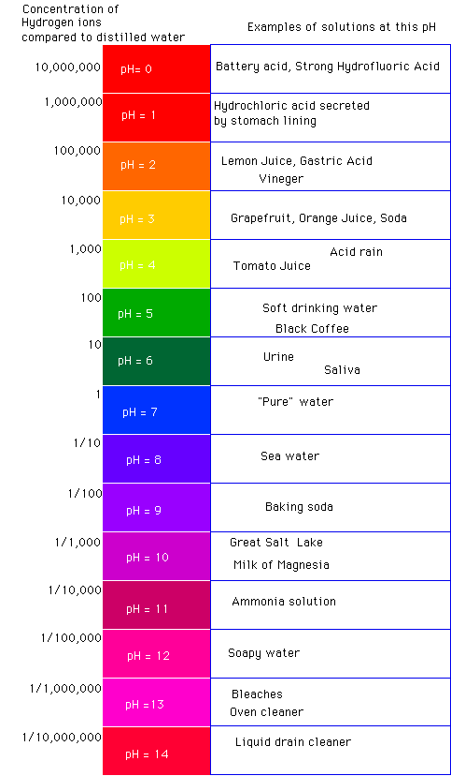

For additional information, watch the following videos:
http://www.brainpop.com/science/matterandchemistry/acidsandbases/
http://www.brainpop.com/science/matterandchemistry/phscale/
http://www.brainpop.com/science/ourfragileenvironment/waterpollution/

To login
User Name: rochestercity
Password: student

Answer the following questions based on the reading and on the videos:
- What can you infer from the fact that minor changes in water temperature can kill entire species?
- Many species are not well suited to their natural habitats
- Many species are extremely sensitive to changes in their environments
- Many species have extremely weak immune systems
- Many species that live in water once lived on land
- Bodies of water often neutralize foreign substances. What does this mean?
- The water cools down hot substances
- The water turns foreign substances into food
- The water makes potentially dangerous substances harmless
- The water makes potentially dangerous substances even more dangerous
- Which pollutant is most commonly released into waterways by families and individuals?
- Laundry detergent
- Hot water that’s been used to cool heavy machinery
- Pesticides and fertilizers
- Chemicals like benzene and PCBs
- Which of these substances is acidic?
- Water
- Floor cleaner
- Baking soda
- Lemon juice
- What is the most likely pH of a tube of toothpaste?
- 3
- 5
- 7
- 9
- How is a standard hydrogen atom different from a hydrogen ion?
- A hydrogen ion has an extra electron
- A hydrogen ion is missing an electron
- A hydrogen ion has an extra proton
- A hydrogen ion is missing a proton
- What might happen if you mixed a strong acid with an equally strong base?
- You would see an explosive chemical reaction
- The acid would destroy the base
- The base would destroy the acid
- You would wind up with a pH-neutral substance
- What might happen if buffers did not exist within the human body?
- Our blood and other bodily fluids might become too acidic or too basic
- Out stomach acid would not be able to break down food
- We would not be able to process glucose within our cells
- We would not be able to inhale oxygen into our lungs
- What might happen if acidic chemicals were emitted into the air by factories?
- The acid would destroy metallic elements in the air
- The acid would be neutralized by bases in the clouds
- Acid rain might destroy ecosystems and farmland
- Violent chemical reactions would take place within the atmosphere
- Healthy environments have a pH closest to
- 1
- 3
- 7
- 10
- What happens immediately after you dissolve acid in water?
- Positively charged hydrogen atoms are released
- Hydronium ions are released
- Negatively charged hydrogen atoms are released
- Neutrally charged hydrogen atoms are released
- Acids are caustic to the touch. In this context, what does “caustic” mean?
- Stinging or burning
- Pleasant
- Sarcastic
- Gentle
- An hydronium ion is like a(n) molecule with an extra hydrogen atom.
- Acid
- Base
- Water
- Vinegar
- What is a property of a base?
- Slippery touch
- Sour taste
- Ability to dissolve metal
- Ability to form hydronium ions
- How do acidic solutions taste?
- Delicious
- Sweet
- Bitter
- Sour
- Which of the following would be classified as a base?
- Apple juice
- Ginger ale
- Baking soda
- Distilled water
- pH stands for
- potency of hydrogen
- Plurality of hydrogen
- Potential of hydrogen
- Pleurisy of hydrogen
- What do acids and bases have in common?
- They both eat away at metal
- They both conduct electricity
- They both have a sour taste
- They both form positively charged ions when dissolved in water
- Acids and bases combine to form
- Salts and juice
- Water and chlorine
- Water and salts
- Hydroxide and hydronium
- In terms of H+ and OH- ions, explain the difference between acids and bases.

