LOCAL TAP SHOE SUPPLIERS

- Bailey Slipper Shop
3300 Monroe Ave.
Pittsford Plaza Mall (across from Pittsford Plaza)
381-2520

Students receive a 10% discount at Bailey’s when they present a SOTA ID or bus pass.

Please look in the yellow pages under “dance apparel” for more stores, and call before going to make sure they are open.

You can also order shoes through a catalog or online. Two good stores are:

- Discount Dance Supply
www.discountdance.com
1-800-328-7107

- Dance Distributors
www.dancedistributors.com
1-800-333-2623

Both stores offer a wide range of styles starting at $14. A customer service representative can help you with sizes.

*UNTIL YOU HAVE YOUR TAP SHOES:
You must participate in class by wearing socks, bare feet, or another type of dance shoe.
Please see me immediately if you have questions or problems!

TAP SHOE STYLES

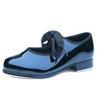
GOOD: 1. Basic patent leather tap shoe ($10-20)

Comments: This shoe is fine for the beginner. It is the least expensive shoe, but it does not sound as good as the other styles. If you think you might want to go on in tap, you should invest in a better shoe.

BETTER: 2. For Women: Mary Jane tap shoe and
character tap shoes with different heels
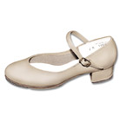
($30-60)

Comments: These will produce a better sound. I do not recommend shoes with high heels because they are not as supportive and do not produce a great heel sound.

EVEN BETTER: 3. Jazz tap shoe or oxford tap shoe--with ties
or elastic ($10-$50)
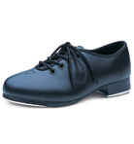
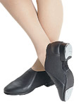

Comments: These offer great support and sound!

BEST: 4. Jazz tap shoe or oxford tap shoe with
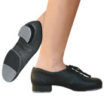
reinforced toe and split sole ($45-70)

Comments: The toe helps with toe stands, and the split sole gives the shoe greater flexibility. Great for advanced tappers.

