Name:________________________________ AP ENGLISH – Independent Reading Assignment #2
Due: November 3
“Que va,” the boy said, “It is what a man must do.”
Directions: Carefully review each of the SIX TASKS below before you begin reading, in order to focus your reading. Once you have finished, complete each task below – typed, MLA Format.
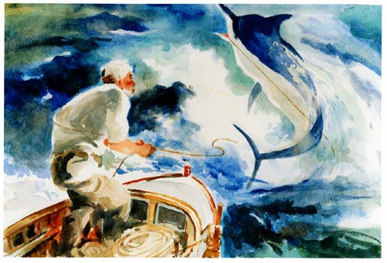

Task 1: Lessons on MANLINESS (WOMANLINESS) from Old Man and the Sea, by Ernest Hemingway:
1) choose one of the following quotes,2) turn it into a claim following the Rhetorical Précis format, 3) further examine the quote and thoroughly explain what it means, 4) then find one example from the novel to support the claim, 5) Explain why your evidence supports the claim.
- “A man is not made for defeat.”
- A man does not depend on luck.
- A man bears pain and hardship without complaint. – Grace Under Pressure
- A man does not boast.
- A man finds inspiration from others.
- A man goes down swinging–no matter his age.
- A man’s legacy comes from maintaining his integrity.

Task 2: Possessions-answer each question below:
What does Santiago possess that is not essential to his survival as a fisherman? What do you possess that is essential to your survival? What might we learn from the differences?

Task 3: Motif – The literary device ‘motif’ is any element, subject, idea or concept that is constantly present through the entire body of literature. Using a motif refers to the repetition of a specific theme dominating the literary work.
Find at least TWO examples of the BASEBALL motif used throughout the novel – explain the metaphorical or allegorical meaning of each example as compared with Santiago.

Note: Joe DiMaggio born Giuseppe Paolo DiMaggio, nicknamed "Joltin' Joe" and "The Yankee Clipper", was an American Major League Baseball center fielder who played his entire 13-year career for the New York Yankees. He is perhaps best known for his 56-game hitting streak (May 15 – July 16, 1941), a record that still stands.(Wikipedia)

Task 4: Remind yourself of the passage below and then answer the question which follows:
“He was very fond of the flying fish as they were his principal friends on the ocean. He was sorry for the birds, especially the small delicate dark terns that were always flying, and looking and almost never finding, and he thought, ‘the birds have a harder life than we do except for the robber birds and the heavy strong ones. Why did they make the birds so delicate and fine as those sea swallows when the ocean can be so cruel? She is very kind and beautiful. But she can be so cruel and it comes so suddenly and such birds that fly, dipping and hunting, with their small sad voices are made too delicately for the sea.’”

Think about what you learn about the old man’s feelings about the sea and its creatures here, and in one or two other moments in his voyage. Then write a claim, that Hemingway would support, about one’s relationship with nature, supported by one or more rhetorical strategies Hemingway utilizes to develop this claim. (Task 4 continues next page)

What to do
1. Locate the passage in the text, read it in context and think carefully about the old man’s feelings, remembering that they are almost always in conflict with each other.
2. Try to get to the feelings and write about them, making sure you include an explanation of the language Hemingway uses to describe them.
3. Think of another passage in which Santiago’s feelings are prominent.
4. Tease out the strands of feelings. Write about them, supporting what you say with some consideration of the writer’s rhetorical strategies used to convey his message.

Task 6: Choose two passages and complete a graphic organizer similar to the GO on pages 51-53 of AP Text.

Task 5: Assert whether you believe Santiago is a Success or a Failure and support your position. Your response should be no less than two paragraphs.

Spanish words:
- Manolin is the diminutive (shortened) Spanish name for the Biblical Emmanuel, the redeemer.
- Santiago from the Canary Isles, is the Spanish name for St. James, whose body was found in a rudderless, drifting boat. It was enshrined at Compostella in Spain. It rapidly became and remains one of the holiest of all Roman Catholic shrines. Biblically a fisherman, then a fisher of men. St. James was the patron saint of the conquistadores, the Spanish conquerors of the Caribbean and South America, who believed they were bringing heroic values to the New World.
- The Virgin of Cobre (whose picture is in the old man’s shack) was a statue of the Virgin Mary (mother of Jesus) which was found floating in the sea and brought to Cuba in 1628. It was lodged in the sanctuary of the chapel of Our Lady of Charity in Cobre, a small town in south east Cuba. In 1916 she was declared the patroness of the island. We are to assume that Santiago’s wife has brought it back from a pilgrimage to the chapel.
- salao– really bad luck
- agua mala– evil water: i.e. the jellyfish
- gran ligas– big leagues
- el campeon– the champion
- Brisa – wind

