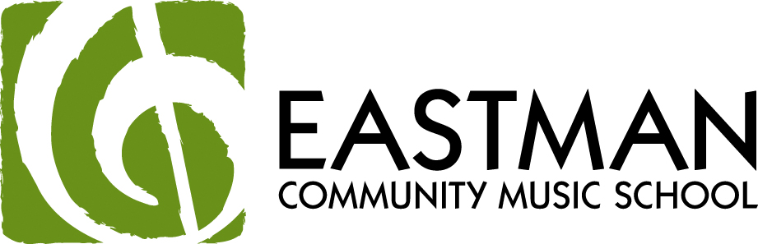

EASTMAN PATHWAYS

ANNOUNCING A MUSIC SCHOLARSHIP OPPORTUNITY
FOR ROCHESTER CITY SCHOOL DISTRICT MUSIC STUDENTS

Dear Music Student and Parents,

Would you like to study your musical instrument at Eastman? It’s possible through the Eastman Pathways scholarship program, part of a continuing partnership between the Eastman School of Music and the Rochester City School District. A limited number of Eastman Pathways tuition scholarships are available for study in Eastman’s Community Music School (ECMS) for 2012-2013. Eastman Pathways is for RCSD music students and offers weekly instruction on all band and orchestra instruments, plus piano and guitar, or vocal instruction through the Eastman Children’s Choir (5th-8th) or Eastman Youth Chamber Singers (9th–12th), or in private voice lessons (9th-12th). Jazz instruction is available on most instruments.

ELIGIBILITY:
- New applicants must be in 4th-10th grades
- All instrumental applicants must have played their instrument for at least one year and audition on a NYSSMA solo. No beginning students are accepted in the program
- All applicants must be
  - in good academic standing (grades are checked in June) and have no disciplinary referrals
  - a participant in the school music program and continue in 2012-2013
  - recommended by their RCSD instrumental, vocal or general music teacher
- Students attending SOTA must be registered in a music ensemble

FINANCIAL INFORMATION FOR PARENTS:
- Students whose families earn under $40,000 will receive full tuition scholarships. All other scholarships will be awarded on a sliding scale. Acceptance is based on the quality of student audition and teacher recommendation, not income.
- Although not looked unless a student is selected, Parents must submit a copy of page 1 of their 2011 IRS form (1040, 1040A or 1040EZ) on which the student is claimed as a dependent.
- All students are required to pay a $20.00 annual registration fee. In addition, if a theory class is taken, there may be a fee (up to $25/semester) for theory text/materials.

APPLICATION PROCEDURE:

March 3: Attend the Eastman Pathways Open House, 2:00-4:30 p.m., to learn about the program.

March 3-17: Complete the application in person at the ECMS Office, 3rd floor, Messinger Hall 10 Gibbs Street (corner of Gibbs and East Avenue) Monday-Friday, 9:00 a.m. - 6:00 p.m., or Saturday, 9:00 a.m. - 2:00 p.m.
You will need to bring:
- Copy of the parent’s 2011 IRS form (2010 if 2011 not available) with Adjusted Gross Income in a sealed envelope.

March 26-31: Call the ECMS office (274-1400) to schedule an audition time. You will need to specify your instrument and give the name and composer of the solo you will perform.
- Audition days: Friday, April 27, 3-7 p.m., or Saturday, April 28, 12:00-7:00 p.m.
- Expected audition materials include: scales and a solo that demonstrates your highest level of achievement in tone and technique.
  - We recommend that 4th-5th graders perform a NYSSMA solo at level 1 or higher
  - 6th-8th graders perform a level 2 or higher
  - 9th-10th graders perform level 3 or higher
  - Do not bring band or orchestra music. Sight-reading will be given. Students must be proficient in note reading.
  - Have your RCSD teacher help you select a solo. Elementary choral students should sing a standard song like My Country Tis of Thee, My Favorite Things or Edelweiss or another traditional song.
- All auditioning students (instrumental and vocal) should bring 2 copies of your music – one for you and one for the judges.

May 14: Acceptance notices will be mailed by May 14, 2012.

June 5, 2012: Orientation Session and Celebration is mandatory for all accepted students (new and returning) at 6:30 p.m., Eastman School of Music. Check in and payment of the annual $20.00 registration fee (this is a one-time fee for the year); staff will be available beginning at 6:00 p.m. to accept payment. Completion of the registration form will occur at the end of the program.

FOR MORE INFORMATION, PLEASE REFER TO THE ECMS WEBSITE, www.esm.rochester.edu/community and click Pathways

OR

CONTACT DEBORAH HARLOFF
EXECUTIVE DIRECTOR OF VISUAL AND PERFORMING ARTS, RCSD
262-8473

