WFA Technology
Excel Notes - NO ACTION REQUIRED
Title Bar
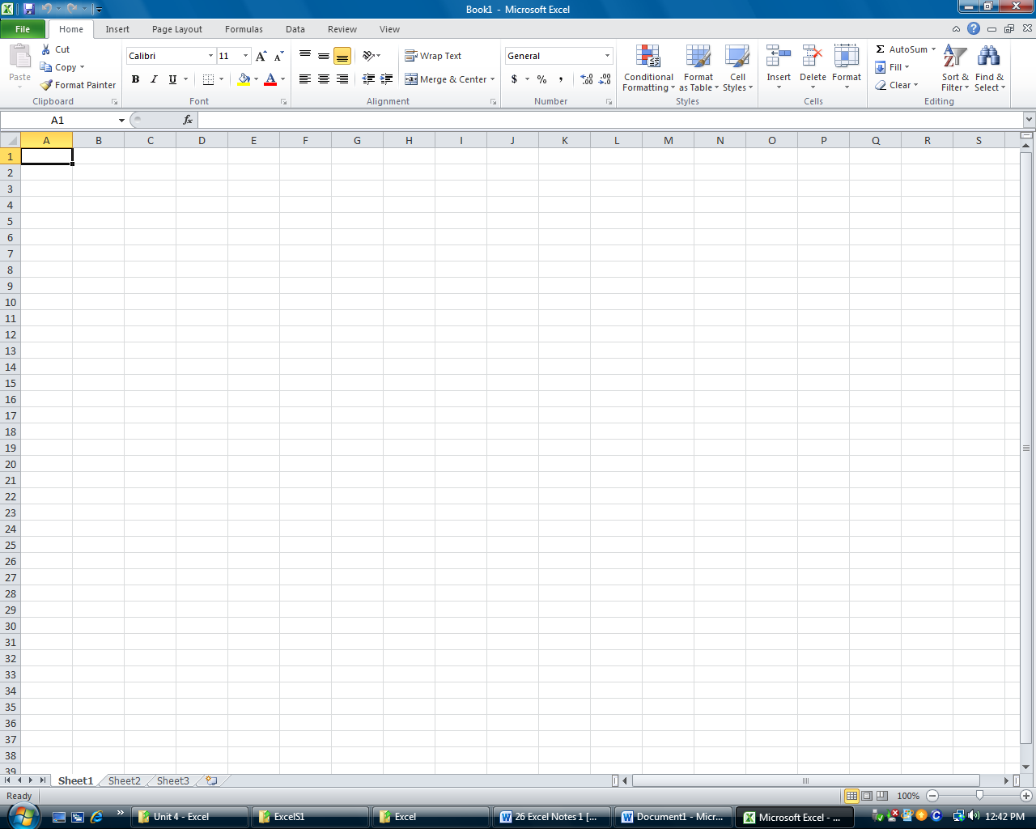
Formula Bar
Scroll Bar
Row Headings
Column Headings
Worksheets
Name Box for active cell

Cell
Scroll Bar
Cell – The intersection of a column and row. Cells can contain numbers, text, or formulas
Fill Handle - The small black square in the lower-right corner of the cell. When you point to the fill handle, the pointer changes to a black cross..
Formatting a Cell, Row or Column
- Click on a Cell, Row # or Column #
- 2.Click on the changes needed on the Home Tab EX. Bold, Center, underline

- Select the Cell, Row # or Column # that you want to change
- Go to the Home Tab and select the changes EX. Bold, Center, underline
- To add a $ sign, %, or decimal to the cells or change the date format click here

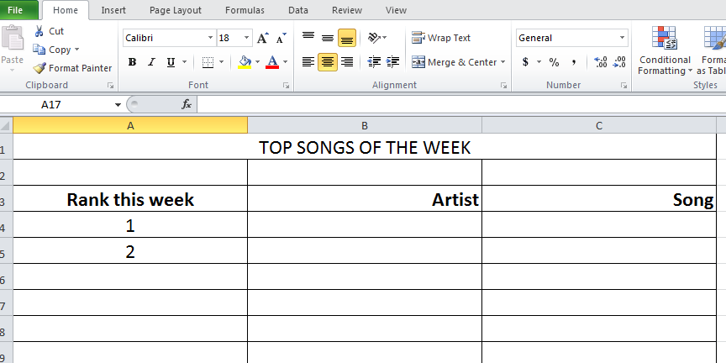
To add a $ sign, %, or decimal to the cells or change the date format click here
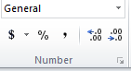
Changing Column or Row width 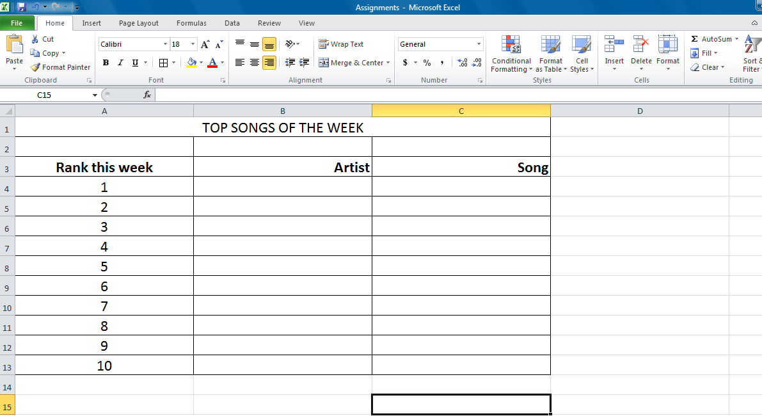
Move the mouse to the line between the columns or rows. The mouse turns into
Hold the mouse as you drag it to the desired width

Merge and Center
1.Using the mouse select the cells you want (Ex: A1 thru D1)
2. Click on the merge and center icon on the Home tab
Auto fill
Excel allows you to fill in chronological data automatically without typing it. (ex: Months, #s, Days of week)
Type in the first two numbers of the sequence, highlight the cells, then drag the fill handle down (you will get a + sign) to fill in the remaining numbers

WFA Technology Assignment #1
Excel Formatting
Directions:
- Start - Microsoft Excel
- Merge and Center the Title “TOP SONGS OF THE WEEK” (Cells A1 thru D1)

- Use auto fill for the Rank (column A) to enter 1-5. Only type in 1 & 2 then autofill the rest
- Center Align Column A, Right Align Column B & C
- Bold Row 3
- Log onto www.AT40.com and look at the Top 40 Chart of this Week
- Enter the data into Excel as per below for the Top 5 Songs (or you can make up your own)
- Make up any price
Column
- Rename the worksheet “A1” and Save the file as “Excel”

 | A | B | C | D  Row
1 | TOP SONGS OF THE WEEK
2 |  |  |  | Bold  Row 3
3 | Rank | Artist | Song | Price
4 | 1
5 | 2
6 | 3
7 | 4
8 | 5
9
10
11
12
13

Autosum - allows you to Add, Average, Count, find the Minimum or Maximum of a RANGE of cells.

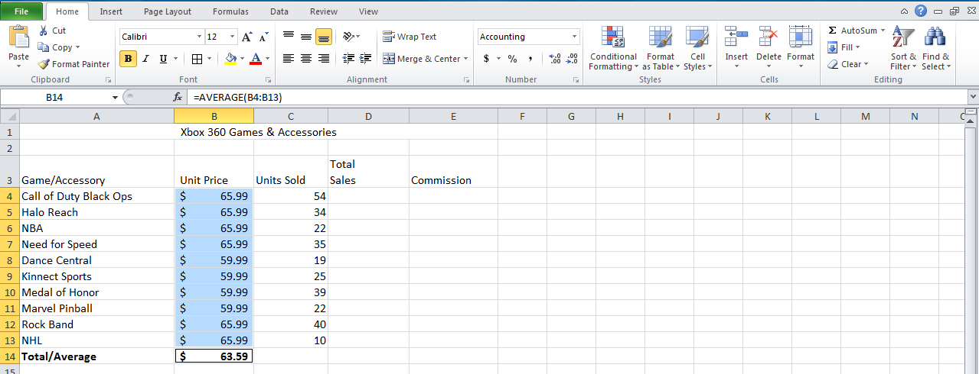
- To use autosum, first highlight the cells you want to sum, average, or count OR just click in the cell where you want the results to show

2. Click on Autosum and choose either SUM or AVERAGE or COUNT

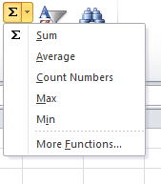

The end result will fill in for you

3. The end result will fill in

To display formulas on your worksheet hit Ctrl + ~ (Tilde)

Test auto sum by totaling up your prices for assignment #1, column D

WFA Technology Assignment #2
Excel Auto Sum

Assignment #2 Directions:
- Go to worksheet 2 and Rename the worksheet “A2”
- Enter the data into Excel as below for Xbox 360 Sales (or make up your own game titles & prices)
- Merge and Center the Title “Xbox 360 Games” (A1 thru D1)
- Format Column B as Currency with a $ sign
- Use to find the AVERAGE unit price for Column B (enter in cell B4)
- Use to find the SUM of Units sold for Column C (enter in cell C15)
- Bold Row 1, 14, 15

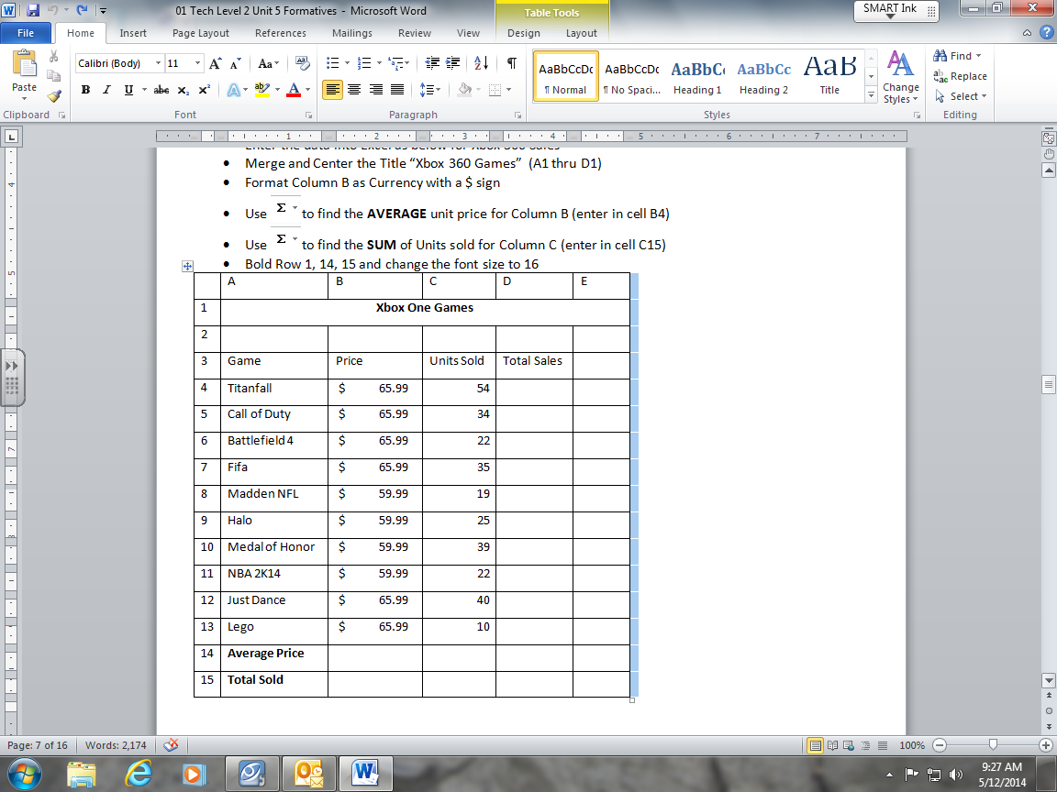

Charts/Graphs – To insert a chart/graph:

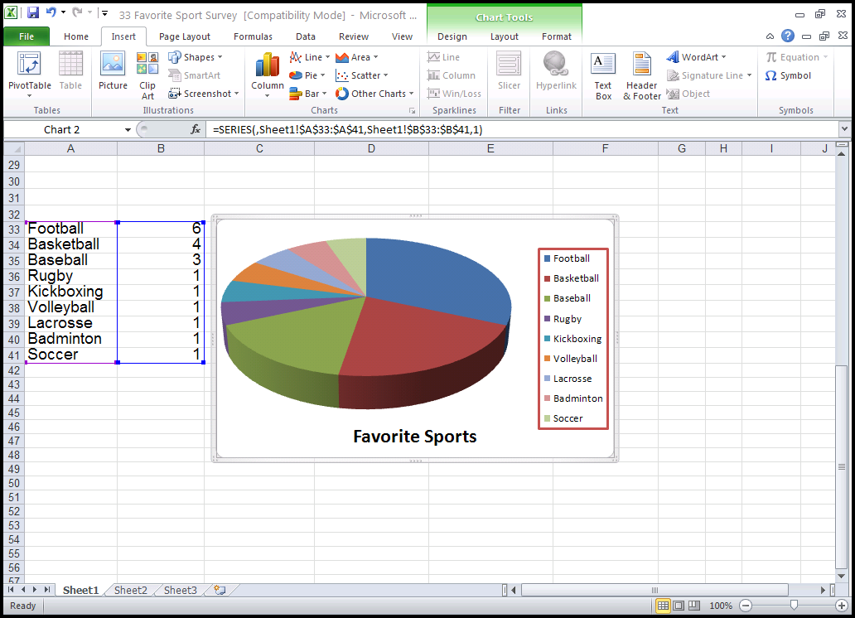
1 Select the data you want to graph
2 Go to insert tab and choose the type of chart
Legend
Chart Tools:
Design-Change Color
Layout – Change Chart
Title & Legend

To change the color or legend of your chart: Click the chart, go to Chart tools and design tab
To add titles to your chart: Click the chart, go to Chart tools then Layout tab and Chart Titles
To change the Legend: Click the chart, go to Chart Tools then Layout Tab and Legend

WFA Technology Assignment #3
Excel Bar Chart
Do Together:
1. Open up your Excel assignments and click on “A2” worksheet
2. We will create a graph of Xbox games
3. Select Game Column, hold down Ctrl, then select Price column.
4. Click on Insert – Line Chart.

Assignment #3 Directions:
- Go to sheet 3 and Rename the worksheet as “A3”
- Enter the data into Excel as below for Wilson’s Sumo Wrestling Team
- Merge and Center the Title “Wilson Sumo Wrestling Team” (A1 thru C1)
- Create a bar chart of the name and weight column (Hold down ctrl key to select both)
- Add a Vertical axis title of “Weight” and “Name”
- Add a chart title “Wilson Sumo Weight”

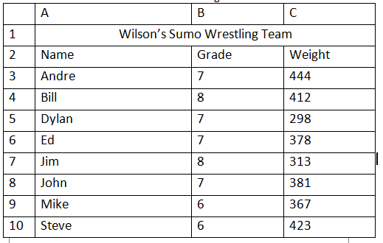
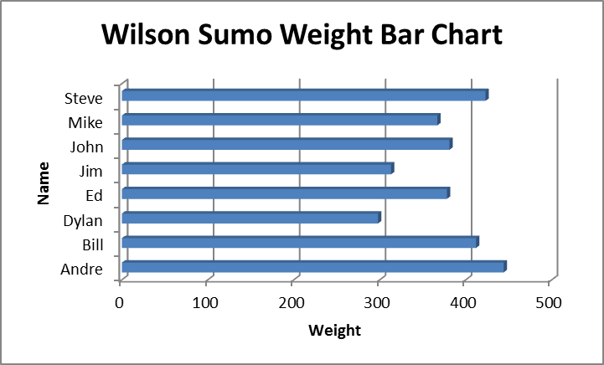

WFA Technology Assignment #4
Excel Pie Chart
Assignment #4 Directions:
- Open up your Excel assignments
- Go to sheet 4 and Rename the worksheet “A4”
- Enter the data into Excel as below for Wilson’s Family Budget
- Merge and Center the Title “Wilson Family Budget” (A1 thru B1)
- Use AutoSum to determine the total expenses
- Create a pie graph of the Category and expense column
- Do not include the Total in the pie graph
- Add a chart title “Wilson Family Budget”
- Add “Data Labels” to the Inside End (this will show your amounts on the graph)
- To add Data Labels Go to Chart Tools, Layout Tab, Choose Data Labels

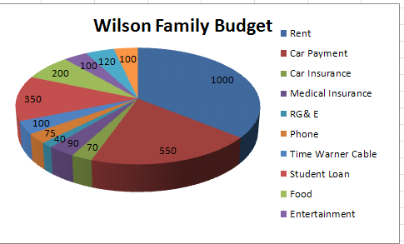
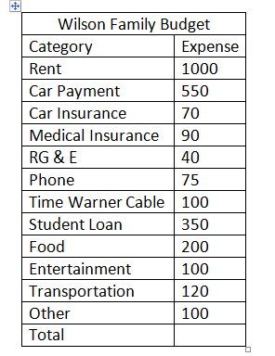

WFA Technology Assignment #5
Excel Line Chart
Assignment #5 Directions:
- Open up your Excel assignments
- Go to Worksheet 5 and Rename the worksheet as “A5”
- Enter the data into Excel as below for Rochester Weather
- Use Autofill for the months
- Merge and Center the Title “Rochester Weather” (A1 thru D1)
- Use Autosum to determine the average weather
- Use Autofill to copy the formula for the average weather to cells below
- Format Column D so there are no decimals
- Create a line graph of the High, Low and Average columns
- Add a chart title “Rochester Weather”
- Add a vertical axis title “Temperature”
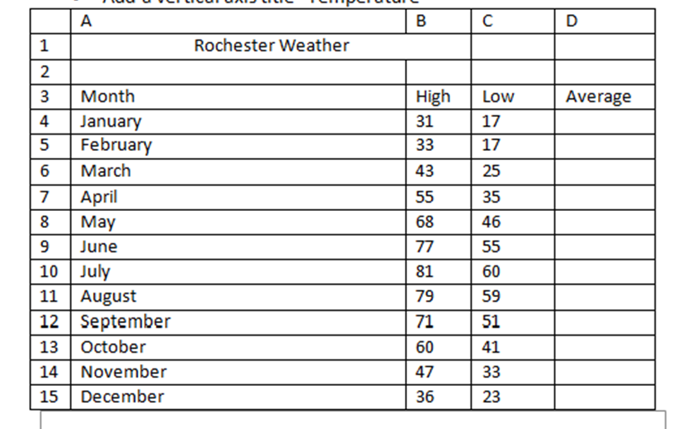

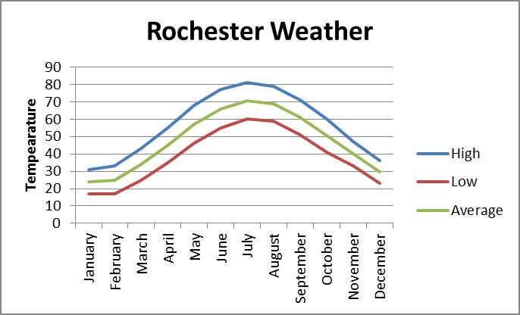
WFA Technology Assignment #6
Excel Quiz
Directions:
- Enter the data into your Excel file and save as worksheet A6
- Total each column using autosum
- Add a $ sign to all columns with numbers
- Insert a column chart, title your chart “Comparative Sales”
- Make sure your chart matches the chart below

 | Jan | Feb | Mar | Apr | May | TOTAL
Rohnny | 2,500 | 6,000 | 950 | 7,000 | 3,450 | ?
Shamar | 3,400 | 4,500 | 1,250 | 625 | 2,300 | ?
Jasmine | 800 | 525 | 8,100 | 6,750 | 4,000 | ?
Your Name | 5,500 | 4,350 | 800 | 1,225 | 3,255 | ?
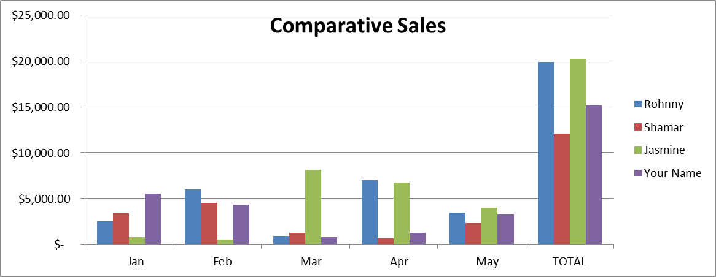

Formulas
Excel can perform standard math functions by using the below symbols:
+ for addition
- For subtraction
/ for division
* for multiplication

All formulas start with the equal symbol (=) then the cell location
Example Formulas:

=A2+B2 This will give you the SUM of cells A2 and B2
= SUM(A1:A5) This will give you the SUM of the Cells A1 thru A5
=AVERAGE (A1:A5) This will give you the AVERAGE of Cells A1 thru A5
=A2*B2 This will give you A2 multiplied by B2

To display formulas on your worksheet hit Ctrl + ~ (Tilde)
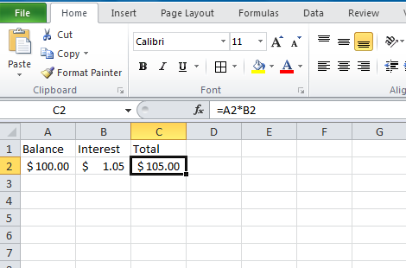
Formula Bar

To enter in a formula you can either type it into the formula bar or click on the Insert Function (fx) icon on the Formula Bar

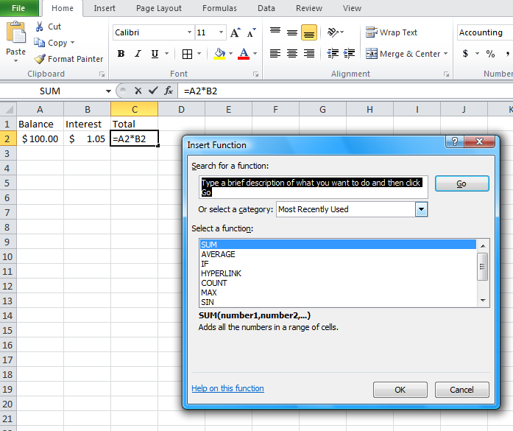
Insert Function
- When you click on fx the insert function box displays
- Select the function you want and select OK

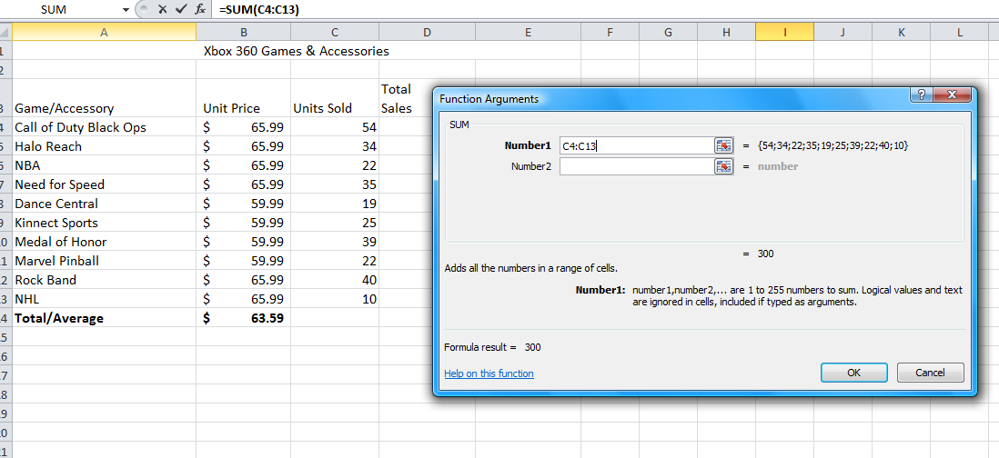
3. Then highlight which cells you want and click OK.

Note: the formula fills in automatically

WFA Technology Assignment #7
Formulas
The King’s Coffers: Using Functions in Microsoft Excel

Once upon a time there lived a king whose greed knew no bounds. The only thing that even came close was his contempt for those who couldn’t pay his taxes. While the king already had much more money than any person could ever have use for, no amount was ever enough. Each and every year the king would send his tax collectors out into the
countryside to collect the king’s bounty.

When figuring out each person’s taxes the tax collectors would come up with an amount they considered fair, and then double it. Those who could not pay were thrown into jail until they could pay off their debt (and being in jail wasn’t a paying job).

Today you will have access to the king’s records. We will find out how much money the king has made collecting taxes. We also determine the answers to questions pertaining to the number of people who paid (and haven’t paid) their taxes.

Directions:
- Enter the following data into an Excel spreadsheet:

 | A | B
1 | James | 95
2 | Ronnie | 18
3 | Chelsea | 69
4 | Trinity | 0
5 | Jekhi | 1
6 | Starr | 19
7 | Jeffrey | 67
8 | Mohamad | 123
9 | Yefire | 19
10 | Keyanna | 322
11 | Breonna | 0
12
13 | Total Tax Collected
14 | Average Tax Collected | Data to be determined by using formulas
15 | Least Tax Collected
16 | Number of Tax Payers
17 | Number of Tax Payers who Paid
18 | Number of Tax payers who haven’t paid

- Calculate the total tax collected first. Do this task by using the SUM function. Click in Cell B13 (where you want the results to go) then Click on fx and select SUM. Highlight the cells you want to SUM. (The formula will be =SUM(B1:B11) See example below

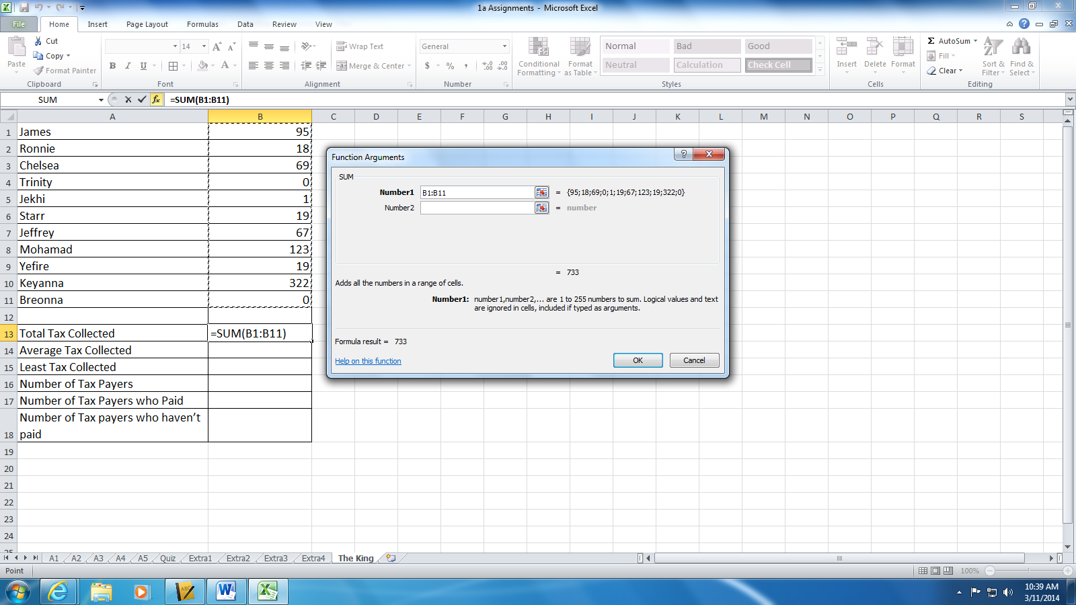

Now that you understand how to use a function on a set of data here are a few more functions to try on your own. Each of these functions uses the range of data that you previously worked with (B1 to B11).

AVERAGE (B1:B11) Computes the average value for the provided range of data
MIN (B1:B11) Computes the lowest value for the provided range of data (Least Tax)
COUNT (B1:B11) Counts the number of data items in the provided range of data (Number of Tax Payers)
COUNTIF(C2:C12,">0") Counts the number of data items in the provided range of data as long as a given data item is “>0” (greater than zero). (Number of Tax Payers who haven’t paid)

Answer each of the questions below using the results you obtained.

- What was the total number of coins collected in the form of taxes?

- What was the greatest number of coins collected from any one individual tax payer?

- What was the average number of coins collected from any one individual tax payer?

- What was the least number of coins collected from any one individual tax payer?

- How many people are tax payers?

- How many people actually paid their taxes?

- How many people will be sent to jail for not paying their taxes?

