Evolution Review

Vocabulary
- Evolution: a change in a population (a bunch of the same species living in the same area) over time. Evolution comes from mutations that are beneficial or have an adaptive value to survival, where the new organisms survive to reproduce while the original species dies out
- Adaptive value: when an adaptation helps an individual survive
- Adaptation: a change in an individual over time to meet the needs of the environment
- Natural selection: organisms that are best adapted to their environment will survive and reproduce, those that are not will die off
- Mutation: a change in DNA (or the mRNA during transcription) that leads to new proteins being made which leads to the expression of new/different traits
- Genetic variation: the different combination of genes that is inherited from parents (sexual reproduction)
- Extinction: when an entire species dies off
- Geologic time: the time that the Earth has been around (about 4.5 billion years)
- Fossil record: collection of fossils that provide clues to the history of Earth’s organisms (proof for the theory of evolution, think about the whales in Egypt and how they figured out that they evolved from a wolf-like creature)

Evolution Notes
- Theory of evolution is a concept that has been tested in many different ways that has a lot of evidence to back it up. Evidence can be found by studying
  - Structural Evidence:
    - The fossil record: fossils studied during different time periods tell a story of how an organism changed over time or when an organism became extinct
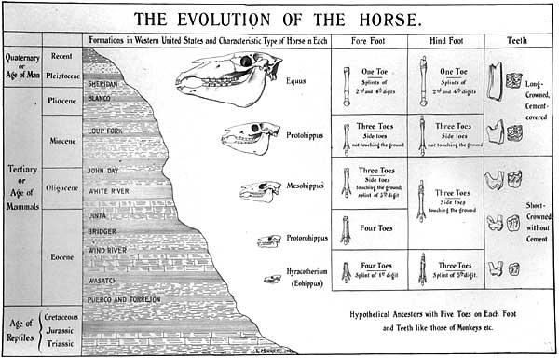
    - Analogous structures: structures that do the same job but are built differently (like the wings of a bird and the wings of a butterfly or housefly)
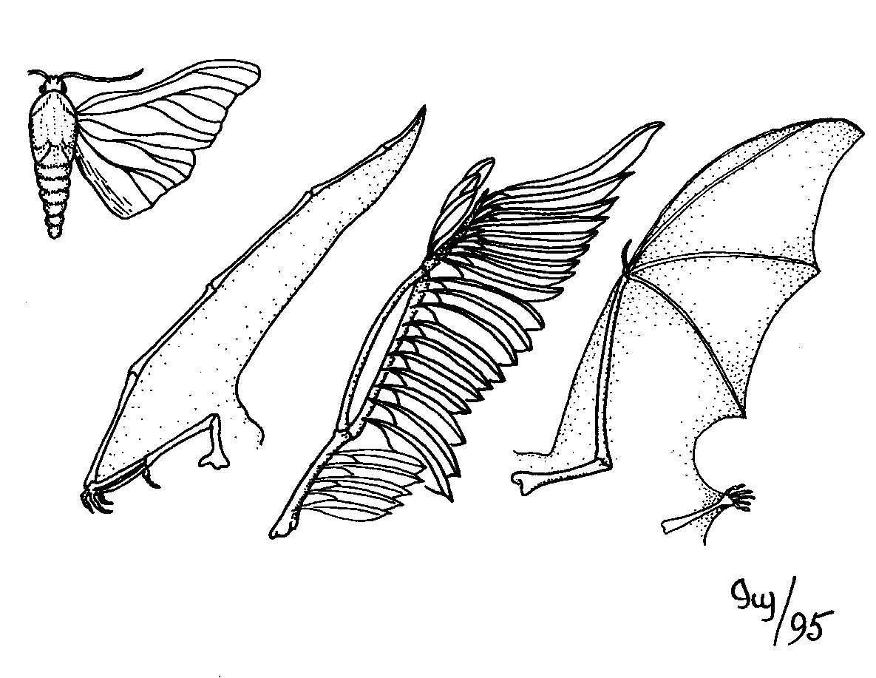
    - Vestigial structures: structures that used to be important but do not appear to have a use today (appendix that was used for digestion of plant materials like tree bark that our ancestors need but we do not)
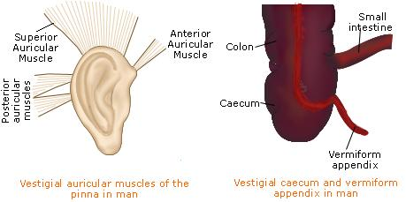
    - Homologous structures: structures that have the same structure but different uses (usually in bones) like the fin of a whale, the wing of a bat or bird and the hand of a human
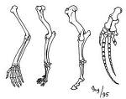
    - Observable characteristics like height, weight, color, etc
    - Embryology: comparing the development of offspring in different organisms (the early stages of development between humans, fish, birds, reptiles all are very similar)
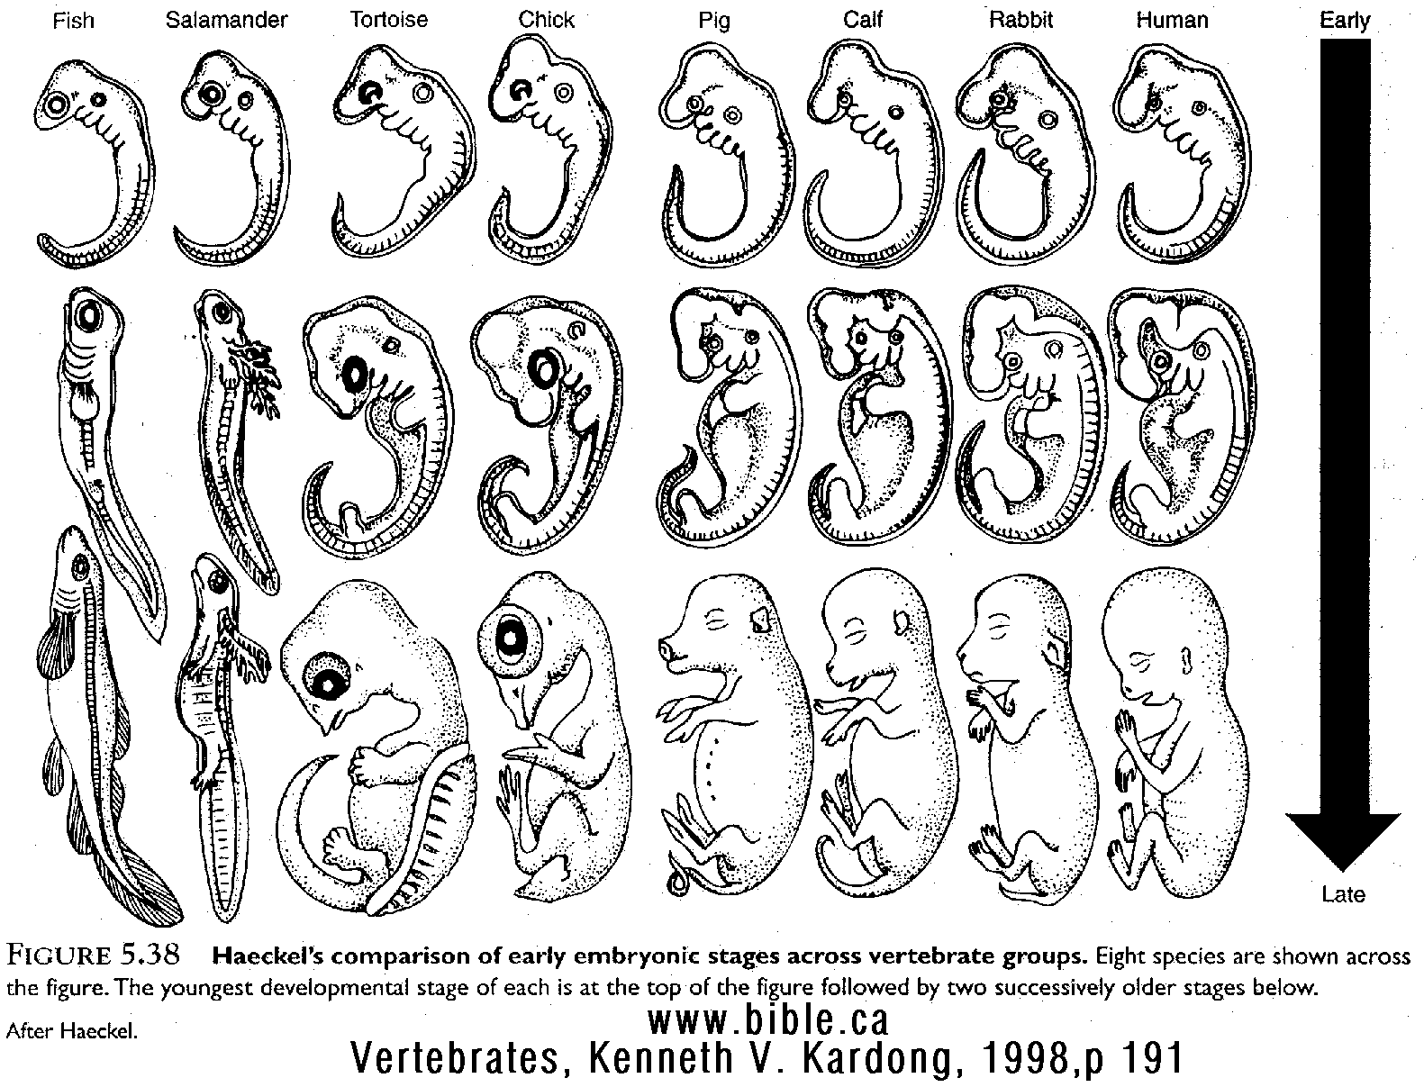
    - Comparative Anatomy: looking at the similarities and differences between body parts of organisms
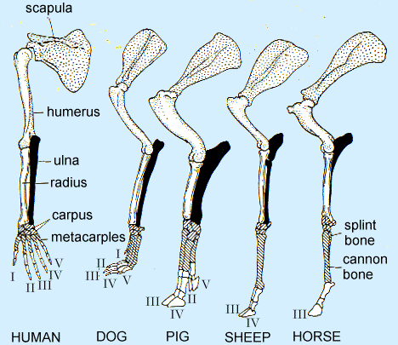

  - Molecular Evidence:
    - Comparing DNA obtained from gel electrophoresis or looking at the sequence of DNA (genome) of an organism
    - Comparing amino acid/protein sequences, including the presence of certain enzymes or using chromatography to separate pigments that are present (especially good in plants)

Molecular evidence is much more reliable (better than) structural evidence, because things can look the same but have different DNA or amino acids so they are not as closely related as they may appear.

Organisms have evolved so that certain conditions will help them survive the natural selection process:
- The overproduction of offspring to ensure that some species will survive
- The finite (limited) supply of resources will cause competition in a species
- Genetic variation of offspring due to mutation and genetic shuffling
- Selection by the environment for those better adapted to survive and reproduce

Single celled organisms (like bacteria) can evolve in the matter of minutes to hours but multicelled organisms take millions of years to evolve into something new.

A good strategy for dealing with evolution questions is to read through the question and decide if it is talking about natural selection or competition for limited resources or for a relationship. One of these three will be the answer every time.

Reminder: Science likes to use several different terms for the SAME thing: for evolution, when talking about limiting factors, they will also use the terms finite resources, selecting agents, or limiting resources. They all mean the same thing: biotic and abiotic things that will control population growth and survival. Some examples include available food, water, space, shelter, mates, temperature, etc.

Reading Evolutionary Trees (cladograms):

Evolutionary trees are based on both time and the relationship between the organisms. The more closely related, the closer they are on the tree, but that relationship is based on a common ancestor, NOT on a special relationships. For example, on the tree below,

A is the common ancestor for all of the indicated species. B and C and then E and F are more closely related because they have a common ancestor (the point at which they meet the tree together where it is circled) than say B and F. If the tree does not reach all the way to present time (A, D, E and F), then those species were not well adapted enough to survive and they became extinct.
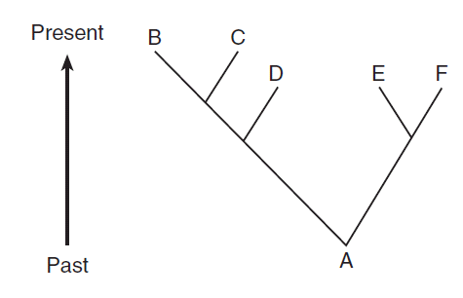
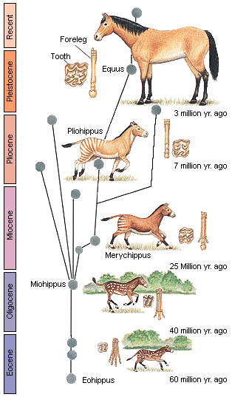

Relationships and Biodiversity

Important Terms
Biodiversity Gel Electrophoresis

Evolutionary relationships Genus species
Molecular Evidence Habitat Destruction
Structural Evidence Habitat Degradation
Chromatography Human Impact
DNA
Extinct Amino Acids
Transcription Translation
Enzymes

Key Points
- The diversity of life on the planet has been created through the process of evolution by means of natural selection.
- Through natural selection, organisms have evolved to lessen competition, and therefore fill a wide array of niches. This biodiversity increases the stability of ecosystems.
- Biodiversity has important benefits to mankind, including development of new food sources and medicines; as well as beneficial, free, ecosystem services. Ecosystem degradation and destruction lead to the loss of genetic biodiversity and increases the chance that an ecosystem will become less stable and collapse.

Procedures
*Safety precautions are moronic for this lab. Goggles in step 4 & 5 are for a vinegar and baking soda reaction and paper chromatography using food coloring, vinegar, and water.

- Seven tests are conducted to determine the relatedness of Samples X,Y, and Z to Botana curus. They are as follows:
  - Structural Characteristics of Plants
    - Compare the characteristics of the bagged samples
  - Structural Characteristics of Seeds
    - Compare the characteristics of the bagged samples
  - Structural Characteristics of Stems (Internal Microscopic Structures)
    - Use low power on the microscope to examine cross sections of the stems. Look for a scattered arrangement of bundles or a circular arrangement of bundles.
  - Paper Chromatography to Separate Plant Pigments
    - Using clean, separate pipettes for each sample, transfer two drops of each plant extract to a piece of chromatography paper, two cm above the bottom. Label the top of the paper with the proper sample names.
    - Place the paper into a cup of water, 1 cm deep. The water should NOT touch the spots of plant extract.
    - Keep checking the sample to make sure the water does not reach the labeled top part of the paper. When the water is done rising, check the color and relative amounts of pigments and record this in the data table.
  - Indicator Test for Enzyme M
    - Placing a scoop of the indicator powder into 4 depressions of the well tray, check the extracts for the presence of Enzyme M. A fizzing reaction indicates that Enzyme M is present in the extract.
  - Gel Electrophoresis (simulated) to Compare DNA
    - Obtain colored paper strips representing portions of DNA molecules. The sequence of bases are representative of molecules isolated from Botana curus and Species X,Y, and Z. An enzyme will be used to cut between C and G of the sequences to produce different sized portions of the DNA. These will be placed on a simulated gel plate to compare the relatedness of B. curus to X, Y, and Z.
  - Translating the DNA Code to Make a Protein
    - Using the DNA codons, create the complementary messenger RNA, remembering that the DNA base A specifies the RNA base U (*T is replaced with U in RNA). Using the Universal Genetic Code table, translate the mRNA base sequences into the correct amino acid sequences of the protein.

Analysis
- This lab has 7 tests used to determine the relatedness of 4 plant samples. Remember that scientists use a variety of evidence to determine evolutionary relationships, including cell types, structural morphology, DNA, behavior, embryology, and fossils. The more criteria that are shared between organisms, the more likely they are closely related.
- Relatedness can be shown using a “branching tree diagram”, or cladogram. Organisms that are closely related are next to each other on the same branch. More distant relations are further apart on the branch.
- Botana curus shares the most characteristics with Sample Z, making this sample the most closely related. These characteristics included the presence of Enzyme M, the same pigments blue, yellow, and pink, scattered bundles, no difference in the amino acid sequences, and the same DNA banding pattern.
- The evidence that should receive the most emphasis when determining the relatedness would be the genetic sequence, as many things can look similar structurally (convergent evolution), but would be unlikely to share the same DNA sequence if they are not truly closely related.
- The loss of even a single species (extinction) can have major implications for mankind and natural ecosystems.
- Scientists use gel electrophoresis to separate DNA fragments. Negatively charged DNA molecules migrate through the gel like material towards the positively charged pole. The smaller molecules migrate more rapidly through the gel than the larger ones do.

The Beaks of Finches

Important Terms

Variation Competition
Struggle for Survival Adaptation
Environment Selecting Agent
Migration

Key Points

- Species evolve over time. Evolution is a result of the interactions between:
  - The potential for a species to increase its population
  - Genetic variation of offspring due to mutation and genetic recombination.
  - A limited amount of resources in the environment (ex. food, space, mates, etc.)
  - Selection by the environment of those individuals that are better able to survive and produce viable offspring (“survival of the fittest”)

- Some characteristics / variations give individuals an advantage over others in surviving and reproducing. The offspring of these “better adapted” individuals will be more likely to survive and reproduce than those of other individuals. The proportion / frequency of individuals with favorable characteristics will increase.

- Variation in a population increases the likelihood that at least some individuals will survive the changing environmental conditions.

Procedure

- In teams of two, students will simulate competition for food by finches in an island environment.

- The beak variations of finches will be represented by a variety of tools (tweezers, spoons, pliers, etc.)

- In Round One, students simulate feeding on small seeds. Each student will remove seeds alone, without competition from other students.

- The winners of Round One stay on their original island while the losers migrate to a new island with a different food source (large seeds). In Round Two, the same procedure will be followed with one exception. Competition between species will be simulated by having a member from each opposing team feed from the tray at the same time. The winning teams proceed to Round Three and the losing teams are eliminated.

- In Round Three, all surviving teams feeding on large seeds will feed from the same tray of large seeds at the same time. All surviving teams feeding on small seeds will feed on the same tray of small seeds at the same time.

- The winning teams of from Round Three will possess the beak variation that is best fit for feeding on that particular type of seed.

- All trials in each round run for the same length of time. Only those seeds that are successfully removed are counted.

Analysis

- Those individuals with beaks best adapted for feeding on small seeds remained on the island at the end of Round One while those with “less adapted” beaks migrated to a new island.

- Competition for food in Round Two should have had an adverse effect on feeding success.

- There were fewer survivors at the end of Round Three due to increased competition.

- The following four components of Natural Selection were simulated:

  - Variation: different beaks, different size seeds
  - Competition: more than one bird feeding at one bowl
  - Struggle for survival: each bird trying to get enough food to survive
  - Adaptation: particular characteristics of “beaks”
  - Environment: students, seeds, dishes are part of environment
  - Selecting agent: type of “beak” and / or type of seed available

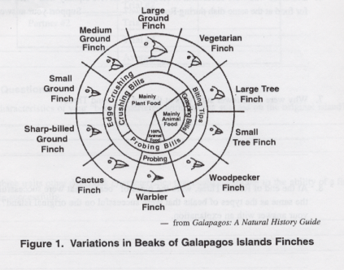
* Be sure you study the diagram to the left that shows the variations in beaks of Galapagos Island finches. The diagram represents the types of beaks, the function of the beaks, and the type of food the finches eat.

Review Questions.

1. Which statement is best supported by the theory of evolution?
(1) Genetic alterations occur every time cell reproduction occurs.
(2) The fossil record provides samples of every organism that ever lived.
(3) Populations that have advantageous characteristics will increase in number.
(4) Few organisms survive when the environment remains the same.

2. Which statement provides evidence that evolution is still occurring at the present time?
(1) The extinction rate of species has decreased in the last 50 years.
(2) Many bird species and some butterfly species make annual migrations.
(3) New varieties of plant species appear more frequently in regions undergoing climatic change.
(4) Through cloning, the genetic makeup of organisms can be predicted.

3. Which concept is best illustrated in the flowchart below?
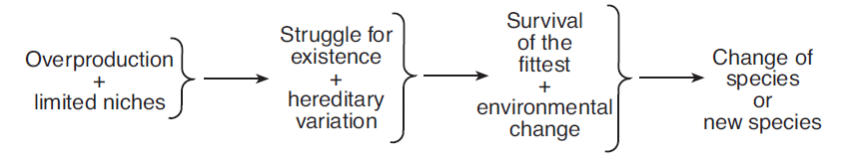
(1) natural selection (3) dynamic equilibrium
(2) genetic manipulation (4) material cycles

4. Scientists have discovered that the Oklahoma salamander, Eurycea tynerensis, develops into its adult form in streams where the streambeds are made of fine, tightly packed gravel. Salamanders living in streams with streambeds made of large, loosely packed gravel remain immature. This situation is an example of
(1) the production of gametes
(2) faulty genes found in aquatic organisms
(3) development influenced by the environment
(4) the production of new organisms by environmental engineering

5. A species of bird known as Bird of Paradise has been observed in the jungles of New Guinea. The males shake their bodies and sometimes hang upside down to show off their bright colors and long feathers to attract females. Females usually mate with the “flashiest” males. These observations can be used to support the concept that
(1) unusual courtship behaviors lead to extinction
(2) some organisms are better adapted for asexual reproduction
(3) homeostasis in an organism is influenced by physical characteristics
(4) behaviors that lead to reproductive success have evolved

The characteristics of four finches that inhabit the same island are represented in the chart below.
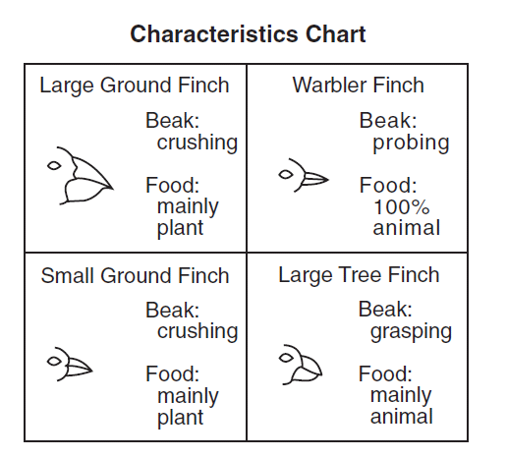
6. Complete the table below using information in the characteristics chart and your knowledge of biology. [2]

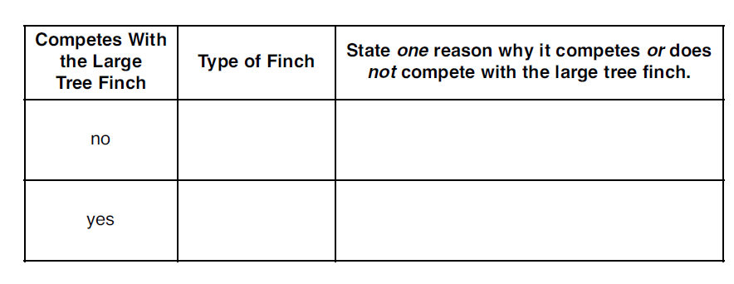
7. Studies of the finches of the Galapagos Islands have shown that
(1) DNA will change to produce structures needed by birds to survive intense competition
(2) a bird’s beak changes annually in response to the type of food that is most abundant each year
(3) natural selection occurs when there are scarce resources and intense competition
(4) the beak of a finch will change if the environment of the bird remains stable

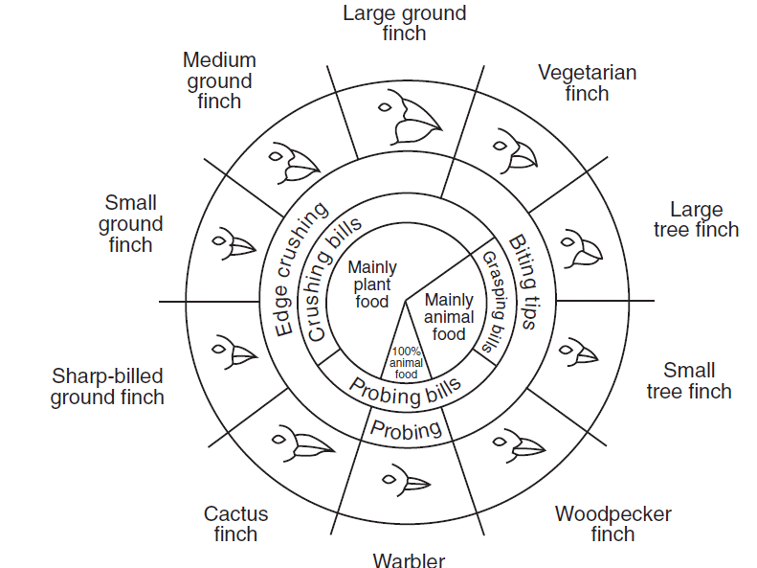
8. Small ground finches and medium ground finches live on an island with abundant plant and animal food. Predict how the small ground finch and the medium ground finch would be affected if warbler finches migrated to the island where these finches live. Support your answer. [1]
_______________________________________________________________________
_______________________________________________________________________

9. The differences observed in the bird beaks are most likely due to
(1) asexual reproduction of these finch species
(2) the selection for different shaped beaks that best suit different niches
(3) the genetic recombination associated with mitotic cell division
(4) the genetic engineering of the DNA of each of these species

10. The only finch that is completely carnivorous has a beak adapted for
(1) probing, only
(2) probing and edge crushing
(3) probing and biting
(4) biting and edge crushing

11. Which two finches would compete the least for food?
(1) small ground finch and large ground finch
(2) large ground finch and sharp-billed ground finch
(3) small tree finch and medium ground finch
(4) vegetarian finch and small ground finch

12. A boy inherits genes for tallness, but his growth is limited as a result of poor nutrition. This is an example of
(1) an inherited disorder
(2) environmental influence on gene expression
(3) expression of a hidden trait
(4) a characteristic controlled by more than one pair of genes

13. What will most likely occur if two different plant species compete for the same requirements in an ecosystem?
(1) They will usually develop different requirements.
(2) One species may adapt to a different environment.
(3) One species may be eliminated from that ecosystem.
(4) They will alter the environment so that they can both survive in that ecosystem.

14. If an ecosystem is changed through a natural disaster, organisms will have the best chance of survival if
(1) their environment has few abiotic factors
(2) the organisms are large
(3) the population size is small
(4) their species exhibits genetic variation

15. Ancestors of the giant panda had rounded paws with five very short toes. Today, the giant panda has a sixth toe, often referred to as a thumb, even though it develops from a wrist bone. This unique thumb is an adaptation that allows the panda to easily hold and eat bamboo shoots. The presence of the giant panda’s thumb is most likely the result of
(1) natural selection
(2) selective breeding
(3) asexual reproduction
(4) ecological succession

16. Three different species of finch inhabit one particular Galapagos Island. All three species of finch prefer plant food and have edge-crushing bills. Explain how all three species of finch can live successfully on the same island. [1]
_______________________________________________________________________
_______________________________________________________________________

17. State one reason why large ground finches and large tree finches can coexist on the same island. [1]
_______________________________________________________________________
_______________________________________________________________________

A plant known as caltrop is found on one of the Galapagos Islands. The caltrop plant produces seeds with tough, spiny coats. There is a bird species, Geospiza fortis, that can crack the tough seed coat and eat the contents inside. On one part of the island where there are many of these birds, the caltrop plants produce fewer seeds and the coats of the seeds have longer and more numerous spines. On another part of the island where there are few of these birds, the plants produce more seeds and the seed coats have fewer, shorter spines.

18. Identify one variation the caltrop seeds have for survival. [1]
_______________________________________________________________________
19. Identify one process that can result in adaptations. [1]
_______________________________________________________________________

Two adaptations of the monarch butterfly that aid in its survival are the production of a certain chemical and a distinctive coloration that other animals can easily recognize. When a monarch butterfly is eaten, the presence of the chemical results in a bad taste to the predator. Although the viceroy butterfly does not contain the chemical that
tastes bad to a predator, it does resemble the monarch in size, shape, and coloration.

20. Explain how the combination of this chemical and the distinctive coloration aid in the survival of the monarch butterfly. [1]
_______________________________________________________________________
_______________________________________________________________________

21. How do the characteristics of the viceroy butterfly aid in its survival? [1]
_______________________________________________________________________
_______________________________________________________________________

22. A population of bats feeds on flying insects. Some of these bats have a gene that results in much stronger flight muscles than those of the other bats in the area. Explain how this variation could lead to evolutionary change within this species of bat. In your answer, be sure to include an explanation of:
• competition within the bat population [1]
• survival of various individuals within the bat population [1]
• how the frequency of the trait for stronger flight muscles would be expected
to change within the bat population over time [1]
___________________________________________________________________________
___________________________________________________________________________
___________________________________________________________________________
___________________________________________________________________________
___________________________________________________________________________
______________________________________________________________________________________________________________________________________________________________________________________________________________________________________________________________________________________________________________________________________________________________________________________________________________________________________________________________________________________________________________________________________________________________________________________________________________________________________________________________________________________________________________________________________________________________________________

23. A diagram of evolutionary pathways of various animal species is shown below.
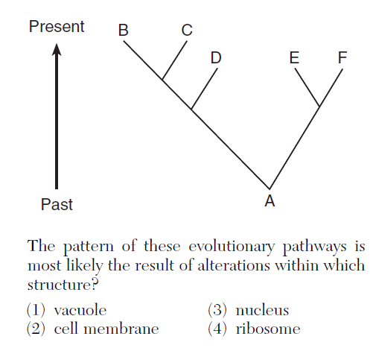

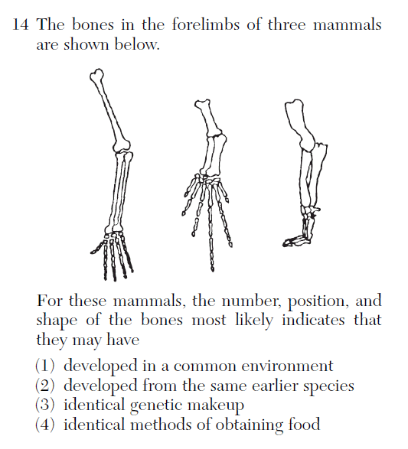
Base your answers to questions 25 through 27 on the information below and on your
knowledge of biology.

Mutations are often referred to as the “raw materials” of evolution.

25 State one reason that mutations are often referred to as the “raw materials” of
evolution. [1]
_______________________________________________________________________
_______________________________________________________________________
_______________________________________________________________________
26 Use appropriate letters to write a 9-base DNA sequence that could represent a portion of a gene. [1]
_________________________________
27. Show one example of what could happen to the 9-base DNA sequence you wrote in question 26 if a mutation occurred in that gene. [1]
_________________________________

